Press Release
Iberostar switches off its lights for nature during Earth Hour, saving an estimated 45,000 kWh

- The hotel chain will be joining the thirteenth edition of this WWF initiative, marked by a global blackout.
- The aim of this movement is to combat climate change and raise awareness of a worldwide problem.
- This action forms part of a series of initiatives promoted by Iberostar within its ‘Wave of Change’ movement for the protection of our seas and oceans.
Palma de Mallorca, March 2019. For the fifth year running, the Iberostar Group will be playing an active role in events to commemorate Earth Hour, scheduled for this Saturday between 8.30 p.m. and 9.30 p.m. The hotel chain is part of this global movement to combat climate change and defend nature through raising awareness actions targeting institutions, companies and society in general centred on a problem that affects the entire planet.
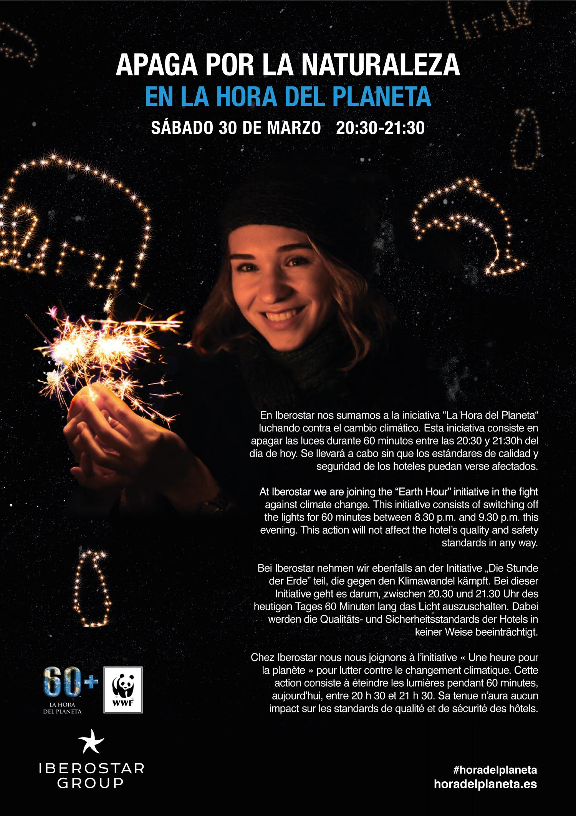
The action consists of a blackout in homes, businesses, buildings and famous landmarks. Iberostar will be switching off the lights in its corporate offices and the communal areas of more than 120 hotels in 19 countries around the world. The Group estimates that this 60 minute gesture will save up to 45,000 kWh of energy, and prevent the emission of more than 17 tons of CO₂.
Under the slogan #Connect2Earth, the WWF seeks to encourage sustainable lifestyles, promote renewable development, conserve our forests, seas and natural resources or combat the loss of diversity. Actions such as these are Iberostar’s way of raising awareness amongst customers and employees of the importance of working each day to combat climate change, setting an example with initiatives based on its ‘Wave of Change’ movement for the protection of seas and oceans; the elimination of single-use plastics; responsible fish consumption and improving coastal health.
All this has positioned Iberostar at the forefront of responsible tourism thanks to an ambitious sustainable management strategy applied to all its areas of activity.

