PRESS RELEASE

IBEROSTAR OPENS TWO HOTELS

IN ONE OF MONTENEGRO’S FINEST LOCATIONS

* ***The new 5 star Iberostar Perast and the 4 star Iberostar Herceg Novi are the latest additions to the chain’s portfolio in Montenegro, comprising 3 hotels and a total of 848 rooms.***
* ***The two new hotels boast an unbeatable location on the Bay of Kotor, included on UNESCO’s World Heritage list since 1979 due to its outstanding natural, historical and cultural value.***
* ***The new five star Iberostar Perast, included in Iberostar’s heritage hotels segment, offers guests the chance to stay in a newly-renovated 18th century palace.***

***Palma de Mallorca, 4th June 2018.*** June will see the opening of two new fully renovated **Iberostar Hotels & Resorts** hotels in Montenegro: the **Iberostar Herceg Novi** and the **Iberostar Perast**. The Group has been operating in this country since 2005 when it took over the **Iberostar Bellevue,** a sun and sand hotelin the southern city of Budva. The two new hotels, the **Iberostar Herceg Novi** and the **Iberostar Perast,** are further examples of the company’s determined commitment to offer its customers first class accommodation in truly outstanding locations. Indeed, the Bay of Kotor, where the two new hotels stand, has been included on the UNESCO World Heritage list since 1979 due to its wealth of environmental, cultural and historical assets. In addition to the superb setting on the shores of the Adriatic, the area boasts a rich historical legacy dating back to the days when several towns formed part of the Venetian Republic between the 16th and 18th centuries.

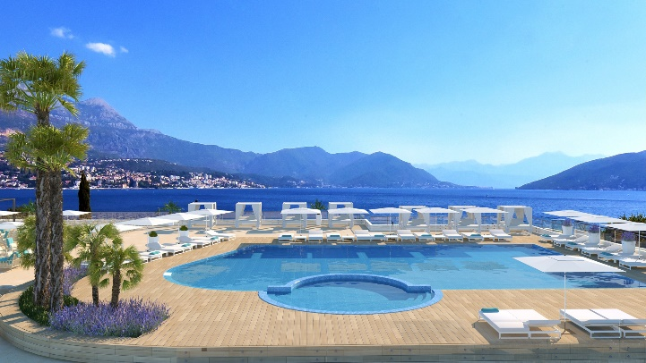The **Iberostar Herceg Novi** was the first hotel to open on 1st June. The hotel has 183 rooms and stands on the seafront in the municipality of Herceg Novi. It has been fully renovated throughout and the facilities include its own jetty and a beach club offering breathtaking views over the bay. It is the ideal base from which to discover the area’s wealth of history, explore the stunning natural landscapes and enjoy numerous water sports.

The superb services and amenities include a modern spa and a **Fit & Fun** activity programme. There is also a buffet-style restaurant and four bars serving a mouth-watering selection of Mediterranean and local dishes that will suit all tastes.

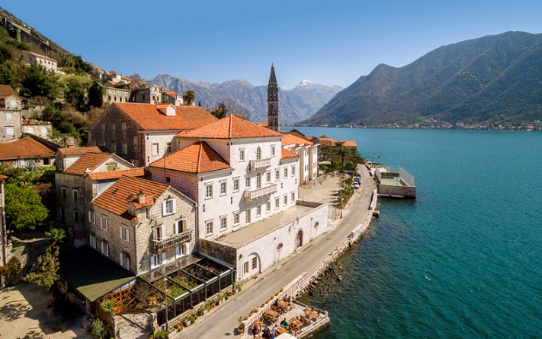The latest addition to the Iberostar Group’s hotels in Montenegro will be opening in late June. The new five star **Iberostar Perast** is a unique hotel housed in an 18th century palace that has been renovated in avant-garde style yet which retains its original architecture. It is part of **Iberostar Heritage**, the chain’s historic hotel segment, made up of unique hotels that combine art, history, culture and beauty.

The new Iberostar hotel is situated in Perast, a small seafaring town in Montenegro and home to the finest examples of Baroque architecture in the Adriatic region. Magnificent palaces and churches whose beauty and secrets remain intact nestle along the shores of Europe’s southernmost fjord. Two small islands, Sveti Dorde – the site of a 12th century Benedictine monastery - and Gospa od Škrpjela, the only artificial island in the Adriatic, add the perfect finishing touches to a setting that for centuries enchanted nobles, princes, sailors and adventurers.

Situated a mere five metres from the shoreline, the Iberostar Perast stands out for its soul and character, its old-world charm and prime location. From the hotel, guests can explore the beauty of the town and the surrounding area, as it is just 12 km from Kotor’s historic quarter, 45 km from Buvda Citadel and two hours from Dubrovnik city centre.

The Iberostar Perast is housed in the town’s largest palace, built in the 18th century by the Smekjas, a family of wealthy merchants. The first mention of this dynasty dates back to the second half of the 16th century, but it was in the mid 18th century when Petar Smekja, on board the ship ‘Leon Coronato’, contributed to the creation of profitable economic connections between the Baltic nations and Venice, which would make him extremely wealthy. In 1748 he received the title of Count and in 1779 his family was included amongst Kotor’s nobility. Building work on the Smejka family palace, which currently houses the Iberostar Perast, began in 1764, using stone obtained exclusively from the island of Korčula. The entrance still bears the family’s coat-of-arms, featuring a hand holding the stem of a plant (*čičimak*) with stars. Work on the building was finally completed in the 1930s.

The hotel, which has around a hundred rooms, offers a first class range of services and facilities, as well as superb local and international gastronomy and a private jetty. All the amenities are tailored to cater for families or adults ensuring guests will enjoy the charms of the past in an avant-garde building steeped in history set against a spectacular natural backdrop.

\***Note for the editor**: click on this link to access a photo gallery.