PRESS RELEASE

IBEROSTAR INVESTS MORE THAN 66 MILLION EUROS IN RENOVATION WORK AT THREE OF ITS HOTELS IN SPAIN

* ***Over the last six years, the Iberostar Group has assigned more than 500 million euros to renovation projects and acquisitions and plans to invest a further 800 million in the coming years. As a result of this ambition investment strategy, renovation work has already been carried out on no less than 70% of its hotel portfolio.***

***Palma de Mallorca, 31st May 2018.* The Iberostar Group** is immersed in an ambitious renovation strategy designed to position its hotels at the forefront of the market in terms of quality and offer guests the finest holiday experience. To date, investments totalling more than 500 million euros have resulted in the renovation of 70% of its hotel portfolio. This month saw a prime example of the Group’s commitment to this strategy with the opening of a further three completely renovated hotels following an investment of more than 66 million euros: the **Iberostar Marbella Coral Beach**, **Iberostar Alcudia Park**, and **Iberostar Fuerteventura Palace**.All three are part of the company’s **ocean resorts segment**.

The launch of these hotels, together with others that are already operating or are about to open, are clear indicators of **Iberostar’s** determination to ensure the evolution, innovation and sustainability of its products. In this sense, in January the company announced its intention to continue with its repositioning efforts over the next few years, with investments of 800 million euros allocated to Europe and America until 2022. The Iberostar Group has strengthened the corporate values that set it apart from the rest and are based on four key elements: the **very best locations**, **delicious gastronomy options**, an **unshakeable vocation for service** and a **focus on and belief in people** – those that make up the Group, as well as its customers, partners and society in general.

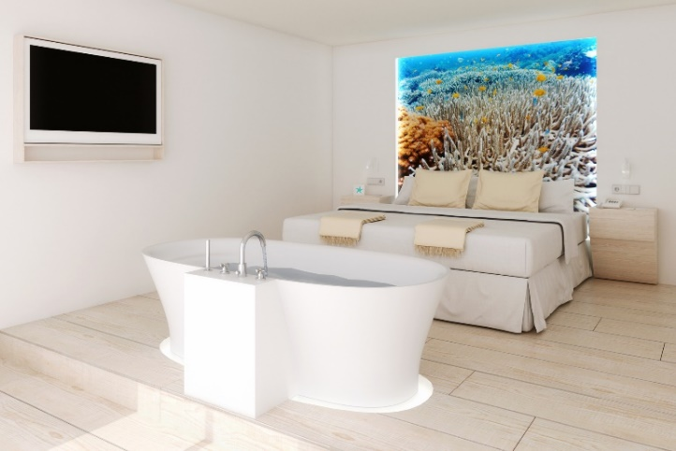The first of this month’s openings was the **Iberostar Fuerteventura Palace**. Following two partial renovation projects in 2015 and 2016, this month the hotel has once again started welcoming guests to its fully renovated facilities. This five star, adults only hotel is just a short distance from the idyllic Jandía Beach. The 437 rooms include a number set apart exclusively for **Star Prestige** guests, a premium service offering a truly memorable experience including special rooms and exclusive spaces that are the perfect setting for forgetting daily routines and indulging in some well-deserved pampering. The range of facilities and amenities at this hotel includes a spa and two restaurants, as well as other additional services.

**The Iberostar Alcudia Park,** situated on the seafront of one of Majorca’s most spectacular beaches and boasting views of Alcudia Bay, is now also open. This four star hotel is undoubtedly the best choice for families, thanks to its **Star Camp** programme created for younger guests, which includes countless activities and new areas guaranteeing an unforgettable holiday filled with fun and laughter. The hotel also offers an *adults only* option thanks to its **Star Prestige** service.

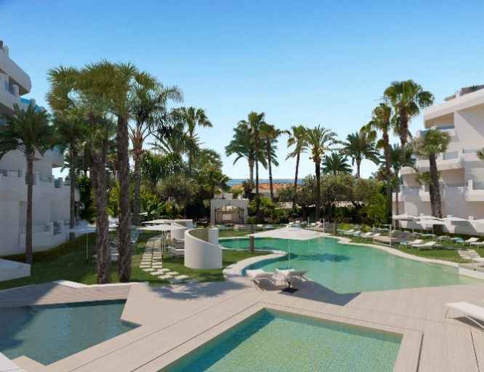The third hotel to open this month is the **Iberostar Marbella Coral Beach,** boasting a prime location on Río Verde Beach, awarded a Blue Flag in 2017, and just one kilometre from Puerto Banús, one of Marbella’s most exclusive areas. This superior four star hotel, which was previously for adults only, has now been renovated and reopened, offering a range of services for families. The 172 hotel rooms have been fully refurbished and now include a choice of unique themed accommodation options: *sharing Jacuzzi doubles, do nothing doubles, film doubles* and *sharing pool doubles*. Renovation work has also been carried out on the hall, bar, swimming pools and sun terrace.

**Aurelio Vázquez, the Iberostar Group’s COO**, stated: “*We are delighted to announce the reopening of these three hotels in Spain, which are set to be followed by others both in the country and abroad. These successful renovation projects reflect our ongoing dedication and commitment to improving and perfecting our hotels and services. We are confident that these excellent results are set to continue”.*

The renovation strategy got underway in 2018 with the opening of the **Iberostar Sábila** on Tenerife’s Costa Adeje. Another Canary Island hotel, the **Iberostar Lanzarote Park,** has also been upgraded to five star category, and now features a family zone with a separate water park and a **Star Prestige** area.

Outside Spain, the company has also centred its efforts on enhancing its services and facilities with improvements to the **Iberostar Founty Beach** in Morocco, which welcomed its first guests on 4th May following the completion of the renovation project. In addition, the **Iberostar Mehari Djerba** in Tunisia, now has a new adults only **Star Prestige** area.

\***Note for the editor**: click on this link to access a photo gallery.