PRESS RELEASE

IBEROSTAR SÁBILA,

THE ALOE VERA HOTEL

* ***March saw the opening of the Iberostar Sábila, a five-star adult only hotel in the south of Tenerife where aloe vera is king. The outstanding range of leisure and relaxation facilities, a unique location and mouth-watering gastronomy guarantee a one-of-a-kind experience.***
* ***As part of its exclusive range of amenities, the hotel offers a choice of products and services ranging from beauty treatments, to a wide selection of food and drink featuring the legendary aloe vera plant as their main ingredient.***

**24th April 2018.** Aloe vera was considered by Ancient Greece’s scientists as the ‘universal panacea’ and known to the Egyptians as the ‘plant of immortality’. Indeed, **Cleopatra** would bathe in Aloe Vera juice to keep her skin smooth and glowing, and for centuries this plant has been used for both medicinal and cosmetic purposes. **Alexander the Great** conquered the Island of Socotra for its aloe vera plantations and even **Christopher Columbus**, en route to the New World, wrote in his journal, “All is well, aloe vera is on board”.

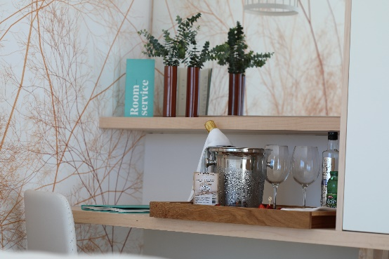

Hundreds of years later, **Iberostar Hotels & Resorts** has opened the **Iberostar Sábila**, an exclusive five star hotel whose name comes from the Arabic word ‘*Sabaira*’ and whose scientific name is ‘**aloe’**. Its location in southern Tenerife, home to one of the largest crops of this plant in Europe, makes this ‘adult only’ hotel an outstanding, unique option for relaxing and unwinding. With a meticulously designed range of products and services, created and inspired by the myriad benefits this plant offers, Iberostar Sábila inspires contact with nature, the land and the sea.

Renowned for its healing properties and multiple benefits for beauty and relaxation, the professionals at Iberostar have reinterpreted this plant’s wealth of properties to create a unique setting in which to enjoy a select range of exclusive products. The range of options includes beauty treatments at the spa; exclusive amenities in the Wellness Rooms, the perfect spot for relaxing over a cup of aloe and mango tea, aloe water or a white tea and aloe vera infusion; a gin and tonic made with aloe gin or an aloe vodka as you admire the sunset from the terrace; a refreshing after-dinner daiquiri digestif made with homemade Canary Island aloe liqueur; or even breakfast overlooking the sea enjoying freshly-baked bread spread with delicious aloe vera jam.

In addition to a wide range of products offering the benefits of aloe vera, the Café Bar also serves a mouth-watering selection of healthy options to complete a truly delicious experience, including chocolate and walnut cookies and *mantecada* pastries made with green banana flour.

Top quality gastronomy is one of the core principles behind Iberostar’s holiday offer. Accordingly, the company has positioned the **Iberostar Sábila** at the forefront of southern Tenerife’s culinary scene, with an offer that includes an innovative food market, where guests can discover seven stalls, each with their own unique character and specialising in first class products such as meat, fish, ham, cheese, tapas or cured meats. All the essential ingredients to ensure a unique culinary experience.

The **Iberostar Sábila** is Iberostar Hotels & Resorts’ newest establishment and epitomises the company’s ongoing commitment to ensuring its guests enjoy a truly memorable holiday with all five senses, based on excellence and innovation, core values that ensure an unforgettable experience.

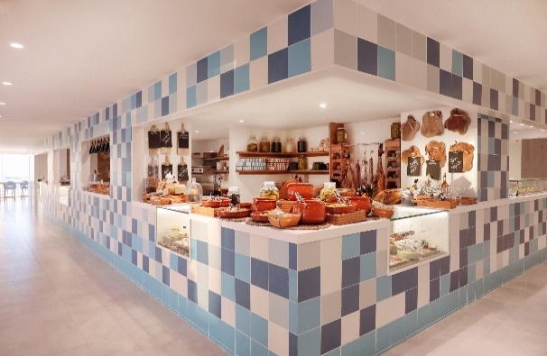**The Iberostar Sábila** is an **Iberostar Selection** hotel, included in the chain’s **ocean resort segment**. The renovation and opening of this hotel forms part of the company’s profit reinvestment strategy, aimed at guaranteeing the very highest standards in all areas of the holiday experience. Each Iberostar renovation project is designed to cover all aspects related to innovation and sustainability, ensuring maximum respect and care for the local environment.

\***Editor’s note**: click on [this link](https://edelmanftp.box.com/s/3iphthtqur1jgpfc8r0nzetan7ngv92z) to access a selection of photos of the Iberostar Sábila.

**About Iberostar Hotels & Resorts**

Iberostar Hotels & Resorts is a holiday hotel chain that the Fluxà family founded in Palma de Mallorca (Balearic Islands, Spain) in 1986. As a member of the Iberostar Group - one of Spain’s top tourist groups with over 60 years of history-- Iberostar Hotels & Resorts currently boasts over 110 four- and five-star hotels in 17 countries around the globe.

**For further information:** [www.iberostar.com](http://www.iberostar.com/)

**For more information please visit: iberostar.com**

**Iberostar UK Press Office – Edelman**

Tel: (0)20 3047 2682

**Francesca Boden (**[Francesca.Boden@edelman.com](mailto:Francesca.Boden@edelman.com)**)**

**Blair Paskin (**[Blair.Paskin@edelman.com](mailto:Blair.Paskin@edelman.com)**)**