PRESS RELEASE

IBEROSTAR GRAND PORTALS NOUS REOPENS WITH A

CUTTING-EDGE RANGE OF AMENITIES

* **The chain’s most luxurious establishment in Majorca is reopening this season with a new and exclusive spa featuring top name products, including a range by the German skin care house BABOR and Perricone MD - a celebrity favourite.**
* **ASTIR, the hotel’s fabulous gourmet restaurant, has come up with a new menu inspired by the cultural history of the island, where local produce lies at the heart of its gastronomy.**

***Mallorca, 9th April 2018***. As Spring and warmer weather arrive, the **Iberostar Grand Portals Nous** is reopening this March, with new and exclusive ideas designed to continue offering guests a host of delightful surprises. This five-star hotel in Majorca, designed by Marcel Wanders, is set to become a key focal point this season thanks to its new **PHYSICA** spa, and the exciting new culinary delights on offer at the **ASTIR** gourmet restaurant.

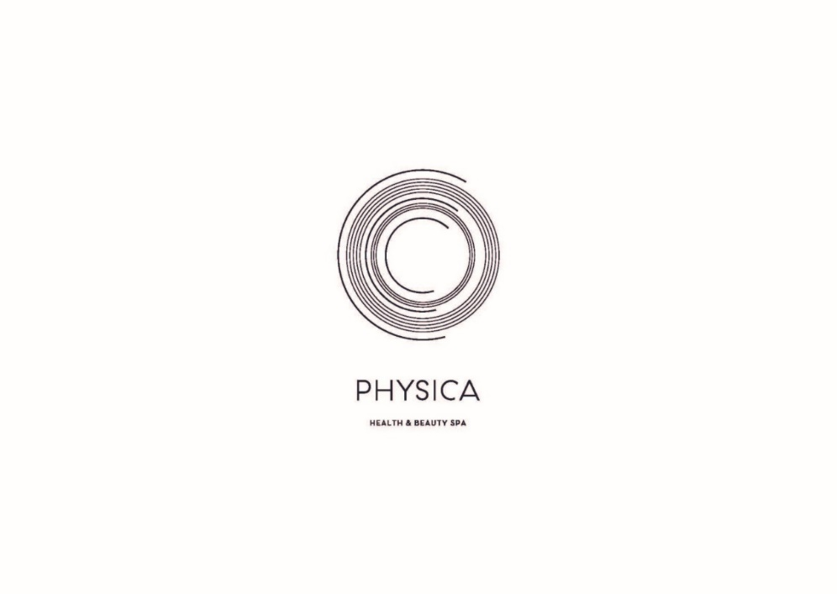The new **PHYSICA** spa concept is dedicated to guests’ health and beauty, focusing particularly on a variety of treatments based on specific areas of medicine - a growing trend that is becoming increasingly popular with visitors. In addition to relaxing and experiencing the benefits of the water circuit in an authentic avant-garde setting, guests can also take advantage of personalised expert advice, as well as the very latest innovations in cosmetic technologies. These include a cutting-edge range of services featuring first class products from the German cosmetics house BABOR, renowned around the world for their organic and sustainable characteristics, as well as luxury cosmetics by Perricone MD, popular with many A-listers, such as Gwyneth Paltrow.

The services available at the new spa include innovative treatments created by Dr Raaul Cohen, an expert naturopath and colonic hydrotherapist. Dr Cohen will be on hand to advise all those guests eager to make the most of the opportunity to boost their wellbeing during their stay. The range of weekly programmes will include special diets and daily treatments that are ideal for cleansing both body and mind.

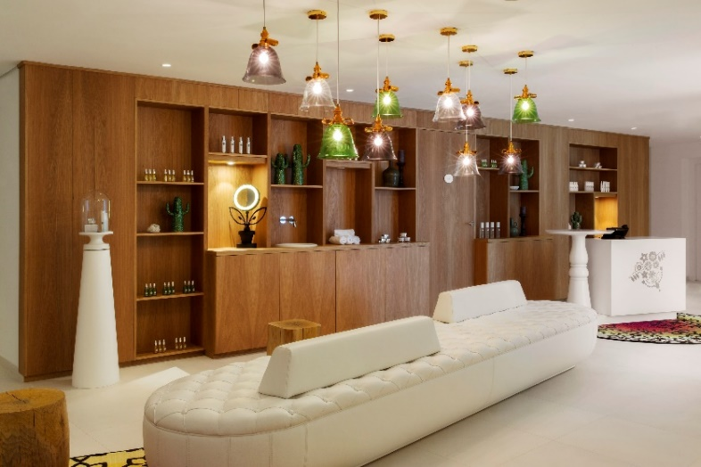In preparation for the summer season, the spa has also created treatments ranging from exclusive massages and manicures to intensive therapies designed to combat ‘orange peel skin’, such as the innovative Stop Cellulite 3D method. And for those guests keen to continue with their newly-found beauty routine back home, the **PHYSICA HEALTH & BEAUTY SPA** also has a store selling products used in the spa, as well as a selection of items by Marcel Wanders which can be seen in the hotel.

What’s more, Majorca’s residents will have the chance to become members of the spa and fitness centre, with either monthly or quarterly admission packages on offer. In addition to this, a whole host of advantages and special rates at the hotel and its facilities are also available, including exclusive discounts in the restaurant, Champagne Bar, or on the treatments and services available at the spa.

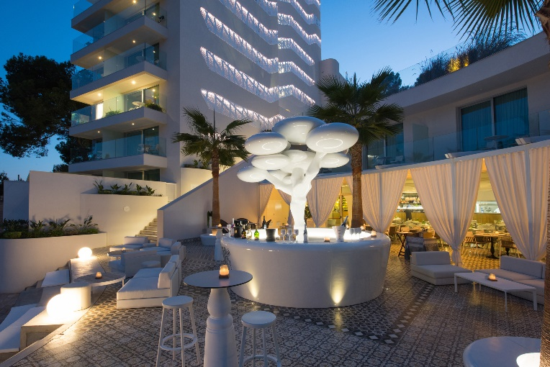Adding the perfect finishing touch to every guest’s stay - guaranteed to satisfy even the most demanding palate - the new menu at the **ASTIR** gourmet restaurant offers a wealth of new surprises, including around twenty new creations in a mouth-watering fusion of the finest ingredients and freshly sourced Majorcan produce. New to the restaurant, internationally-renowned chef Iván Crespo has designed a menu inspired by Majorca’s cultural history, tailored to suit all tastes, and paired with the very finest wines.

Meat of the highest quality from the famous ‘Bodega El Capricho’ in León, or the much acclaimed Sóller prawns are just a few of the delicacies on the menu at **ASTIR** which are guaranteed to whet your appetite. And to round off a perfect evening, the hotel’s exclusive **Champagne Bar** is a magical venue where you can enjoy the very finest champagnes, whilst admiring the magnificent seafront vistas.

With the Easter holidays just around the corner, the **Iberostar Grand Portals Nous** is undoubtedly the ideal option for everyone who appreciates wellness, rest, and relaxation. This, accompanied by the finest gastronomy and outstanding service, in a truly magnificent setting - all just a short flight away. Whatever the occasion or reason for travel, this exclusive hotel offers everything you need for a truly unparalleled experience.

**About Iberostar Hotels & Resorts**

Iberostar Hotels & Resorts is a holiday hotel chain that the Fluxà family founded in Palma de Mallorca (Balearic Islands, Spain) in 1986. As a member of the Iberostar Group - one of Spain’s top tourist groups with over 60 years of history-- Iberostar Hotels & Resorts currently boasts over 110 four- and five-star hotels in 17 countries around the globe.

**For further information:** [www.iberostar.com](http://www.iberostar.com/)

**For more information please visit: iberostar.com**

**Iberostar UK Press Office – Edelman**

Tel: (0)20 3047 2682

**Francesca Boden (**[Francesca.Boden@edelman.com](mailto:Francesca.Boden@edelman.com)**)**

**Blair Paskin (**[Blair.Paskin@edelman.com](mailto:Blair.Paskin@edelman.com)**)**