PRESS RELEASE

IBEROSTAR OPENS ITS FIRST HOTEL IN BARCELONA

* ***The Iberostar Paseo de Gracia is Iberostar Hotels & Resorts’ first new hotel in 2018 and the chain’s first establishment in the city of Barcelona.***
* ***With an unbeatable location, the hotel boasts panoramic views of the city’s skyline, visible from the property’s terrace, and it is located right in front of Plaza de Catalunya.***
* ***The hotel is part of Iberostar’s new urban hotel segment, which includes establishments in the heart of major tourist cities, thus solidifying the company’s commitment to the city lodging sector.***

Madrid, January 21, 2018 – Known for its five-star, all-inclusive hotels in the Caribbean, Iberostar Hotels & Resorts opens the doors of its newest hotel, the Iberostar Paseo de Gracia, marking the chain’s first hotel in Barcelona. This establishment is part of the urban hotel segment and is the first of 15 hotels that Iberostar will open over the course of 2018.

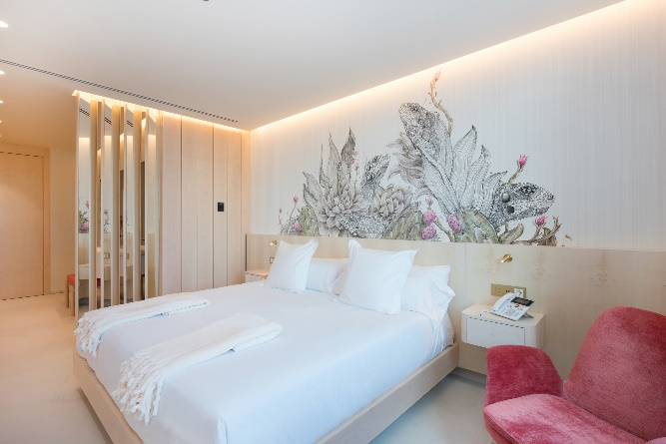At just 7.5 miles from the El Prat International Airport, and located in the heart of Plaza de Catalunya, the hotel is in one of Barcelona’s most vibrant and centric neighborhoods, surrounded by modern buildings, prestigious fashion stores and famous restaurants. The Iberostar Paseo de Gracia is in a historic building designed in the monumental classical style and dates to 1942. It features neo-baroque decor at its foundations, including sculptures by Frederic Marés and boasts panoramic views of the city’s skyline, visible from the property’s terrace.

While the new building dates back to 1942, as the result of the transformation of the historic Hotel Colon in 1902, it was built along the same architectonic lines as the nearby Casa Pich i Pon.

This superior four-star hotel boasts 119 rooms, including double rooms, rooms with city views or corner city views, rooms with or without terrace, and two duplex suites (the Tower Suite and the Barcelona Suite) with panoramic views, as well as a fully-equipped gym, rooftop pool and meetings and event spaces where guests can enjoy a unique 360° view of the city.

The hotel’s extensive culinary offering includes the Ca’s Menestral Restaurant, which specializes in the cuisine of the Balearic Islands and Mallorca, in addition to offering a variety of international dishes, the Mmmallorca Coffee Bakery Bar, located in the lobby and where guests can enjoy delicacies such as Soller oranges or almond ice creams, and a sky bar, located in the penthouse, which provides the perfect atmosphere for gazing on the Barcelona sunset while sipping a cocktail. Guests who would rather relax in their rooms also have room service available 24 hours a day.

“We’re thrilled to have the Iberostar Paseo de Gracia be our first grand opening of 2018. We continue to work hard at boosting our presence in the world’s top tourist cities, with hotels in privileged locations and in unique buildings,” said Aurelio Vazquez, Chief Operations Officer of Grupo Iberostar. “This hotel is the perfect embodiment of our urban hotels line, where we are now bringing the excellence of our products and services to urban settings. Because of its design, its strategic location and its high standards of service, we are certain that the Iberostar Paseo de Gracia will become one of our most representative urban hotels in the not too distant future.”

The hotel’s privileged location in the heart of downtown Barcelona provides guests a wide variety of entertainment possibilities: from shopping to visiting the numerous tourist attractions that make Barcelona one of the world’s top tourist destinations.

As part of Iberostar’s latest strategy, the company recently unveiled a new segmentation of its line of hotels. The Iberostar Paseo de Gracias becomes part of the urban hotel segment that the company is using to strengthen its commitment to [city tourism](https://www.google.es/url?sa=t&rct=j&q=&esrc=s&source=web&cd=1&cad=rja&uact=8&ved=0ahUKEwiq17rjsovUAhVD1hoKHZ6fBPAQFggkMAA&url=http://elpais.com/tag/turismo/a&usg=AFQjCNF0jBKZ7AMocfCvDjdZ9bdCRMmO4A&sig2=rNDTxIgOfKsMQnqhQ9CGEg). Identified by the navy blue color, urban hotels are top-level buildings located in the heart of the world’s top tourist cities, such as Madrid, New York, Lisbon, Budapest, Miami and Havana.

**About IBEROSTAR Hotels & Resorts**

IBEROSTAR Hotels & Resorts is a holiday hotel chain that the Fluxà family founded in Palma de Mallorca (Balearic Islands, Spain) in 1986. As a member of the IBEROSTAR GROUP-- one of Spain’s top tourist groups with over 60 years of history-- IBEROSTAR Hotels & Resorts currently boasts over 110 four- and five-star hotels in 17 countries around the globe.

**For further information:** [www.iberostar.com](http://www.iberostar.com/)

**Iberostar – Edelman Press Office**

**Ober Delgado** (ober.delgado@edelman.com)

Tel: +1.305.358.2830

