PRESS RELEASE

Iberostar runs 5 of Spain’s top 10 ‘All Inclusive’ hotels

THE IBEROSTAR ANTHELIA, SPAIN’S BEST ALL INCLUSIVE HOTEL FOR THE SIXTH CONSECUTIVE YEAR

* ***The Iberostar Anthelia has received TripAdvisor’s Travellers’ Choice award for Spain’s best hotel in the All Inclusive category thanks to the excellent reviews, comments and opinions posted by the website’s millions of users.***
* ***No fewer than 5 of the company’s hotels rank amongst the top 10 in this category, confirming Iberostar Hotels & Resorts leading position at the forefront of this highly competitive and demanding segment.***

***London, 1st February 2018***. The **Iberostar Anthelia Hotel** on Tenerife has been proclaimed Spain’s best All Inclusive hotel for the sixth year running by [TripAdvisor](http://www.tripadvisor.es)®, the world’s biggest travel website, which today announced the winners of its Travellers’ ChoiceTM Awards for All Inclusive Tourist Resorts. This annual award is based on the opinions of millions of TripAdvisor users around the world. The criteria for deciding the winners are based on the number and quality of the opinions and reviews posted on TripAdvisor over a 12 month period.

No fewer than 5 Iberostar hotels rank among the top 10 in this category, clear proof of the company’s leading position in a sector as competitive and demanding as the All Inclusive segment: **the** **Iberostar Lanzarote Park** (Lanzarote, Las Palmas), in fourth place, **the** **Iberostar Las Dalias** (Costa Adeje, Tenerife), the fifth best hotel, **the** **Iberostar Jardín del Sol Suites** (Santa Ponsa, Majorca), which ranks seventh in this category, and **the** **Iberostar Club Cala Barca** (Portopetro, Majorca), which came in tenth, are all perfect examples of Iberostar’s unshakeable commitment to providing top quality products.

**Aurelio Vázquez, the Iberostar Group’s Chief Operations Officer,** stated: “*We are extremely satisfied to learn that the Iberostar Anthelia has once again received the award for the best hotel in this category. This prize further consolidates Iberostar’s leadership in terms of customer satisfaction, a value which is rooted at the centre of our business strategy. The fact that it has been acknowledged as Spain’s top All Inclusive hotel for six years running is the result of Iberostar’s ongoing determination to put the quality and excellence of its products and services first. Over the last few years we have invested heavily in renovating all our hotels, including the Iberostar Anthelia, and we are delighted that our guests value our efforts so positively”.*

**The Iberostar Anthelia** is a five star hotel that was renovated throughout in 2017. It is located on Costa Adeje, in the south of the island of Tenerife, on the beachfront at Playa de Fañabé. This Iberostar Selection hotel is included in the company’s new beach resorts segment, which includes all those establishments designed to guarantee guests a fabulous holiday experience right on the beachfront.

The hotel is one of the best-known in the Canary Islands, rated highly by those looking for a family holiday or who prefer to rest and unwind with their partner or alone. It offers a wide range of services tailored to meet the needs of all guests, boasting matchless facilities, a large number of sports options and an extensive daytime and evening leisure and entertainment programme.

In addition to its prime location, the hotel also offers guests the chance to enjoy delicious culinary experiences. Its five restaurants, including three à la carte options, and three bars guarantee guests a wide choice of menus, ranging from the island’s traditional fare to a selection of the finest international dishes.

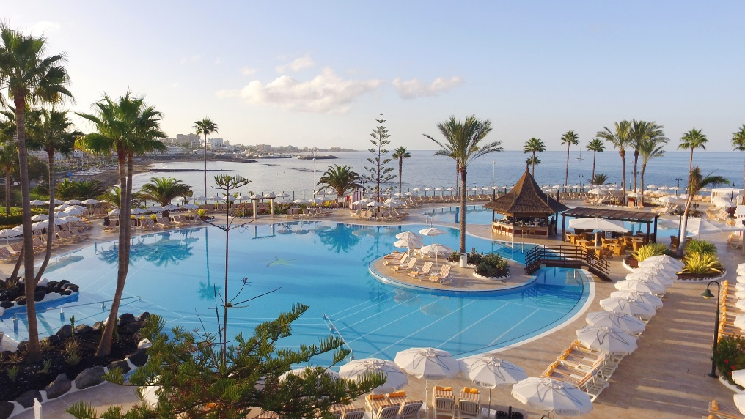

As part of its new strategy, the Iberostar Group has recently presented its new hotel segments. **The** **Iberostar Anthelia** is included in the beach resorts segment, created to consolidate the company’s already firm commitment to beach tourism. Identified by a turquoise colour, these beachfront hotels are designed to ensure guests enjoy a fabulous holiday experience by the sea.

Whatever guests are looking for, **Iberostar Hotels & Resorts** is always guaranteed to satisfy anyone looking for outstanding service and an unforgettable holiday. This is reflected in the chain’s 10 hotels that have received awards thanks to the reviews posted by TripAdvisor users. Prizes that are given in accordance with the millions of comments and opinions from around the world included on TripAdvisor in a single year, based on outstanding service, quality and value for money.

**About IBEROSTAR Hotels & Resorts**

IBEROSTAR Hotels & Resorts is a holiday hotel chain that the Fluxà family founded in Palma de Mallorca (Balearic Islands, Spain) in 1986. As a member of the IBEROSTAR GROUP-- one of Spain’s top tourist groups with over 60 years of history-- IBEROSTAR Hotels & Resorts currently boasts over 110 four- and five-star hotels in 17 countries around the globe.

**For further information:** [www.iberostar.com](http://www.iberostar.com/)

**For more information please visit: iberostar.com**

**IBEROSTAR UK Press Office – Edelman**

Tel: (0)20 3047 2682

**Francesca Boden (**[Francesca.Boden@edelman.com](mailto:Francesca.Boden@edelman.com)**)**

**Olivia Howard (**[Olivia.Howard@edelman.com](mailto:Olivia.Howard@edelman.com)**)**