PRESS RELEASE

IBEROSTAR OPENS DOORS

OF FIRST HOTEL IN THE HEART OF BARCELONA

* ***The Iberostar Paseo de Gracia is Iberostar Hotels & Resorts’ first new hotel in 2018 and the chain’s first establishment in the city of Barcelona.***
* ***With an unbeatable location, the hotel is located right in the middle of Plaza de Catalunya, with a panoramic view of the city’s skyline visible from the property’s terrace.***
* ***The hotel is part of Iberostar’s new urban hotel segment, which includes establishments in the heart of major tourist cities, thus solidifying the company’s commitment to the city lodging sector.***

***Madrid, 20th January 2018***. **Iberostar Hotels & Resorts** is opening the doors to its newest hotel, the **Iberostar Paseo de Gracia**, marking the chain’s first hotel in Barcelona. This establishment is part of the urban hotel segment and is the first of 15 hotels that Iberostar will open over the course of 2018.

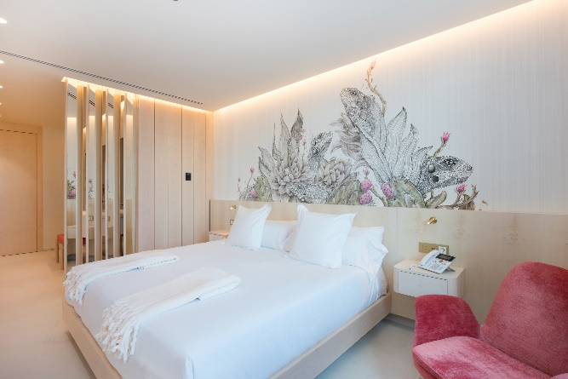Just 12 kilometres from the airport, and located in the heart of Plaza de Catalunya, the hotel is in one of Barcelona’s most vibrant and eccentric neighbourhoods, surrounded by modern buildings, in addition to prestigious fashion stores and exquisite restaurants.

The **Iberostar Paseo de Gracia** is located in an historic building designed in the monumental classical style, with neo-baroque décor at its foundations, including sculptures by Frederic Marés. While the new building dates back to 1942, as the result of the transformation of the historic Hotel Colon in 1902, it was built along the same architectonic lines as the nearby Casa Pich i Pon.

This superior four-star hotel boasts 119 rooms, including double rooms, rooms with city views or corner city views, rooms with or without terraces, and two duplex suites (the Tower Suite and the Barcelona Suite) with panoramic views in the building’s tower. With a 360° view, these spaces can host exclusive events where guests can enjoy a unique view of the city’s skyline.

The hotel’s extensive culinary offering includes a restaurant (Ca’s Menestral) that specialises in the cuisine of the Balearic Islands and Mallorca, in addition to offering a variety of international dishes. There is also a unique, traditional Majorcan bar, called *Mmmallorca Coffee Bakery Bar*. Here guests will be able to enjoy delicacies such as Soller orange or almond ice creams in the hotel lobby (on the ground floor), while there is also a terrace (sky bar) in the penthouse that is divided into several areas with one of the best views for gazing on the Barcelona sunset whilst sipping a cocktail. Guests who would rather relax in their rooms also have room service available 24 hours a day.

And for those who want to stay in shape, the hotel offers a fully-equipped gym. There is also a rooftop pool with spectacular views of the city, ideal for the hottest days.

**Aurelio Vázquez, Chief Operations Officer** **of Iberostar Hotels & Resorts** said: “*We’re thrilled to open the doors of the Hotel Iberostar Paseo de Gracia in our first grand opening of 2018. We continue to work hard at boosting our presence in the world’s top tourist cities, with hotels in privileged locations and in unique buildings. This hotel is the perfect embodiment of our urban hotels line, where we are now bringing the excellence of our products and services to urban settings. Because of its design, its fabulous location and its high standards of service, we are certain that the Iberostar Paseo de Gracia will become a favourite urban hotels in the not too distant future”.*

As part of the company’s latest strategy, Iberostar recently unveiled the new segmentation of its hotels. This establishment is part of the urban hotels segment that the company is using to strengthen its commitment to [city tourism](https://www.google.es/url?sa=t&rct=j&q=&esrc=s&source=web&cd=1&cad=rja&uact=8&ved=0ahUKEwiq17rjsovUAhVD1hoKHZ6fBPAQFggkMAA&url=http://elpais.com/tag/turismo/a&usg=AFQjCNF0jBKZ7AMocfCvDjdZ9bdCRMmO4A&sig2=rNDTxIgOfKsMQnqhQ9CGEg). Identified by their navy-blue colour, urban hotels are top-level buildings located in the heart of the world’s top tourist cities, such as Madrid, New York, Lisbon, Budapest, Miami and Havana.

Whether you are travelling for business or for pleasure, the hotel’s privileged location in the heart of downtown Ciudad Condal means that you will be able to enjoy a wide variety of entertainment possibilities: from shopping to visiting the numerous tourist attractions that make Barcelona one of the world’s top tourist destinations.

**About IBEROSTAR Hotels & Resorts**

IBEROSTAR Hotels & Resorts is a holiday hotel chain that the Fluxà family founded in Palma de Mallorca (Balearic Islands, Spain) in 1986. As a member of the IBEROSTAR GROUP-- one of Spain’s top tourist groups with over 60 years of history-- IBEROSTAR Hotels & Resorts currently boasts over 110 four- and five-star hotels in 17 countries around the globe.

**For further information:** [www.iberostar.com](http://www.iberostar.com/)

**For more information please visit: iberostar.com**

**IBEROSTAR UK Press Office – Edelman**

Tel: (0)20 3047 2682

**Francesca Boden (**[Francesca.Boden@edelman.com](mailto:Francesca.Boden@edelman.com)**)**

**Olivia Howard (**[Olivia.Howard@edelman.com](mailto:Olivia.Howard@edelman.com)**)**