PRESS RELEASE

**GRUPO IBEROSTAR PLANS**

**A RETURN TO CHILDHOOD ON NOVEMBER 20th**

* ***GRUPO IBEROSTAR will be joining forces with UNICEF and the United Nations on November 20th to commemorate World Children’s Day, an initiative designed to work for a decent, safe and happy childhood for boys and girls all over the world.***
* ***Under the slogan ‘We're all going back to being kids today’, the international tourism group will be encouraging all parents and children staying at their hotels to take part in this global initiative in aid of a very good cause.***

**Madrid, November 17, 2017.- GRUPO IBEROSTAR**’s commitment to the younger generations is once again reflected in the special actions it is organizing to commemorate **World Children’s Day**. With the backing of **UNICEF** and **the United Nations**, the group has come up with a packed program of activities that will be carried out at a number of hotels, raising awareness of the event among parents and their children, promoting its objectives and guaranteeing a fun-filled family day.

The rights of children were officially drawn up in **the United Nations Convention on the Rights of the Child**, back in 1989. World Children’s Day is intended to remind citizens around the world that children are the most vulnerable segment of society and the greatest victims of the world’s problems and crises. According to **UNICEF**, 385 million children live in extreme poverty, 264 million children and youth are out of school and 5.6 million children under five died in 2016.

Through its Foundation, **GRUPO IBEROSTAR** upholds the Declaration of the Rights of the Child and supports its objectives by carrying out a series of initiatives in favor of children. Since 2006, the Group has worked on a permanent basis with UNICEF, providing ongoing cooperation and support, undertaking ambitious projects in countries such as Brazil, the Dominican Republic and Cuba. On **November 20th**, the Group’s core business, IBEROSTAR Hotels & Resorts, will be taking part in **World Children’s Day** with a series of activities dedicated especially to them.

Under the slogan “***We're all going back to being kids* today**”, 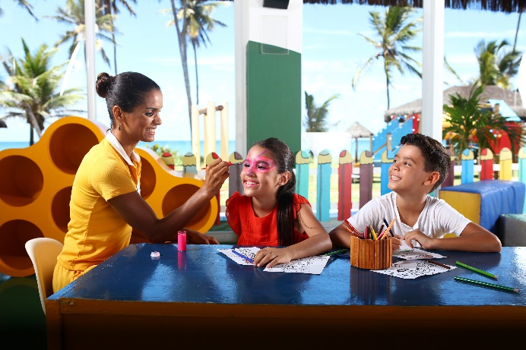our youngest guests and their parents will be able to join in *‘Kids Only’* initiatives at the pools, painting workshops to decorate murals with our mascots Starky and Stella, as well as fun-filled evening shows. In addition, information leaflets will be placed in all rooms to raise awareness about this special date and the need to respect children’s rights.

Since it was set up in 2004, the **IBEROSTAR FOUNDATION** has focused its vision and mission on people, education and social innovation. Throughout this time, children have remained firmly at the core of all its efforts. As a result, since its early days, the **IBEROSTAR FOUNDATION** has successfully undertaken **180 projects and actions** targeting this group, reaching no fewer than **300,000 direct beneficiaries.**

**About GRUPO IBEROSTAR**

GRUPO IBEROSTAR is a Spanish, family-owned company and a leader in the tourism industry worldwide. GRUPO IBEROSTAR has been working in the tourism and travel sector for over 60 years. During this time, the Group has grown from a family travel agency to an international company, with several divisions. Today, GRUPO IBEROSTAR has 27,100 employees and is present in 30 countries around the world.

For more information please visit: [www.iberostar.com](http://www.iberostar.com)

**IBEROSTAR Press Office – Edelman**[iberostar@edelman.com](mailto:iberostar@edelman.com)Tel: +1.305.358.28301221 Brickell Ave. Suite 1140 Miami, FL 33131