PRESS RELEASE

**GRUPO IBEROSTAR PLANS A RETURN TO CHILDHOOD ON 20th NOVEMBER**

* ***GRUPO IBEROSTAR joins forces with UNICEF and the United Nations to celebrate World Children’s Day, on 20th November.***
* ***World Children’s Day promotes the welfare of children, championing a safe and happy childhood for all children across the world.***
* ***The international tourism group will be encouraging all parents and children staying at their hotels to take part in this global initiative to support this very worthy cause saying: ‘We're all going back to being kids today’.***

**Madrid, 17th November 2017.- GRUPO *IBEROSTAR’s*** commitment to the younger generations is reflected in its support of **World Children’s Day**. With the backing of **UNICEF** and **the United Nations**, the group has come up with a packed programme of activities that will be carried out at a number of hotels, raising awareness of the event among parents and their children, promoting its purpose and guaranteeing a fun-filled family day.

The rights of children were officially drawn up in **the United Nations Convention on the Rights of the Child**, in 1989. World Children’s Day is intended to remind citizens around the world that children are the most vulnerable segment of society and the greatest victims of the world’s problems and crises. According to **UNICEF**, 385 million children live in extreme poverty, 264 million children and youth are out of school and 5.6 million children under five died in 2016.

Through its Foundation, **GRUPO IBEROSTAR** uphold the Declaration of the Rights of the Child and supports its objectives by carrying out a series of initiatives in favour of children. Since 2006, the Group has continued to work with UNICEF, providing ongoing support and help undertaking ambitious projects in countries such as Brazil, the Dominican Republic and Cuba. On **20th November**, the Group’s core business, IBEROSTAR Hotels & Resorts, will be taking part in **World Children’s Day** with a programme of activities dedicated especially to them.

Under the slogan “***We're all going back to being kids* today**”, 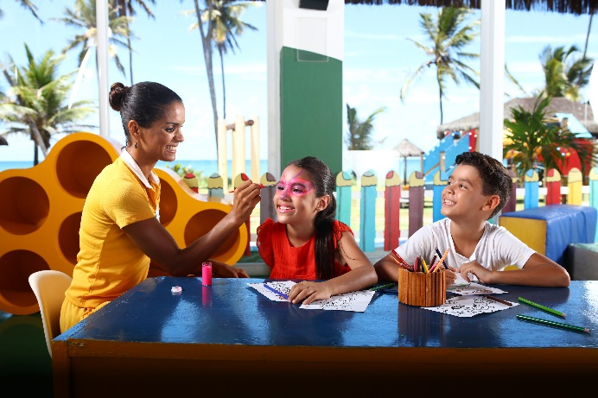our youngest guests and their parents will be able to join in *‘Kids Only’* initiatives at the pools, painting workshops to decorate murals with our mascots Starky and Stella, as well as fun-filled evening shows. In addition, information leaflets will be placed in all rooms to raise awareness about this special date and the need to respect children’s rights.

Since it was set up in 2004, the **IBEROSTAR FOUNDATION** has centred its vision and mission on people, education and social innovation. Throughout this time, children have remained firmly at the centre of all its efforts. As a result, the **IBEROSTAR FOUNDATION** has successfully undertaken **180 projects and actions,** reaching **300,000 direct beneficiaries.**

**About IBEROSTAR Hotels & Resorts**

IBEROSTAR Hotels & Resorts is a resort hotel chain based in Palma de Mallorca (Balearic Islands, Spain), founded by the Fluxà family in 1986. IBEROSTAR Hotels & Resorts is an integral part of GRUPO IBEROSTAR, one of the main Spanish tourist companies with over 60 years of experience, which currently has 100 hotels of 4 and 5 stars in 17 countries around the world. For more information, please visit: IBEROSTAR.com

**For more information please visit: iberostar.com**

**IBEROSTAR UK Press Office – Edelman**

Tel: (0)20 3047 2682

**Francesca Boden (**[Francesca.Boden@edelman.com](mailto:Francesca.Boden@edelman.com)**)**

**Olivia Howard (**[Olivia.Howard@edelman.com](mailto:Olivia.Howard@edelman.com)**)**