PRESS RELEASE

**IBEROSTAR GRAND HOTEL PORTALS NOUS,**

**BEST SUSTAINABLE HOTEL IN SPAIN**

**AT THE 2017-2018 EUROPE HOTEL AWARDS**

* ***The hotel has been declared the most sustainable in Spain and will now be competing for the ‘Best Sustainable Hotel’ Europe Award. The winner will be announced at the Europe Hotel Awards gala event to be held in London on 26th October.***
* ***The IBEROSTAR Grand Hotel Portals Nous has also received International Five Star Standard status from The International Hotel Awards, and is considered one of the world’s finest five star establishments.***
* ***IBEROSTAR Hotels & Resorts opened the IBEROSTAR Grand Hotel Portals Nous in July 2017, the first ‘The Grand Collection’ hotel in the Mediterranean.***

***London, 25 October 2017***. **IBEROSTAR Grand Hotel Portals Nous** has received the award for the Best Sustainable Hotel in Spain at the 2017 edition of the Europe Hotel Awards. The hotel has also been awarded *International Five Star Standard* status, further consolidating its position of excellence within the industry, where it ranks among the world’s finest five star hotels.

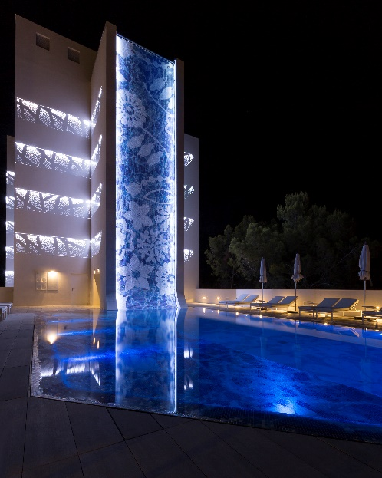The Europe Hotel Awards have been held since 2008 and form part of the International Hotel Awards, previously known as the International Property Awards, which were launched back in 1995. Today, the panel of judges is made up of 70 hotel sector experts and is chaired by Lord Thurso, a member of the British Parliament’s House of Lords. The aim is to identify, showcase and reward excellence in the hotel industry around the world. The criteria used for this global assessment include design, quality, service, innovation, originality and a commitment to sustainability. Of all the candidates put forward for the 2017-2018 edition of the awards, the **IBEROSTAR Grand Hotel Portals Nous** received the prize for *Best Sustainable Hotel* and also received ‘*International Five Star Standard’* status in recognition of its first class quality and a guarantee for its superb standards of quality and service.

**The IBEROSTAR Grand Hotel Portals Nous** will be competing for the ‘Best Sustainable Hotel’ Europe title at the Europe Hotel Awards, which will be held on 26th October at London’s Royal Lancaster Hotel. This event will coincide with IPAX Europe Global, an exclusive networking exhibition targeting hotel industry professionals.

This recently-opened hotel, situated in the exclusive and aspirational Portals Nous area in Majorca, is **IBEROSTAR Hotels & Resorts’** first **The Grand Collection** establishment in the Mediterranean. With interiors designed exclusively by renowned Dutch designer **Marcel Wanders**, this 66 room hotel is the result of a perfect combination of sustainable architecture, avant-garde design and premium services. The mix of transparencies, touches of white and reflective surfaces blend together creating the fabulous design of this unique space.

Meticulous attention is paid to every detail at this superior five star hotel, providing guests with fully personalised stays. In addition to its two penthouse double rooms, it also features six themed suites: two *Naughty Suites* for those wishing to live out their most secret fantasies, and a *Stargazer Suite,* where guests can venture beyond the stars and enjoy a one-of-a-kind astronomical experience. There is also a *Games Suite* where the facilities include a pinball machine, table football, video console and even a putting green on the terrace, a *Heritage Suite* for lovers of art and antiques, and a *Spa Suite*, designed to provide total relaxation.

Five star standards are guaranteed at this hotel thanks to the butler service endorsed by the prestigious **‘British Butlers Guild’**, which includes a magnificent range of exclusive amenities and details.

**Aurelio Vázquez, IBEROSTAR Hotels & Resorts’ CEO for Europe, the Middle East and Africa, stated**: “*We are delighted to have received this award, which reflects* ***IBEROSTAR****’s**firm commitment to the constant improvement and modernisation of its products. Two years ago we embarked on an ambitious strategic renovation plan, and this award is proof that all our hard work and efforts are paying off. We would like to thank The International Hotel Awards for acknowledging our determination in this sense and we are confident that we will continue to demonstrate the magnificent standards of our products and services to our guests”.*

Through its Corporate Social Responsibility Strategic Plan, GRUPO IBEROSTAR is committed to promoting CSR in the areas of human rights, labour law, the environment and ethical management. This undertaking ensures sustainable and responsible management within the framework of its adhesion to the United Nations Global Compact. The IBEROSTAR Grand Hotel Portals Nous is fully aligned with IBEROSTAR Hotels & Resorts’ commitment to the sustainability of its renovation and new building policy, maintaining and boosting the highest quality standards.

**Note for the editor\*** [click here](https://edelmanftp.box.com/s/ej4pwevu9f44orgiif39prnov1ecv9dj) to access the IBEROSTAR Grand Hotel Portals Nous photo gallery.

**About IBEROSTAR Hotels & Resorts**

IBEROSTAR Hotels & Resorts is a resort hotel chain based in Palma de Mallorca (Balearic Islands, Spain), founded by the Fluxà family in 1986. IBEROSTAR Hotels & Resorts is an integral part of GRUPO IBEROSTAR, one of the main Spanish tourist companies with over 60 years of experience, which currently has 100 hotels of 4 and 5 stars in 17 countries around the world. For more information, please visit: IBEROSTAR.com

**For more information please visit: iberostar.com**

**IBEROSTAR UK Press Office – Edelman**

Tel: (0)20 3047 2682

**Francesca Boden (**[Francesca.Boden@edelman.com](mailto:Francesca.Boden@edelman.com)**)**

**Olivia Howard (**[Olivia.Howard@edelman.com](mailto:Olivia.Howard@edelman.com)**)**