PRESS RELEASE

IBEROSTAR OPENS ITS EXCLUSIVE DESIGNER HOTEL IN PORTALS NOUS

- The new five-star IBEROSTAR Grand Hotel Portals Nous is situated in one of Majorca’s most exclusive areas.

- Designed by Marcel Wanders, facilities at the new hotel include Astir, a gourmet restaurant and the only one on the island to serve El Capricho meat, the finest in the world.

- Guests at the hotel will enjoy a butler service endorsed by the prestigious British Butler Guild, as well as an extensive ‘menu’ of special services.

Madrid, Spain - August 3, 2017 - IBEROSTAR Hotels & Resorts opened its newest hotel, the IBEROSTAR Grand Hotel Portals Nous, boasting a prime beachfront location in one of Majorca’s most exclusive areas. This grand luxury five-star hotel is the first establishment in the Mediterranean to be included in The Grand Collection, the company’s premium category, combining impeccable designer architecture with the most innovative and personalized services.

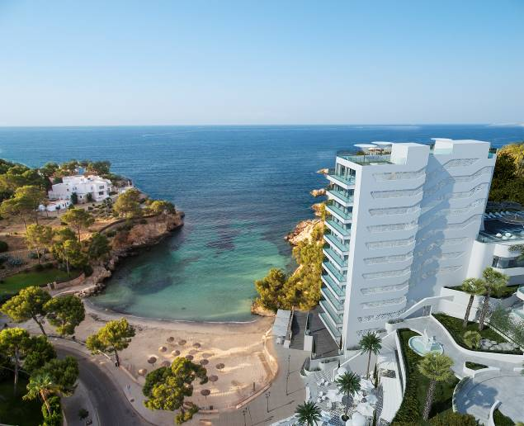
The 66 rooms include four double penthouses with a private terrace and jacuzzi, and five unique themed suites, all designed by Marcel Wanders. The accommodation options include two Naughty Suites for those wishing to live out their most secret fantasies, and a Stargazer Suite, where guests will have the chance to travel far beyond the stars in a unique adventure into outer space. The fun-filled facilities in the Games Suite feature a pinball machine, table football, videogame console and even a putting green on the terrace. In turn, the Heritage Suite has been designed with lovers of art and antiques in mind, whilst the Spa Suite is the ideal choice for those in search of total rest and relaxation. All in all, a fabulous range of one-of-a-kind rooms.

The hotel stands in a prime location set against a stunning backdrop, and meticulous attention has been paid to every detail of the interior design. Five-star hotel standards are guaranteed thanks to the butler service endorsed by the prestigious British Butler Guild, including a fabulous ‘menu’ of special services.

The chain’s painstaking attention to even the smallest detail is also reflected in the hotel’s gastronomy options. The IBEROSTAR Grand Hotel Portals Nous has four spaces serving locally sourced organic products including the Astir Gourmet Restaurant, the Selini Lobby Bar and the Dom Pérignon Champagne Bar. Guests will also be able to take advantage of the Guest Experience offering unlimited personalized services such as getting a table at any of the island’s restaurants without having to give a thought to waiting lists, access to a personal shopper, or even making a last-minute booking for a helicopter or boat. Nothing is beyond the reach of guests staying at the IBEROSTAR Grand Hotel Portals Nous.

About IBEROSTAR Hotels & Resorts
IBEROSTAR Hotels & Resorts is a resort hotel chain based in Palma de Mallorca (Balearic Islands, Spain), founded by the Fluxà family in 1986. IBEROSTAR Hotels & Resorts is an integral part of GRUPO IBEROSTAR, one of the main Spanish tourist companies with over 60 years of experience, which currently has 100 hotels of 4 and 5 stars in 17 countries around the world. For more information, please visit: IBEROSTAR.com

For more information: www.iberostar.com

# # #

Editorial Note: Download more hotel images here.

IBEROSTAR Press Office – Edelman
Tel: +1.305.358.9500 Fax: +1.305.358.1270
iberostar@edelman.com

