IBEROSTAR OPENS NEW HOTEL IN SOUTH BEACH

After IBEROSTAR 70 Park Avenue in New York, the IBEROSTAR Berkeley in Miami Beach, Fla. becomes the second hotel in the U.S., and the 36th in the Americas

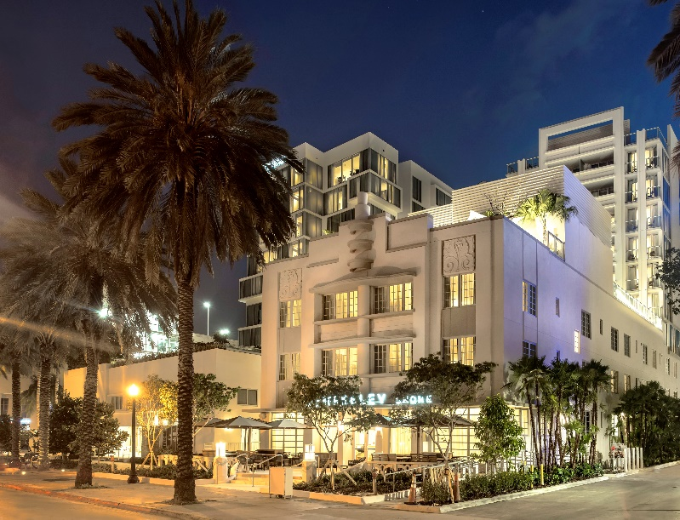
MIAMI – August 8, 2017 – IBEROSTAR Hotels & Resorts, known for its luxurious four and five-star properties located in the most spectacular destinations around the world, has opened the doors of its second U.S. hotel in Miami Beach, Fla. The historic building, now renamed IBEROSTAR Berkeley, was fully renovated under a $43 million investment and is situated at 1610 Collins Avenue, right at the heart of South Beach. The four-star hotel provides a high-quality alternative for the business and leisure traveler.

“We are thrilled to launch the IBEROSTAR Berkeley in South Beach, one of the hottest spots in the world. Its pristine beaches, vibrant culture and perfect weather, combined with our excellent customer service and amenities, make it the ideal dwelling option in the area,” said Enric Noguer, IBEROSTAR Managing Director for the Americas. “This second IBEROSTAR hotel in the United States is proof of our commitment to this market, where we strive to serve international, as well as national tourists, and to connect with the local community and its cultural heritage,” Noguer said.

The glamorous IBEROSTAR Berkeley features 96 brand-new, luxuriously designed guestrooms, including 20 premier rooms with balconies, a lush Sun Deck with spectacular views of Collins Avenue, and signature restaurant BLT Steak for breakfast, lunch and dinner. This pet-friendly hotel also offers a fully-equipped fitness room; a beautiful heated pool and deck with lounge area on the fourth floor; 24-hour room service; full housekeeping with turndown service; and beach club with towels, chairs and umbrellas; among other amenities and services. The standard and deluxe rooms feature one king and two queen size beds, respectively, as well as a minibar with snacks and soft drinks, onyx designer rain showers, comfortable workspaces with outlets and USB ports, and much more.

IBEROSTAR Berkeley is one of the new properties the brand has been developing within the urban segment, with a plan to reach a total of 15 in the next three years in key cities like Budapest, Madrid, Barcelona, Lisbon, New York, Havana, Santo Domingo and Lima, among others. Boasting the superior level of customer service and quality the brand is globally known for, these urban hotels are located at the heart of the city they are in, close to key points of interest. In this case, IBEROSTAR Berkeley is just steps away from the beach; Lincoln Road Mall (for dining, shopping, and art gallery visits); the New World Center, home to the New World Symphony; the Miami Beach Convention Center; the Fillmore Miami Beach at the Jackie Gleason Theater; and the cosmopolitan Ocean Drive; among other iconic locations.

Introductory Offer
IBEROSTAR Berkeley is offering one night free when booking three or more nights Must be booked by August 31st with travel dates of August 1 – November 30, 2017. A 72-hour cancellation policy applies. To book, visit www.IBEROSTAR.com.

About IBEROSTAR Hotels & Resorts
IBEROSTAR Hotels & Resorts is a resort hotel chain based in Palma de Mallorca (Balearic Islands, Spain), founded by the Fluxà family in 1986. IBEROSTAR Hotels & Resorts is an integral part of GRUPO IBEROSTAR, one of the main Spanish tourist companies with over 60 years of experience, which currently has 100 hotels of 4 and 5 stars in 17 countries around the world. For more information, please visit: IBEROSTAR.com

# # #

Editorial Note: Download more hotel images here.

IBEROSTAR Press Office – Edelman
Tel: +1.305.358.9500 Fax: +1.305.358.1270
IBEROSTAR@edelman.com

