### PRESS RELEASE

**IBEROSTAR LAUNCHES NEW APP FOR GUESTS**

* ***Available for iOS and Android, the new IBEROSTAR app is now operating at ten IBEROSTAR hotels in Europe and the Caribbean, and will be gradually introduced into the rest of the portfolio throughout 2017.***
* ***The IBEROSTAR APP establishes a new channel of communication and allows guests to chat in real time with the hotel staff through the e-concierge function.***

**Madrid, February 14, 2017 *–*** In line with the digital transformation of the hospitality industry and the brand’s commitment to providing guests with the most innovative products, **IBEROSTAR Hotels &** **Resorts** launched its new **IBEROSTAR APP** application, a phone app for guests that will enable them to enjoy their experience at the hotel to the fullest.

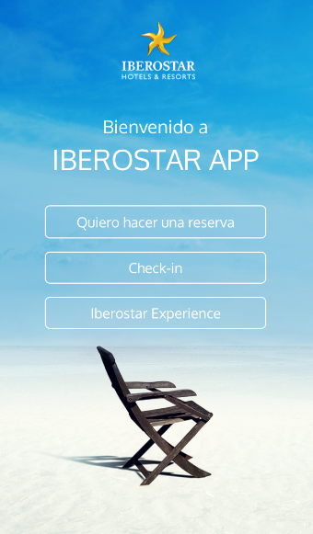The Majorca-based chain is constantly evolving and continues to invest in the improvements of its products and services to offer the best experience to all its guests. This effort is seen in projects such as the development of the new app, opening new channels of communication between the hotel and its guests.

The new tool is an app designed and developed entirely by the company and will therefore not depend on other products on the market. The platform will be open to future innovations, and has the capacity to incorporate new functions such as opening room doors or as a payment platform, positioning it at the forefront of the industry and as a unique benefit for IBEROSTAR guests.

**Tomeu Bennasar**, **Chief Information Officer for GRUPO IBEROSTAR** explained that “for IBEROSTAR, the constant commitment to innovation is essential. Combined with our primary focus on customer service, we are motivated to provide forward-thinking products and services, particularly on smart devices which are now part of our everyday lives. The new app also enables us to better serve our guests in real-time with the inclusion of the e-concierge function, which provides guests access to a digital butler service to ask hotel staff for anything they need at any time”.

Designed to make the browsing, search and booking process simpler and more efficient, as well as enabling guests to select the experiences they wish to enjoy during their stay at the hotels, the **IBEROSTAR APP** includes:

* Three intuitive sections including bookings and access to the web check-in service that will make the arrival procedure even faster and more convenient
* The *IBEROSTAR Experience,* includes an interactive map that provides guests with access to all the hotel’s services and facilities, as well as full details of the gastronomy options, from booking a table at any of the restaurants or consulting the room service menu and ordering dinner to their room
* The **e-concierge function**, whereby users can contact the hotel staff at any time, and employees can chat with guests in real time and resolve their needs and requests. The app also offers users the chance to make the most of their stay by taking advantage of services such as the late check-out, luggage storage or even checking courtesy room availability
* The app also includes a timeline indicating the various events and activities available on-site each day. Users will have the option to save these activities on their mobile calendar and can share on social media, providing a global view of everything that is happening at the hotel in real time

With the launch of this new app, the three stages of IBEROSTAR guests’ travel experience are covered: ‘before’ with the online booking and check-in options; ‘during’, thanks to the wide range of services available and important guest information; and ‘after’, as the app is also a new lasting communication channel between the company and its customers.

The app has already been tested at ten IBEROSTAR hotels in Spain and the Caribbean and will gradually be incorporated into the company’s other hotels during 2017. IBEROSTAR APP is available in Spanish, English and German and can be download for free through App Store and Google Play.

**\*Note for editors**:

* Please find more information on the app in this [video](https://www.youtube.com/watch?v=0m5UJwSt6ok&feature=youtu.be).
* You can download the new app at this [link](https://www.iberostar.com/app-iberostar).

**About IBEROSTAR Hotels & Resorts**

IBEROSTAR Hotels & Resorts is a holiday hotel chain that was founded in 1986 by the Fluxà family and it is also an integral part of GRUPO IBEROSTAR.

GRUPO IBEROSTAR is a Spanish, family-owned company that has been operating in the tourism and travel sector for over 60 years. During this time, the Group has grown from a family travel agency to an international company, with several divisions. Today, GRUPO IBEROSTAR has 27.000 employees and is present in 30 countries around the world.

For more information, please contact:

Edelman  
[IBEROSTAR@edelman.com](mailto:IBEROSTAR@edelman.com)