PRESS RELEASE

THIS IS THE SUITE WHERE CHRISTIAN GREY WOULD STAY IN SPAIN

- The new IBEROSTAR Grand Hotel Portals Nous features an exclusive suite that is the equal to the “playroom” of Mr Grey, the protagonist of the eagerly-awaited film “Fifty Shades Darker”

- The “Naughty Suite” is one of the five themed suites of the hotel that will be opening in Spring 2017 and has all its interiors designed by the prestigious designer Marcel Wanders

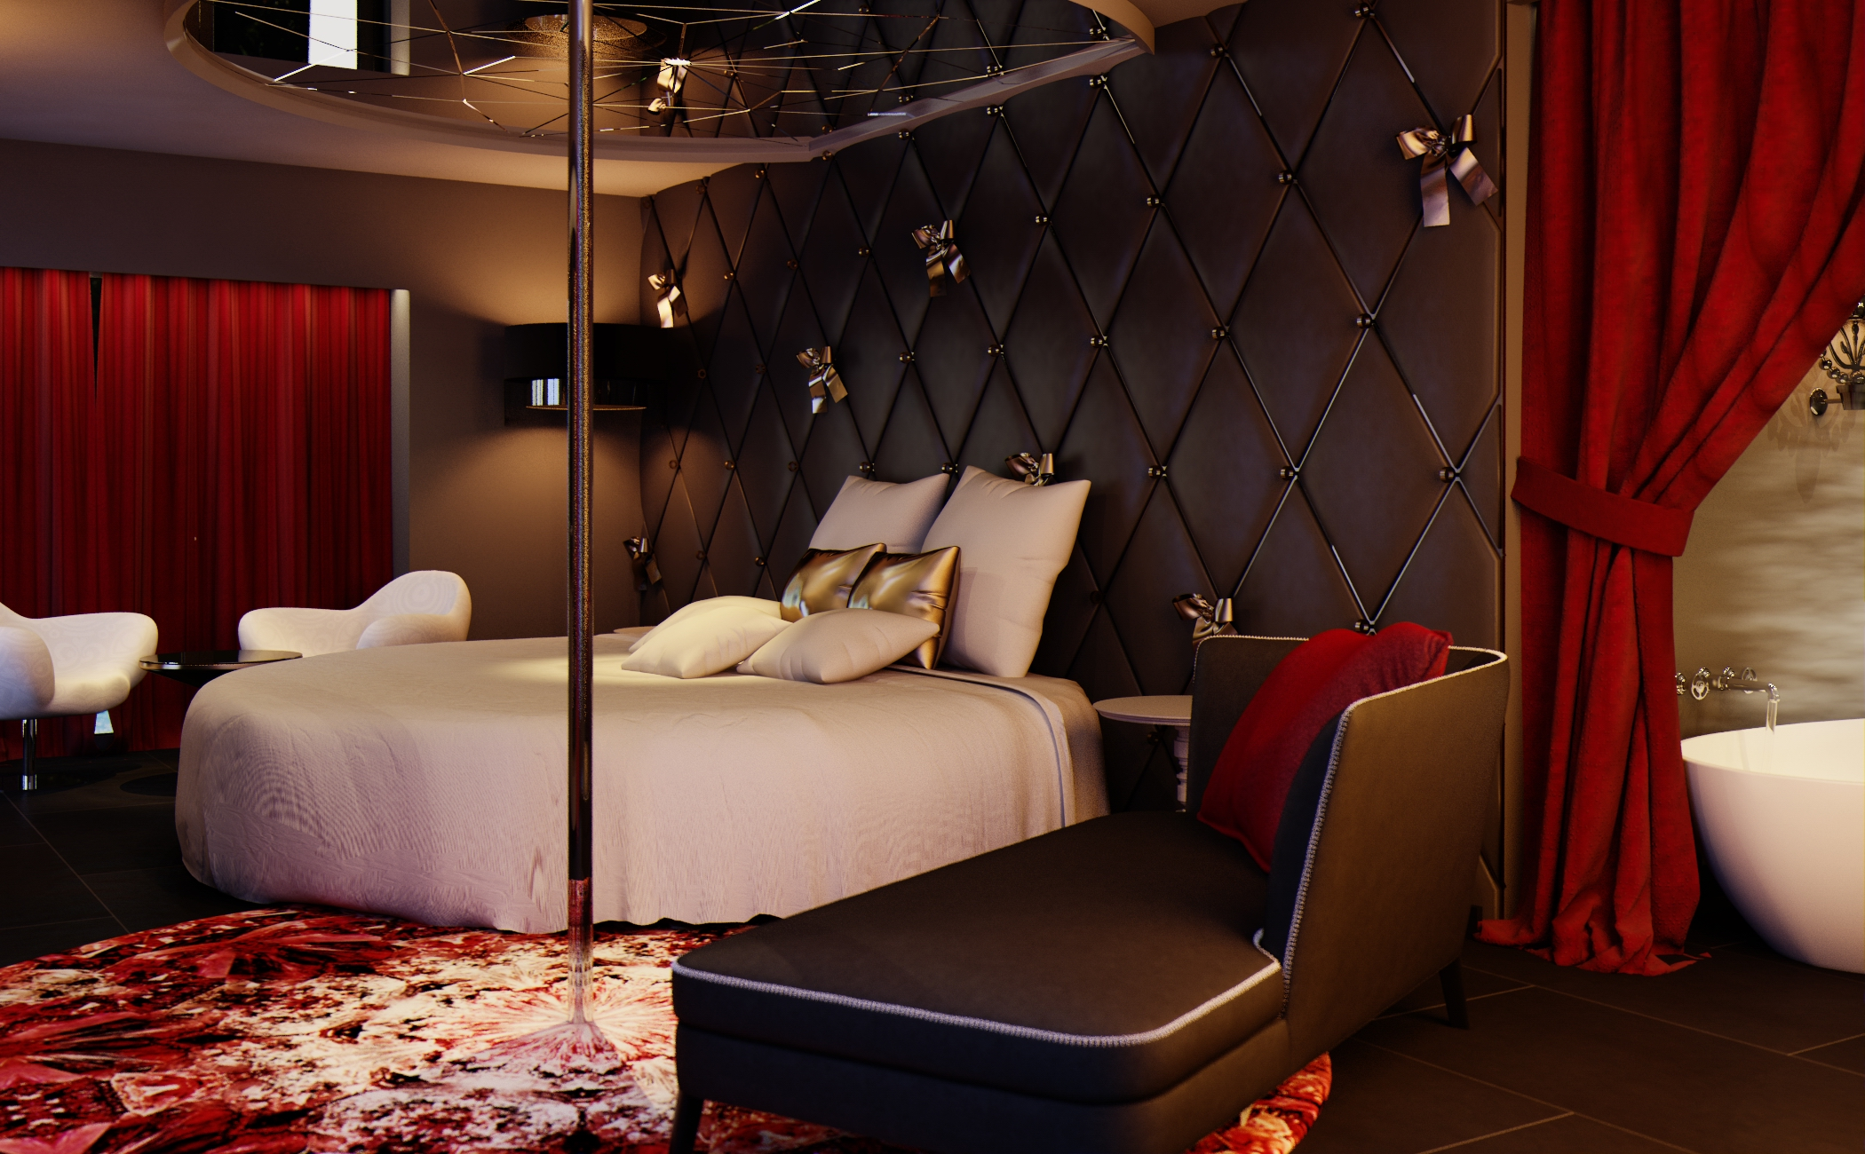
London, 09 February 2017.- This Friday, 10 February, the film “Fifty Shades Darker”, sequel of the blockbuster “Fifty Shades of Grey”, opens in the UK. The saga’s millions of devoted fans are eagerly awaiting its opening to see how the story develops between the magnate Christian Grey and the recent graduate Anastasia. But what they will certainly not know is that in Puerto Portals (Mallorca), the new IBEROSTAR Grand Hotel Portals Nous features an exclusive suite that is the equal of Mr Grey’s “playroom”.

If the Seattle businessman decided to come to Spain with his beloved, we can be sure of his destination and hotel: the Naughty Suite at the IBEROSTAR Grand Hotel Portals Nous.

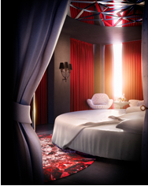
This unique suite is one of the five themed rooms designed by the prestigious designer Marcel Wanders. Wanders is responsible for all the interior design and decoration of this luxurious new hotel and famous for his iconic interiors and artistic creations for brands such as Louis Vuitton, Swarovski, Mandarina Duck and Baccarat.l.

Planned as a specially-created space for the pursuit of pleasure, the Naughty Suite features fabrics with sensual finishes, such as leather and silk textures, and is equipped with all sorts of details that would delight Grey, Anastasia or any of their followers: a large round bed with a ceiling mirror, a chaise longue, a box of “tricks”, a pole-dancing pole and a minibar stocked with champagne. Fans of “Fifty Shades of Grey” need go no further than the Balearic Islands to indulge their most secret fantasies.

The new IBEROSTAR Grand Hotel Portal Nous, specially created as a byword for the most sophisticated luxury in the Mediterranean, is located in a snug cove that gives it the privacy a couple needs. It also features all Iberostar’s Premium services to indulge Grey’s most eccentric caprices, from a butler service endorsed by the prestigious “British Butlers Guild” to the Guest Experience service to supply whatever the client desires without any limits on the imagination. What would happen if Christian Grey wanted his Charlie Tango to fly to the neighbouring island of Ibiza? His wish is our command. IBEROSTAR Grand Hotel Portals Nous would bring his prized helicopter from the West Coast of the USA. At IBEROSTAR we have always fulfilled all our guests’ desires, and now all your fantasies too.

IBEROSTAR Grand Hotel Portals Nous will open its doors in spring 2017, becoming the chain’s first “Grand Collection” category hotel in Mallorca.

Note for the editor:
A selection of high-resolution images can be downloaded from the following link.

IBEROSTAR UK Press Office – Edelman
Tel: (0)20 3047 2682
Leah Pummell (leah.pummell@edelman.com)
Juncal Alonso (juncal.alonso@edelman.com)

