PRESS RELEASE

**IBEROSTAR TO TAKE OVER MANAGEMENT OF HAVANA’S LANDMARK HOTEL RIVIERA**

* ***IBEROSTAR Hotels & Resorts is set to take over management of its second hotel in Havana in January 2017. With a total of 352 rooms and a prime location on the Cuban capital’s Malecón seafront esplanade, the future IBEROSTAR Riviera will have 5* status and be part of the company’s Premium Gold category.***
* ***The IBEROSTAR Riviera will be IBEROSTAR’s twelfth hotel in Cuba, further establishing the Majorcan chain’s commitment to this rapidly growing tourist destination.***

***Palma de Mallorca, 12 December 2016***. - In January 2017, **IBEROSTAR** will be taking over management of the landmark **HOTEL RIVIERA -** its twelfth establishment in Cuba and second in Havana. On completion of the renovation work, the hotel will acquire 5* status and offer all the amenities and services associated with the company’s Premium Gold category.

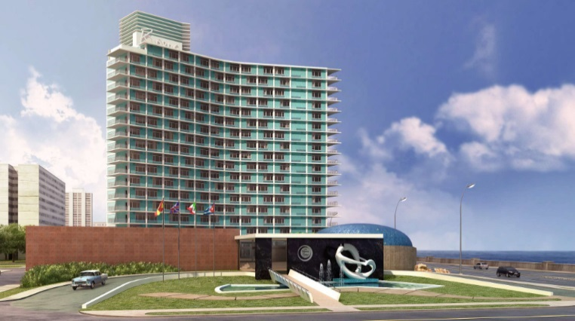

Standing on the Cuban capital’s famous *Malecón* seafront esplanade and built in the style of when it first opened in 1957, the **HOTEL RIVIERA** will soon undergo extensive renovations. When finished, the hotel will feature 352 fully refurnished rooms. The project also includes work on communal areas, and will bring the range of products and services available at the hotel in line with the company’s standards. The hotel will still be home to the legendary Cabaret Copa Room, a large venue for shows and live music and one of the most well-known spots for Havana nightlife.

The new hotel is a key milestone for **IBEROSTAR** and reinforces its commitment to Cuba as a top destination in the hotel chain’s portfolio.

**Enric Noguer**, **CEO America at GRUPO IBEROSTAR** stated: “*IBEROSTAR Riviera is an historically important property with an outstanding reputation, and represents a major step forward in expanding our presence in Havana and Cuba. Cuba is a tremendously important destination for IBEROSTAR and we remain committed to our objective of offering top quality and highly competitive accommodation options in this country.”*

The future **IBEROSTAR Riviera** will be the chain’s second hotel in Havana, joining the **IBEROSTAR Parque Central**. **IBEROSTAR Hotels & Resorts** currently has another eleven hotels in Cuba. In 2017, IBEROSTAR will add its thirteenth hotel to its Cuban portfolio, the **IBEROSTAR Bella Vista Varadero**, a 5 star establishment in Varadero with 827 rooms.

**About IBEROSTAR Hotels & Resorts**

IBEROSTAR Hotels & Resorts is a resort hotel chain based in Palma de Mallorca (Balearic Islands, Spain), founded by the Fluxà family in 1986. IBEROSTAR Hotels & Resorts is an integral part of GRUPO IBEROSTAR, one of the main Spanish tourist companies with over 60 years of experience, which currently has more than 100 hotels of 4 and 5 stars in 16 countries around the world.

For more information please visit: iberostar.com

[prensaiberostar@gmail.com](mailto:prensaiberostar@gmail.com)