PRESS RELEASE

**IBEROSTAR TO TAKE OVER MANAGEMENT OF HAVANA’S LANDMARK HOTEL RIVIERA**

* ***IBEROSTAR Hotels & Resorts is set to take over management of its second hotel in Havana in January 2017. With a total of 352 rooms and a prime location on the Cuban capital’s Malecón seafront esplanade, the future IBEROSTAR Riviera will have 5* status and form part of the company’s Premium Gold category.***
* ***The IBEROSTAR Riviera will be IBEROSTAR’s twelfth hotel in Cuba, further consolidating the Majorcan chain’s commitment to this rapidly growing tourist destination.***

***London, 12th December 2016***. - In January 2017 **IBEROSTAR** will be taking over management of the landmark **HOTEL RIVIERA -** its twelfth establishment in Cuba and second in Havana. On completion of the renovation work, the hotel will acquire 5* status and offer all the facilities and services associated with the company’s Premium Gold category.

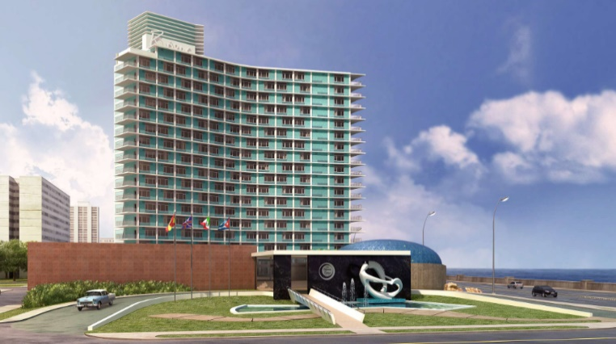

Standing on the Cuban capital’s famous *Malecón* seafront esplanade and built in the style of the period in which it first opened, back in 1957, the **HOTEL RIVIERA** will shortly be immersed in an ambitious integral renovation project. When finished, the hotel will boast 352 fully refurnished rooms. The project also includes work on the communal areas, and will bring the range of products and services available at the hotel in line with the company’s standards. The hotel facilities will also include the legendary Cabaret Copa Room, a large venue for shows and live music and one of Havana’s classic night spots.

The new hotel will be a key milestone in **IBEROSTAR’s** trajectory and further proof of its commitment to Cuba as a key destination in the hotel chain’s portfolio.

**Enric Noguer**, **CEO America at GRUPO IBEROSTAR** stated: “*For us, this hotel is a major step forward as it allows for the qualitative consolidation of our presence in Havana through the incorporation of a hotel that historically has enjoyed an outstanding reputation. Cuba is a tremendously important destination for IBEROSTAR and a crucial part of our expansion strategy, and we will therefore remain committed to our objective of offering top quality and highly competitive accommodation options in this country”.*

The future **IBEROSTAR Riviera** is therefore set to become the chain’s second hotel in Havana, joining the **IBEROSTAR Parque Central**. **IBEROSTAR Hotels & Resorts** currently has another eleven hotels in Cuba. 2017 will also see the addition of a thirteenth hotel to its Cuban portfolio, the **IBEROSTAR Bella Vista Varadero**, a 5 star establishment in Varadero with 827 rooms.

**About IBEROSTAR Hotels & Resorts**

IBEROSTAR Hotels & Resorts is a holiday hotel chain that was founded in 1986 in Palma de Mallorca (Balearic Islands, Spain) by the Fluxà family. An integral part of GRUPO IBEROSTAR, one of Spain’s primary tourism consortiums with more than 60 years of history, today IBEROSTAR Hotels & Resorts is comprised of more than 100 four- and five-star hotels across 16 countries worldwide.

**For more information please visit:** iberostar.com

[prensaiberostar@gmail.com](mailto:prensaiberostar@gmail.com)