PRESS RELEASE

GRUPO IBEROSTAR TO CELEBRATE
UNIVERSAL CHILDREN’S DAY ON NOVEMBER 20

Universal Children’s Day is a UNICEF and United Nations initiative that honors the Declaration of the Rights of the Child, designed to ensure a safe, happy and dignified childhood.

GRUPO IBEROSTAR will join the celebration on November 20th with special programs at its hotels.

Palma de Mallorca, 17th November 2016. - As part of its strong commitment to social and human development, GRUPO IBEROSTAR will celebrate Universal Children’s Day, a United Nations’ initiative held annually on November 20th, at its hotels worldwide.

The Convention on the Rights of the Child is one of the most widely-ratified international human rights treaties and establishes a series of rights for adolescents, covering areas such as life, health, education, play, family life, and protection from violence and discrimination. Based on these principles, Universal Children’s Day was set up in order to celebrate youth’s rights and raise awareness of the importance of creating a happy and safe environment for children everywhere through dialogue and action.

Through its foundation, Fundación IBEROSTAR, GRUPO IBEROSTAR is supporting the Declaration of the Rights of the Child through a series of projects at its properties. On November 20th, the company will be organizing a fun-filled day designed to encourage children and their parents to celebrate and exercise the most important right of all: the right to be happy. IBEROSTAR hotels worldwide will be carrying out a series of leisurely events designed to inform families about these rights, such as:

- Providing informational flyers in each guest’s room
- ‘Kids Only’ activities in and around the pools
- Mural painting with IBEROSTAR’s mascots Starkey and Stella
- Puppet Shows for families
- Evening shows for children and parents alike

Since its inception in 2004, Fundación IBEROSTAR has focused on three key pillars: people, education and culture, and social innovation. Childhood rights is a core action carried out by this not-for-profit organization and to date, Fundación IBEROSTAR has undertaken more than 64 projects targeting this group, reaching a total of 202,922 direct beneficiaries.

* Note for editors:
- Click the below image to view the Fundación IBEROSTAR foundation’s video honoring Universal Children’s Day.

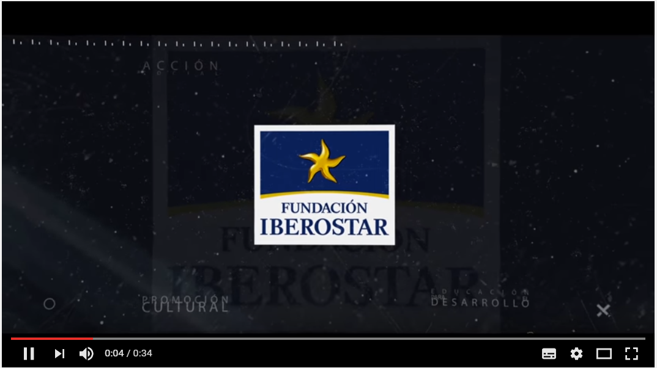

About GRUPO IBEROSTAR

GRUPO IBEROSTAR is a Spanish, family-owned company and a leader in the tourism industry worldwide. GRUPO IBEROSTAR has been working in the tourism and travel sector for over 60 years. During this time, the Group has grown from a family travel agency to an international company, with several divisions.

For more information please visit: http://www.grupoiberostar.com/en

