PRESS RELEASE
GRUPO IBEROSTAR,
60 YEARS TOGETHER ON THIS JOURNEY

- GRUPO IBEROSTAR is firmly positioned at the forefront of the international tourist industry thanks to the passion and commitment of its employees, guests and partners. The company has celebrated 60 years of history with an event that takes a look back at the thrilling journey it has shared with them all.

- On 15th October, all the company’s hotels celebrated this very special anniversary by holding a fabulous party packed with surprises for guests, employees and friends.

London, 20 October 2016. - 2016 is turning out to be a landmark year for the tourist industry: Spain has registered a record number of tourists, with figures of over 70 million visitors; tourism GDP has shot up; and GRUPO IBEROSTAR, one of the most important Spanish companies in the world, is celebrating 60 years of history. Six decades working with its customers and employees on a thrilling journey has positioned it at the forefront of the industry with hotels in 16 countries around the world.

The GRUPO IBEROSTAR story is one of success, passion and commitment to a job well done. Its history is closely linked to the emergence of tourism in Spain, and is now celebrating the sector’s excellent results from an internationally privileged position.

Yet there is much more behind IBEROSTAR’s business success. Understanding the Fluxá family’s entrepreneurial spirit means journeying back to the 19th century and the creation in 1877 of Inca, Majorca’s first footwear company. Almost 80 years later, Lorenzo Fluxà acquired Viajes Iberia, a company founded in the 1930s, which led to the family’s first venture into the tourism industry and made 1956 a milestone year that would mark the beginnings of what IBEROSTAR has become today.

In 1961 the Fluxá family embarked on its initial venture into the hospitality sector following the acquisition of its first hotel in Playa de Palma. That same year Miguel Fluxà joined the company to focus on developing three key business areas: hotels, tourist services and package tour sales. In 1979, GRUPO IBEROSTAR opened its first international offices and laid the foundations for the international expansion of its hotel division thanks to the signing of an exclusive agreement with the tour operator Neckermann. Just four years later, the Fluxá family registered the IBEROSTAR trademark, with its familiar star logo. From then on, all the chain’s hotels included its name and by the early 80s IBEROSTAR Hotels & Resorts had become a firmly consolidated company.

“My father taught us something which I believe is absolutely essential: when we were 12 years old he said to us, “You have to have an international vocation”, explained Miguel Fluxà. “Today we can be proud of having moved beyond a boundary that represents a major challenge for any hotel company, and are present in 16 countries with a portfolio of top quality hotels”.

After a period of sustained growth in the Balearic and Canary Islands it was time to look to the international market, and in 1993 the company opened its first hotel in the Dominican Republic, followed by a further hotel in Cuba. Later, in 1998, GRUPO IBEROSTAR would revolutionise the sector with the launch of its own airline, Iberworld.

The journey was proving to be a major success. The Fluxá family had channelled all its efforts into laying the foundations of IBEROSTAR as it is today.

“I have always been obsessed with quality. It is our most valuable asset, as it is the most important aspect perceived by our guests and one that has positioned us at the forefront of today’s international tourist industry”, Miguel Fluxá explains.

In 2004, the Group created Fundación IBEROSTAR, a foundation aimed at promoting social action and education for development in Spain and Latin America. This period was also one of diversification for the Group, with the founding of the cruise company IBEROJET CRUCEROS. One year later, the fourth generation of the Fluxá family joined the company in order to continue the family tradition.

In line with its ongoing quest for excellence, IBEROSTAR launched The Grand Collection category with the opening of the IBEROSTAR Grand Hotel Paraíso in Mexico. In 2010 the company ventured into the area of urban hotels with the opening of the IBEROSTAR Grand Hotel Budapest in the Hungarian capital, and the IBEROSTAR Grand Hotel Mencey in Santa Cruz de Tenerife.

In 2015 the company’s expansion plans received a further boost with the acquisition of the online travel agency almundo.com, and the international travel service provider W2M. A year later marked the latest major milestone in IBEROSTAR’s 60-year history with the opening of its first hotel in the US, the IBEROSTAR 70 Park Avenue, situated in the heart of New York.

Of course, the journey doesn’t stop here and there are plans for further groundbreaking ports of call. The most immediate of these also puts the spotlight on the US market with the opening of the group’s first hotel in Miami, the IBEROSTAR Berkeley Shore, scheduled for 2017. This project will provide an added boost for IBEROSTAR’s focus on urban products, which all share a common theme: they will be housed in historic buildings in prime locations in the world’s leading tourism destinations.

Miguel Fluxà has always known exactly what he wants. “I have been fortunate to have had a father who taught us that success is always the result of hard work and that honesty is crucial. His message was one of seriousness, a sense of dignity and of always doing the right thing; a message that reached us loud and clear as we have continued to follow in his footsteps”.
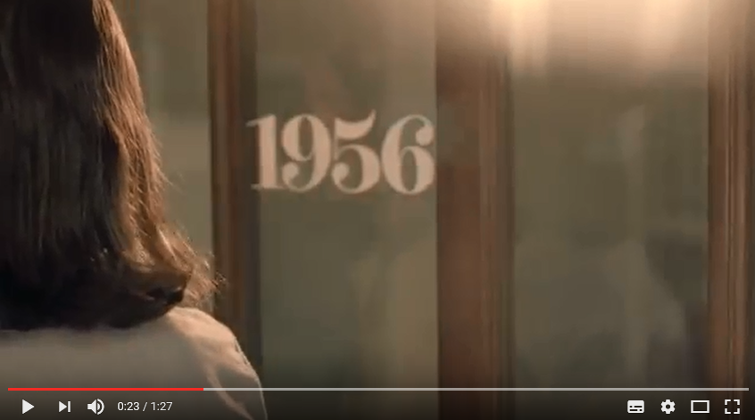
Please click on the link to watch the 60 Years video

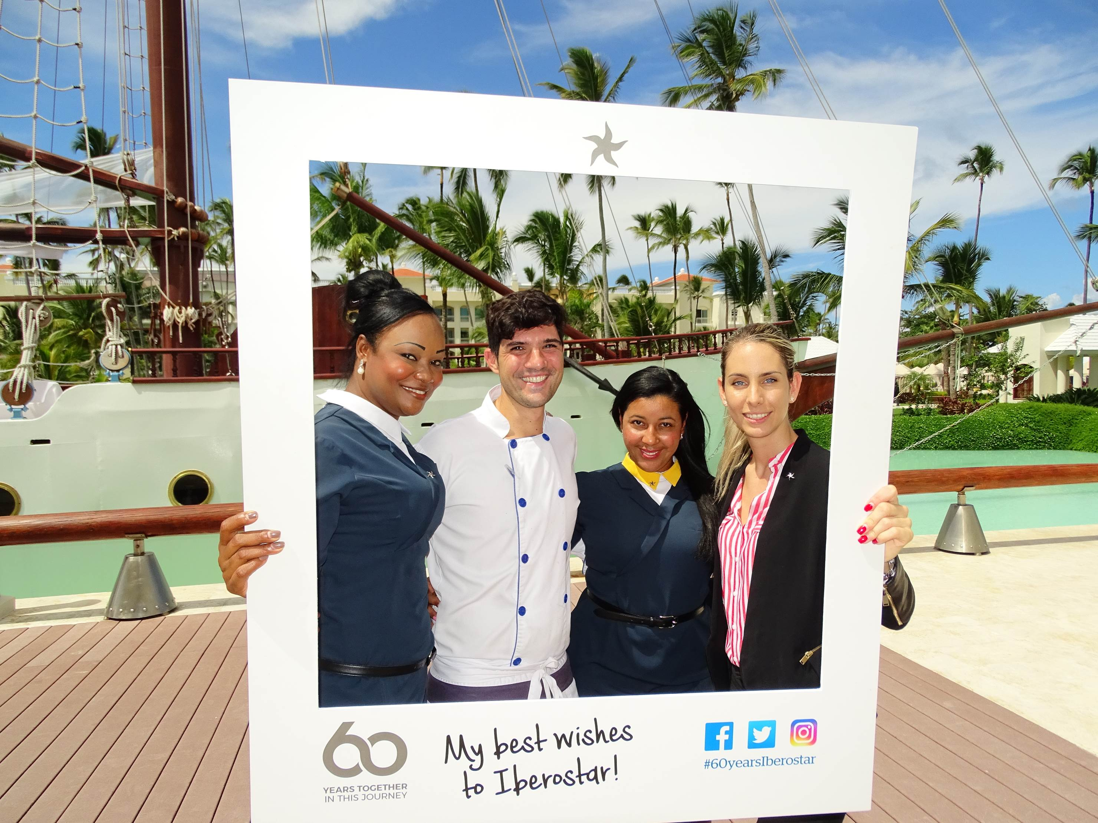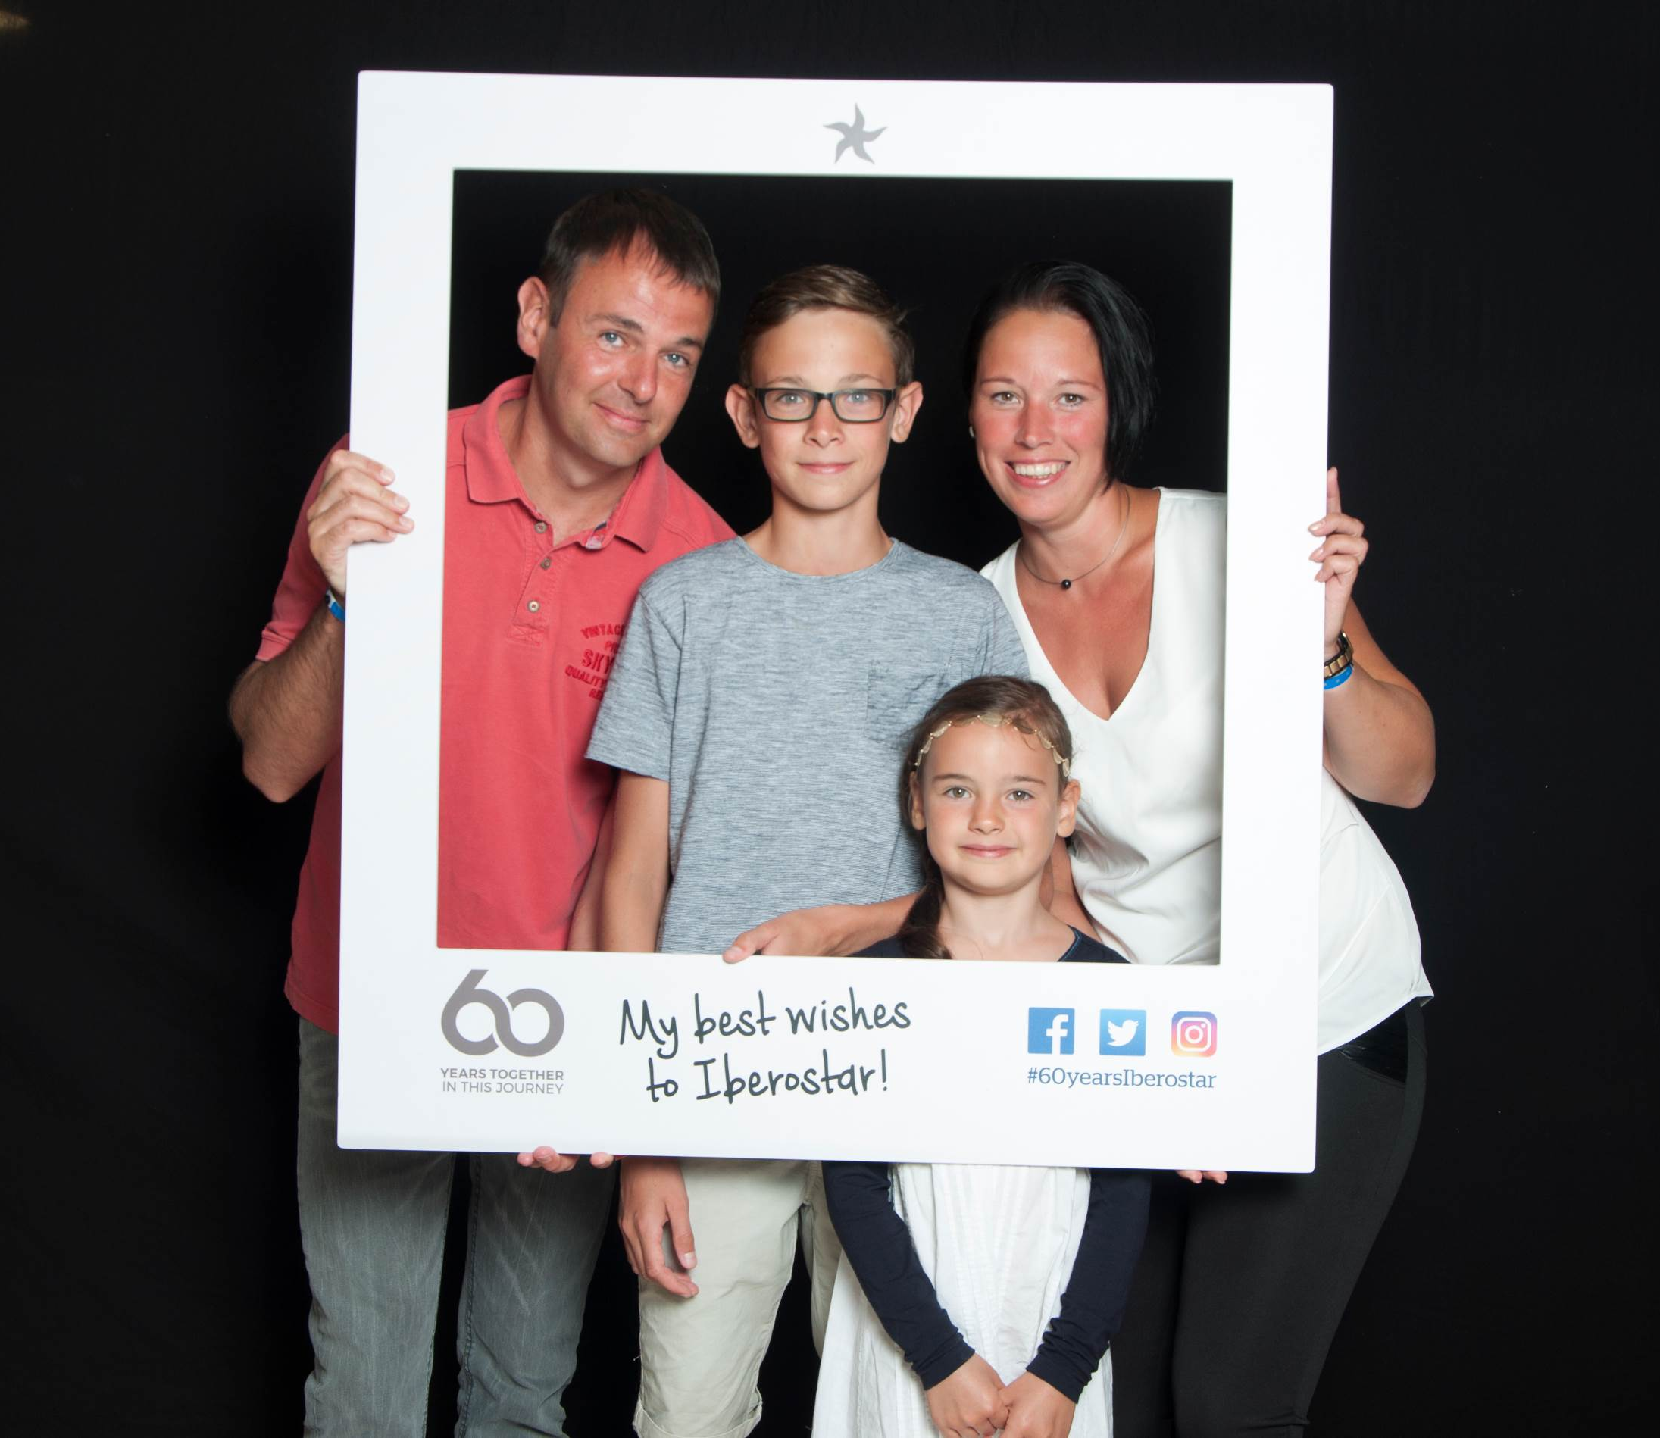

Time to celebrate

To celebrate this outstanding legacy, on 15th October IBEROSTAR commemorated its 60th anniversary. Throughout the day, all the hotels joined in the festivities by offering a host of surprises for guests and employees, who showed their support for the company with countless messages of congratulations including photographs, videos and signature books. The celebrations were rounded off with a cocktail reception and the lighting and launch of sky lanterns containing messages of good wishes for GRUPO IBEROSTAR, in the hope that the journey will continue far into the future. The event marked sixty years filled with the hard work and dreams of a family whose origins lie in a small island, yet which today is present in numerous countries thanks to the commitment and dedication of its guests, employees and stakeholders.

Furthermore, and in order to share this moment with everyone that has accompanied the Group on this venture, the company has set up 60yearsiberostar.com, a space offering an insight into the thrilling story of this family saga since its beginnings back in the late 19th century, taking us through the years and the acquisition of Viajes Iberia in 1956 and the origins of GRUPO IBEROSTAR right up until the present day. 60yearsiberostar.com has also been designed to provide a meeting point and a space for shared celebration and participation, with a special section featuring messages of congratulations from employees, guests and partners, who have already acquired a leading role in the anniversary celebrations thanks to their videos.

Please find images ready to download here: https://edelmanftp.box.com/s/9ueiithsgrbxt2ggzx1avk94fctghll1

About IBEROSTAR Hotels & Resorts

IBEROSTAR Hotels & Resorts is a holiday hotel chain that was founded in 1986 in Palma de Mallorca (Balearic Islands, Spain) by the Fluxà family. An integral part of GRUPO IBEROSTAR, one of Spain’s primary tourism consortiums with more than 80 years of history, today IBEROSTAR Hotels & Resorts is comprised of more than 100 four- and five-star hotels across 16 countries worldwide.

For more information please visit: iberostar.com

IBEROSTAR UK Press Office – Edelman
Tel: (0)20 3047 2682
Leah Pummell (leah.pummell@edelman.com)
Juncal Alonso (juncal.alonso@edelman.com)

