**GLAMOROUS OPENING FOR**

**IBEROSTAR GRAND HOTEL MENCEY**

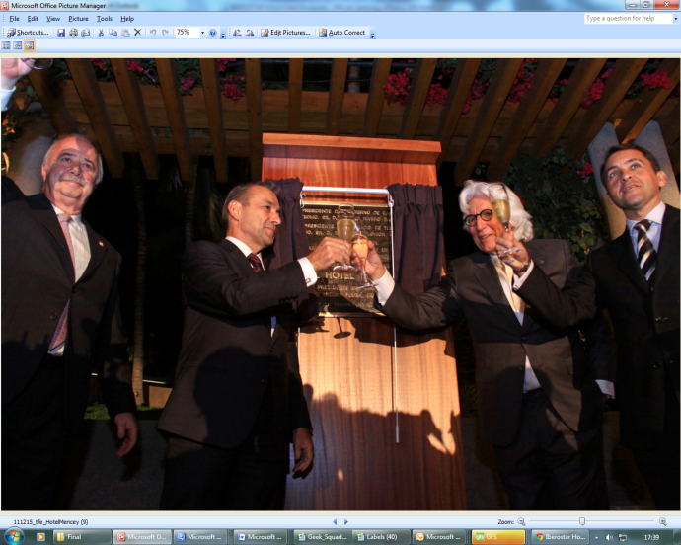

**Tenerife 23rd December** – The IBEROSTAR Grand Hotel Mencey opened its doors in style with performances from the Choir of Saint Marc de Lyon and the Tenerife Symphony Orchestra on Thursday 15th December, marking the grand opening of IBEROSTAR’s second city opening.

To capture the atmosphere of the hotel’s original opening in the 1950s, 40 actors took 500 guests back in time to recreate the magic of the 50s while also bringing a touch of glamour to the grand opening event.

The hotel, the ninth to join the luxurious Grand Collection, was officially opened by Miguel Fluxa, Executive Chairman of GRUPO IBEROSTAR, who was joined by other dignitaries from Tenerife including the President of the Canary Islands Hon. Mr Don Paulino Rivero and Hon. D. Ricardo Melchior, President of the Cabildo of Tenerife and the Hon. D. Jose Manuel Bermudez, Mayor of Santa Cruz de Tenerife.

Miguel Fluxa said “We are delighted to open our second city hotel in Tenerife, bringing the quality and service guests expect from IBEROSTAR to one of the top destinations for tourists in Europe.”

Located in the stunning city of Santa Cruz, the five star IBEROSTAR Grand Hotel Mencey offers guests fabulous views of the city, a spa and fitness centre and a gourmet restaurant with a unique colonial decor.

**Notes to Editor**:

**About IBEROSTAR Grand Collection**

**The Grand Collection** is IBEROSTAR's brand bringing together all great-luxury five-star properties of the hotel chain. Located in unique environments and always offering breathtaking vistas, **IBEROSTAR The Grand Collection** hotels are characterized by offering exclusive services found in high-luxury hotels conceived for turning holidays into an unforgettable experience. Each service has been designed and tailored to meet all the wishes of guests, who have at their disposal a concierge and a 24-hour room service. The suites are carefully-designed, elegant spaces with a separate bedroom and spacious bathrooms, as well as top-quality, Premium-brand, grooming items and additional services.

**The Grand Collection** additionally offers guests an exclusive gastronomic experience.

Under **The Grand Collection** brand and in observance of all standards of exclusivity and exquisite attention the following properties are found:

- IBEROSTAR Grand Hotel Salomé in Costa Adeje, Tenerife (Spain)

- IBEROSTAR Grand Hotel El Mirador in Costa Adeje, Tenerife (Spain)

- IBEROSTAR Grand Hotel Paraíso in Riviera Maya (México)

- IBEROSTAR Grand Hotel Bávaro in Punta Cana (Dominican Republic)

- IBEROSTAR Grand Hotel Rose Hall in Montego Bay (Jamaica)

- IBEROSTAR Grand Hotel Trinidad in Trinidad (Cuba)

- IBEROSTAR Grand Amazon, a boat-hotel that sails the Amazonas River (Manaus, Brasil)

- IBEROSTAR Grand Hotel Budapest in Budapest (Hungary)

- IBEROSTAR Grand Hotel Mencey in Santa Cruz de Tenerife (Spain)

**About IBEROSTAR Hotels & Resorts**

IBEROSTAR Hotels & Resorts is a family-owned hotel chain based in Palma, Majorca. IBEROSTAR resorts are 4 and 5 star properties, located in 15 countries across Europe, Africa, the Caribbean and South America. The hotel chain belongs to GRUPO IBEROSTAR, one of the most consolidated Spanish tourist groups with 50 years experience. IBEROSTAR Hotels & Resorts currently has over 100 hotels and 36,000 rooms.

**For more information:** prensa.iberostar.com

**IBEROSTAR Press Office**

**Edelman**

Tel: +44 203 047 2065

Fiona McHugh (**Fiona.mchugh@edelman.com**)

Nicole Taylor **(Nicole.taylor@edelman.com)**