PRESS RELEASE

IBEROSTAR’S FIRST 5-STAR HOTEL IN
PLAYA DE PALMA

- Following investment of 18 million euros in the full-scale refurbishment of IBEROSTAR Playa de Palma, the chain is opening its first 5-star hotel on the beachfront of this strategic Mallorcan tourist area.

- The prestigious German company GROHE collaborated in the modernization of this IBEROSTAR hotel through the creation of the first GROHE Experience Suite on the island. This pioneering initiative in Mallorca offers guests an innovative new high-tech sensory experience.

Madrid, June 2nd 2016. IBEROSTAR Hotels & Resorts is still immersed in the refurbishment of its hotels as part of the company’s strategy to continue offering guests top-quality hotels in leading destinations. In Mallorca, it is continuing to invest in improvements to one of the island’s key tourist areas through renovations to IBEROSTAR Playa de Palma.

Following its complete overhaul in 2016 at a cost of 18 million euros, the hotel has been upgraded from 4 to 5 stars. Tomorrow it will open to the public, fully modernized and revamped, becoming the first 5-star hotel in Playa de Palma, where the chain already has another two hotels.

Aurelio Vázquez, GRUPO IBEROSTAR’S CEO for Europe, the Middle East and Africa, commented: “Mallorca is our home and we firmly believe in the importance of our continued commitment to Playa de Palma’s regeneration and improvement. With this refurbishment project, we are helping our region to remain a top holiday destination and to grow in tourists, thanks to first-rate products like this one.”
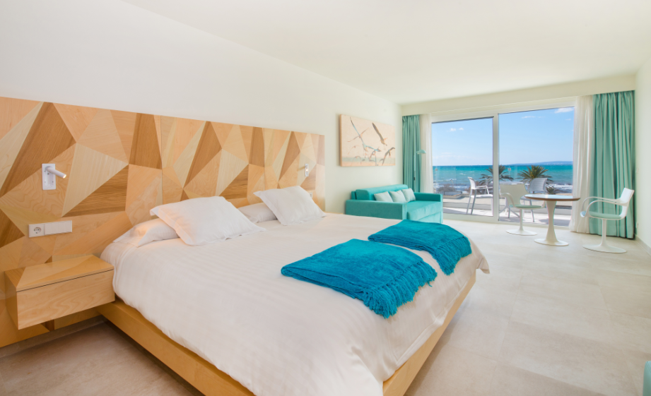
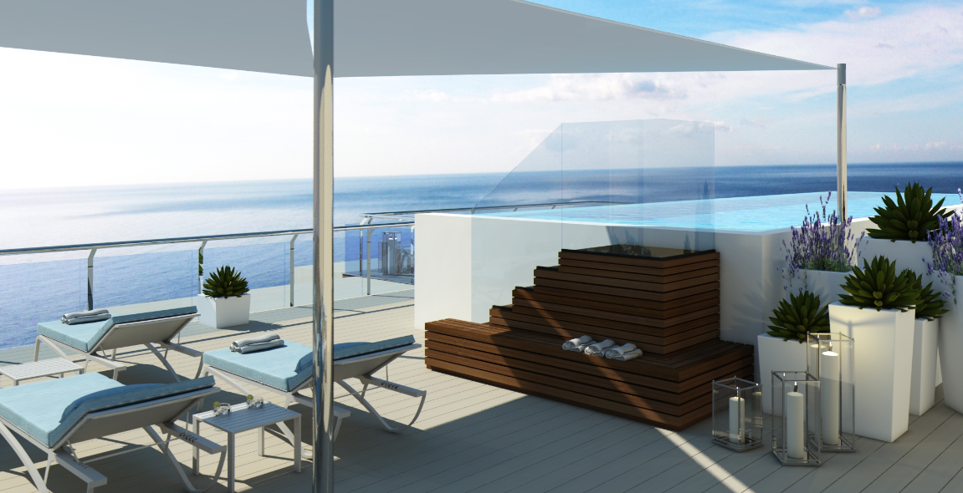

The newly refurbished IBEROSTAR Playa de Palma, which stands on the beachfront promenade, boasts 182 fully revamped rooms, adapted for use by both couples and families in search of a deluxe holiday. All the hotel facilities have been completely renewed, with a new area boasting swimming pools and a sun terrace with garden areas. The hotel also features a spa with a wet area and a selection of treatments and massages for couples.

One of the hotel’s key attractions is its cuisine at the new Marea Restaurant. Thanks to its selection of superior specialities served in informal style, the restaurant is one of Palma’s leading reference points in ingredient-driven cuisine, offering hotel guests and new visitors the chance to sample mouth-watering local products in a setting with a strong Mediterranean flavour.

As complementary activities, guests can enjoy numerous different sporting activities and entertainments, like IBEROSTAR’s Fit & Fun fitness programme.

One of the hotel’s main new highlights is the result of an agreement between IBEROSTAR and GROHE, the German world leader in kitchen and bathroom tap fittings and equipment, for the creation of the first GROHE Experience Suite at a Mallorcan hotel.

This over 100m² suite is located on the hotel’s seventh floor, and it offers a spacious outdoor area with superb views of the beach, a huge light-filled bedroom/living room, a large terrace with a spa bath, and a bathroom kitted out with leading products by GROHE to ensure an all-round spa experience. Equipped with cutting-edge technology by the German company, the suite has a design that pays meticulous attention to even the smallest detail, ensuring full relaxation and a sensory experience that brings into play all five senses.

The hotel also offers the services of its Star Prestige programme, a concept specially designed by the company, with special rooms and facilities fitted out in superior style to satisfy the most discerning of guests.

* Note for the editor: A selection of photographs can be downloaded via this link

