THE LEE WESTWOOD GOLF TOUR, HELPING TRANSFORM TODAY’S YOUNG GOLFERS INTO TOMORROW’S GOLFING HEROES
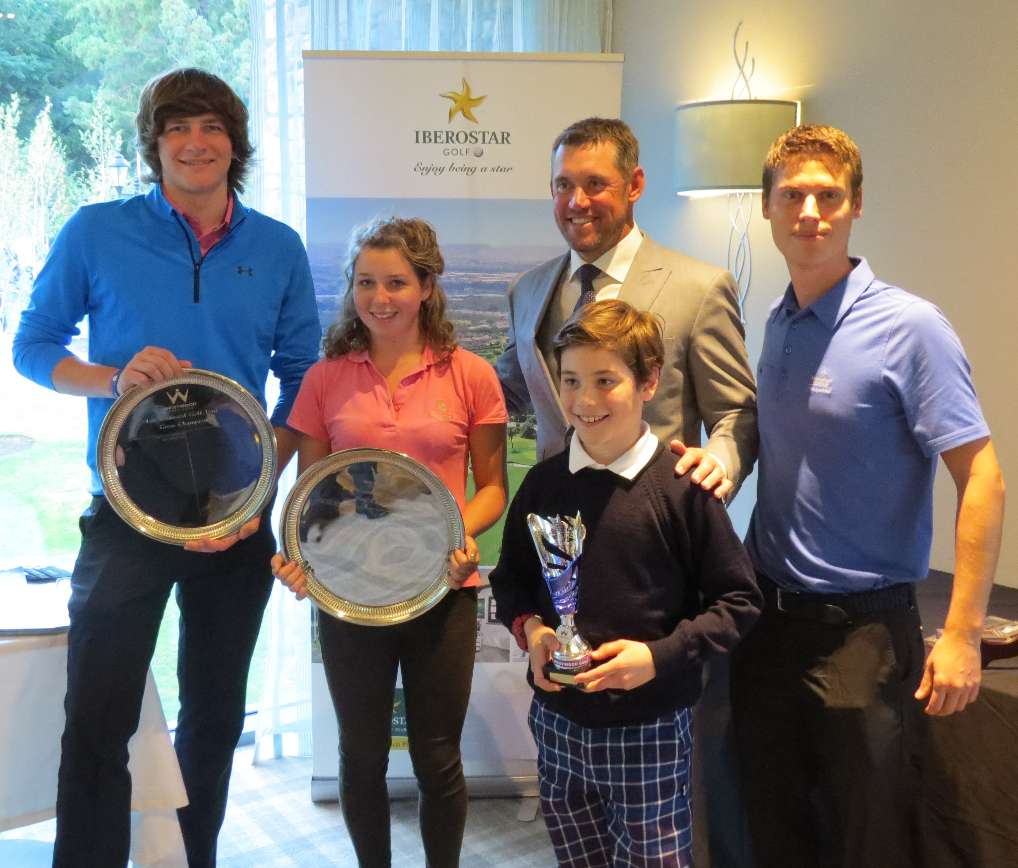

- This year’s Lee Westwood Golf Tour National Regionals saw over 500 young golfers participate for a spot in the final.

- In January, the Winter Training Camp for the renowned English academy, together with the Darren Clarke Golf School, will be held in the facilities of IBEROSTAR Golf Novo Sancti Petri.

London, 21st October 2015: In January, the Winter Training Camp for the Lee Westwood Golf School, together with the Darren Clarke Gold School, will be held in the facilities of IBEROSTAR golf Novo Sancti Petri.

Simon Mackenzie, Golf Sales Manager, speaking on behalf of IBEROSTAR announced at the prize giving; “We are proud to announce our collaboration with the Lee Westwood Golf School to hold their Winter Training Camp in January 2016. This year was a huge success and we look forward to receiving them again, the students worked hard on the Driving Range hitting over 45,000 golf balls in 11 days! Let’s see if they can break that record in January”.

With the recent National Lee Westwood Golf Tour competition, over 90 young golfers competed in the prestigious final. Lee Westwood stated that; “the tour will provide the chance for young golfers to play competitive events just like their golfing heroes”. The tour, which is open to boys and girls under the age of 21, consists of 20 regional events throughout the UK. The National Final was a two-day event held at Close House estate.

IBEROSTAR Hotels & Resorts sponsored three prize categories in the final: Gross Winner, Net Winner and Overall Winner. Each winner was rewarded with four night’s stay for two at IBEROSTAR Royal Andalus Hotel where they will be able to use the great facilities of IBEROSTAR Golf Novo Sancti Petri for a unique golf experience by the sea.

About IBEROSTAR Hotels & Resorts
IBEROSTAR Hotels & Resorts is a resort hotel chain based in Palma de Mallorca (Balearic Islands, Spain), founded by the Fluxà family in 1986. IBEROSTAR Hotels & Resorts is an integral part of GRUPO IBEROSTAR, one of the main Spanish tourist companies with over 80 years of experience, which currently has more than 100 hotels of 4 and 5 stars around the world.

