PRESS RELEASE

IBEROSTAR PLAYA PILAR,
A NEW FIVE STAR HOTEL IN CUBA

- IBEROSTAR Hotels & Resorts ends 2015 with a new opening, further proof of the company’s commitment to Cuba, a key destination, where IBEROSTAR already has 10 hotels.

- IBEROSTAR Playa Pilar is an exclusive five star resort with 482 rooms situated on Key Guillermo, in the Jardines del Rey archipelago.

Madrid, November 6th 2015. - This month IBEROSTAR Hotels & Resorts’ opened their eleventh hotel in Cuba. Situated on Key Guillermo, in the magnificent Jardines del Rey archipelago, the IBEROSTAR Playa Pilar is a five star resort with 482 rooms, made up of 15 buildings and bungalows. The new hotel offers the most exclusive services, guaranteeing a perfect family vacation.

IBEROSTAR Playa Pilar is part of the company’s Premium Gold category and overlooks one of Cuba’s finest beaches, facing the world’s second most important coral reef. In addition, the hotel’s wellness offerings and mouth-watering gastronomy are just a few of the attractions that make the IBEROSTAR Playa Pilar one of the island’s most outstanding hotels.

IBEROSTAR Playa Pilar’s prime beachfront location paired with the company’s long-standing commitment to Cuba, have proven crucial in enabling IBEROSTAR to continue strengthening its position on the island and successfully face the new challenges of the tourism industry.

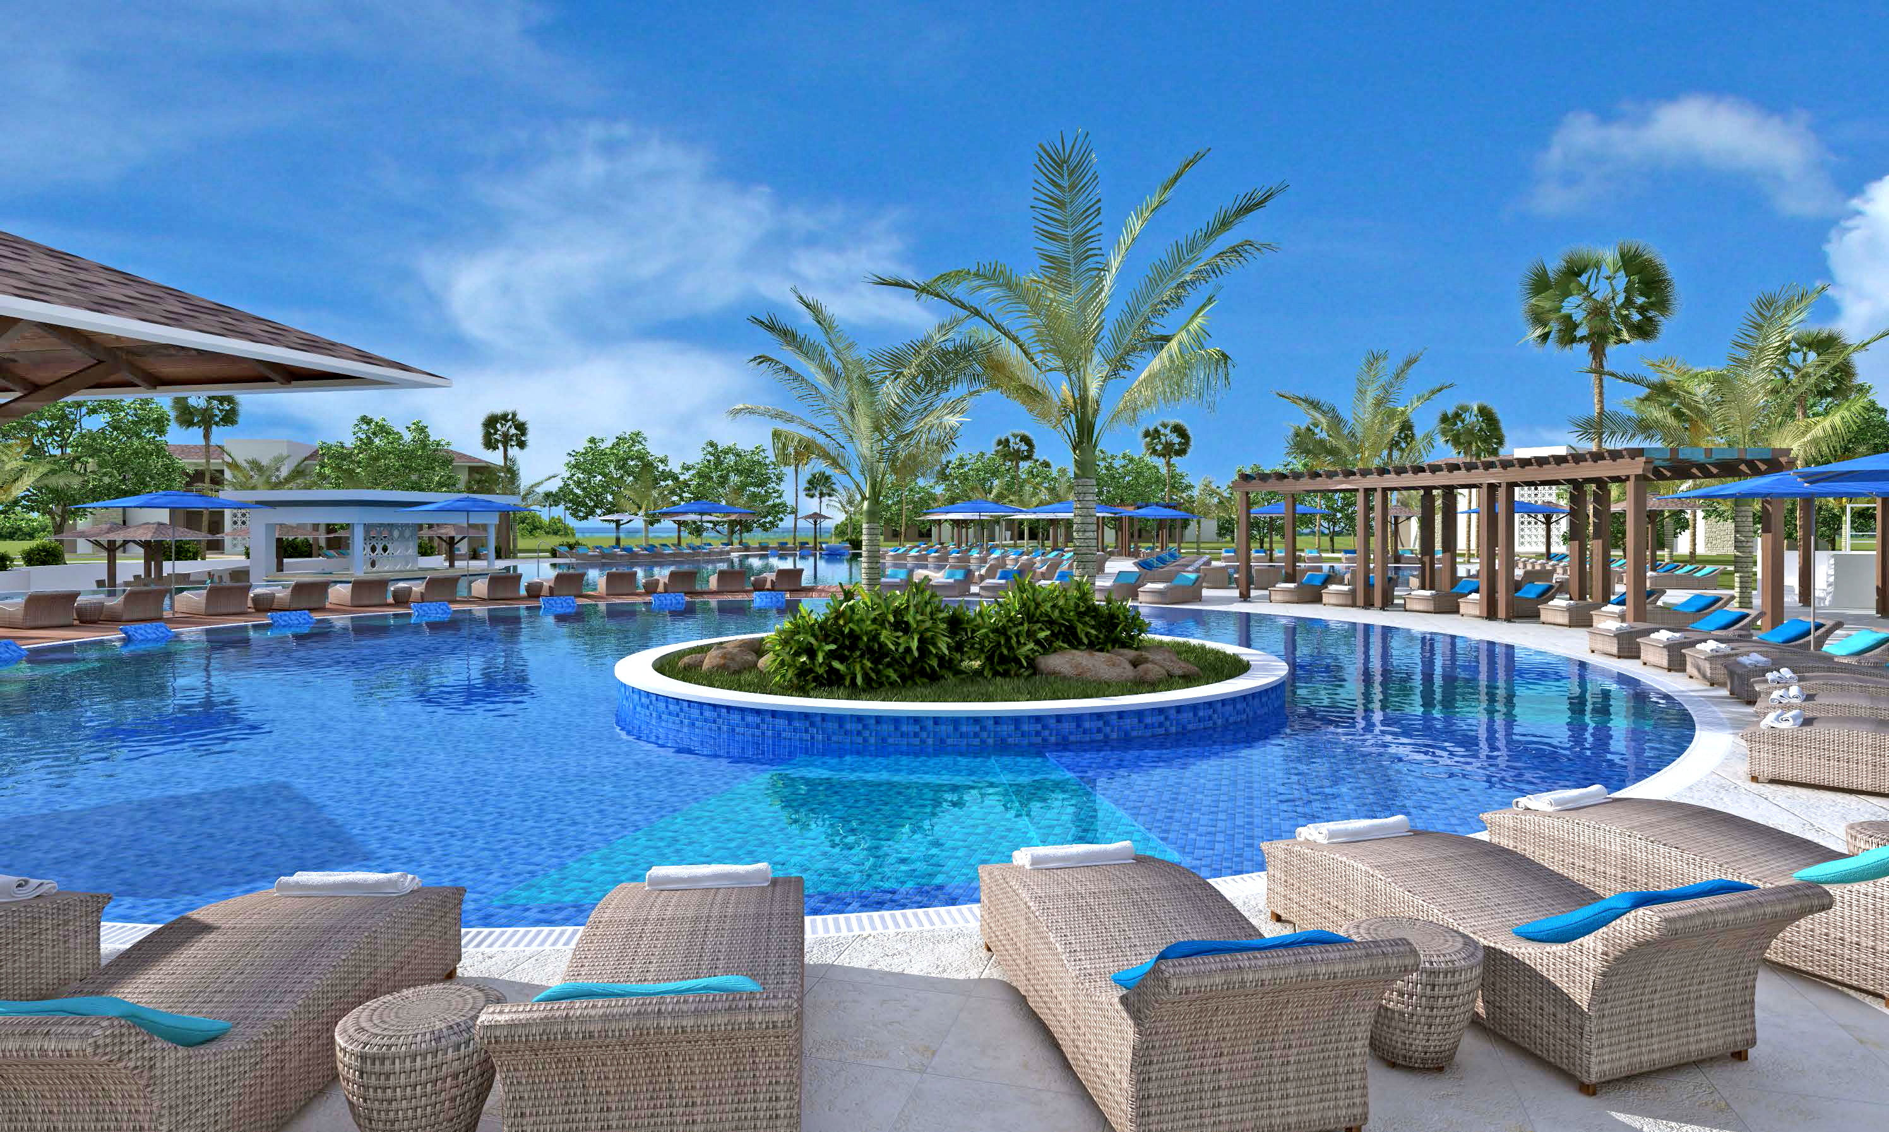

According to José Antonio González, GRUPO IBEROSTAR’s Vice Chairman and CEO of America, “Through the opening of the IBEROSTAR Playa Pilar, our aim is to further solidify our commitment to Cuba as one of our key destinations. We have been operating in the country since 1998 with highly positive results and are delighted to be adding a new hotel, as it will enable us to continue growth in this market, while supporting the local tourism industry, as it tackles new challenges.”

The facilities at the new IBEROSTAR Playa Pilar include five swimming pools, ideal for making the most of Cuba’s unbeatable climate, boating excursions, and a beachfront restaurant. This hotel is ideal for family vacations due to the wide variety of entertainment activities as well as numerous Spa & Wellness services.

The hotel also offers its guests countless activity options, such as water sports like windsurfing, kayaking, and scuba diving, a tennis court, sports club, beach volleyball and basketball. Those in search of rest and relaxation will enjoy a fabulous experience at the Spa & Wellness center, which includes a sauna, thermal baths and an extensive choice of treatments such as massages. The hotel also has its own beauty and hair salon, completing the range of personal care services.

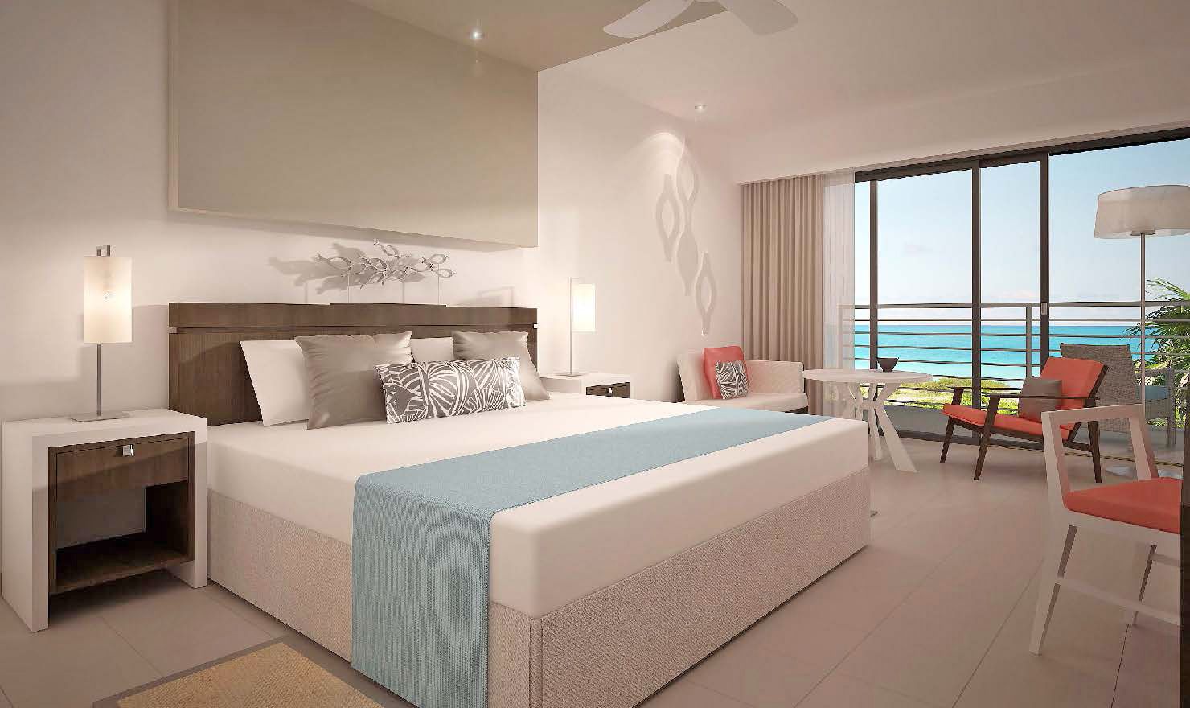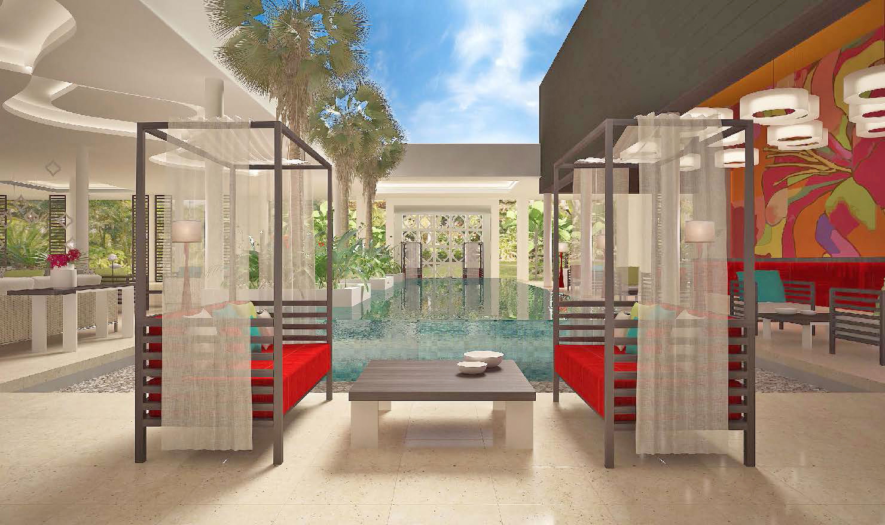

In line with its continued commitment to gastronomy, IBEROSTAR always offers dishes and restaurant services of the highest quality. In keeping with this, the hotel offers a choice of three specialty restaurants – Mediterranean, Creole and Japanese – guaranteed to suit all tastes. Together, the magnificent facilities and superb standards of service at the IBEROSTAR Playa Pilar enable the company to continue offering and improving on the standards of excellence that form an essential part of its philosophy.

