PRESS RELEASE

IBEROSTAR NOW OFFERS FREE WI-FI AT ALL OF ITS HOTELS

Madrid, November 11, 2015. As part of its commitment to offering its guests the finest range of products and services, IBEROSTAR Hotels & Resorts is now offering fast and reliable WiFi at all of its hotels, free of charge.

Starting November 1st, IBEROSTAR guests will be able to enjoy WiFi access free of charge throughout their vacation, demonstrating IBEROSTAR’s continuing commitment to meeting and exceeding customers’ expectations. This free WiFi offer enables guests to keep up with all the latest news, download multimedia content and keep in touch with family and friends during their stay.
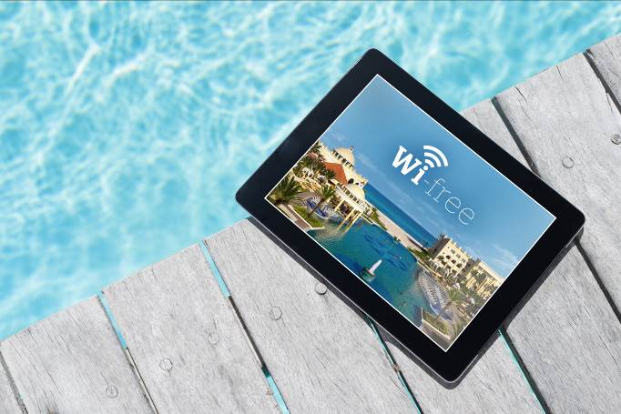


IBEROSTAR Hotels & Resorts’ commitment to innovating and upgrading its facilities will also lead to a boost in communication and interaction with its guests, enabling IBEROSTAR to receive and respond immediately to guests’ requests and comments, as well as keeping guests up to date with the activities and campaigns that will run in the hotels where the WiFi service is in place.

Free WiFi is a major step forward that will improve guests’ experience and allows them to be permanently connected to WiFi at all IBEROSTAR Hotels & Resorts, located in Mexico, Brazil, Jamaica, the Dominican Republic, Spain, Morocco, Hungary, Bulgaria, Montenegro, Greece, Cape Verde and Tunisia.

Note for the editor: the images included in this Press Release can be downloaded here

About IBEROSTAR Hotels & Resorts

IBEROSTAR Hotels & Resorts is a resort hotel chain based in Palma de Mallorca (Balearic Islands, Spain), founded by the Fluxà family in 1986. IBEROSTAR Hotels & Resorts is an integral part of GRUPO IBEROSTAR, one of the main Spanish tourist companies with over 80 years of experience, which currently has more than 100 hotels of 4 and 5 stars in 16 countries around the world.

