PRESS RELEASE

***IBEROSTAR COMPLETES RENOVATION OF HOTELS IN PLAYA DEL CARMEN***

* *Two new lobbies, new restaurants, cigar lounge and new design and décor*

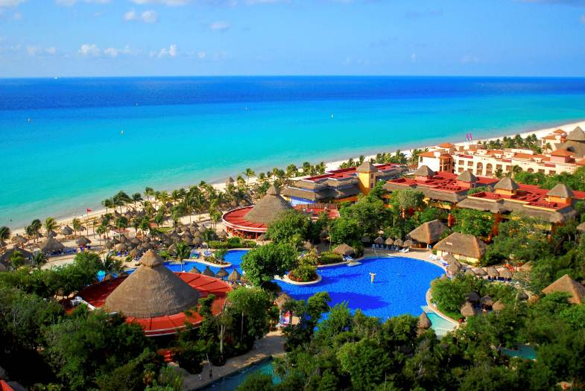**Playa del Carmen, Quintana Roo, February 16, 2016.** In a continued effort to maintain the quality standards that characterize IBEROSTAR Hotels & Resorts, the company has reopened the doors of the IBEROSTAR Tucan and IBEROSTAR Quetzal following a remodeling project started in Oct 2015.

Significant improvements to the hotels include two new lobbies, which have been completely redesigned with complementing furniture and décor, and expanded terrace areas, creating optimal space for guests to rest and relax. In the exterior spaces, IBEROSTAR has updated the décor surrounding the pool and playground areas, including new equipment for the Kids Club. Furthermore, the spas at each property have been renovated.

As for the cuisine, the complex has added a new ice cream parlor on the beach, a local cigar lounge for guests to enjoy and new restaurants. Restaurants are now broken into Mediterranean, Japanese, Mexican, Italian and a Steakhouse, where guests can continue to enjoy the highest quality steaks and other dishes.

From an operational standpoint, the company invested significantly in the improvement of the properties’ electricity grids, gas and sanitation, and the optimization of energy management.

"It was very important to us that we renovate IBEROSTAR Tucan and IBEROSTAR Quetzal so we could continue to offer our guests the best service and excellent quality. The hotel’s major renovation, with updates to restaurants, terraces, furniture and décor, continues to make the hotels one of the top destinations in Playa del Carmen,” said Rafel Carmona, Director of Operations at IBEROSTAR Mexico.

Surrounded by tropical vegetation, guests at IBEROSTAR Tucan and IBEROSTAR Quetzal can enjoy the natural surroundings and wonders of the Mayan Jungle, a paradise of its own. Located on the beach and approximately 2 miles from the center of ​​Playa del Carmen, both hotels are ideally located for guests to experience Mexican culture by visiting nearby towns and archaeological sites.

As a result of the company’s continued effort to always offer the best quality and service to their guests, IBEROSTAR is investing over 90 million euros in remodeling projects in 2016.

###

**About IBEROSTAR Hotels & Resorts**

IBEROSTAR Hotels & Resorts is a resort hotel chain based in Palma de Mallorca (Balearic Islands, Spain), founded by the Fluxà family in 1986. IBEROSTAR Hotels & Resorts is an integral part of GRUPO IBEROSTAR, one of the main Spanish tourist companies with over 80 years of experience, which currently has more than 100 hotels of 4 and 5 stars in 16 countries around the world.

For more information, please visit: IBEROSTAR.com

**Press Contact:**Edelman  
[iberostar@edelman.com](mailto:iberostar@edelman.com)