PRESS RELEASE

IBEROSTAR APPOINTS JAVIER TOR AS NEW SALES DIRECTOR
AT THE IBEROSTAR GRAND HOTEL PORTALS NOUS

- Javier Tor will be the head of sales for the new IBEROSTAR Grand Hotel Portals Nous, the chain’s first Grand Collection category hotel in Mallorca.

- The new five-star establishment, IBEROSTAR Grand Hotel Portals Nous, will open its doors in July 2016.

Palma de Mallorca, 16 March 2016. IBEROSTAR Hotels & Resorts is finalising the next addition to its product portfolio, its first The Grand Collection category hotel in Mallorca: IBEROSTAR Grand Hotel Portals Nous. To manage this new project, the chain has appointed Javier Tor as the new Sales Director. In his new role, Tor will be in charge of leading operations relating to sales and marketing for the new hotel and ensuring compliance with the objectives that will guarantee its success.

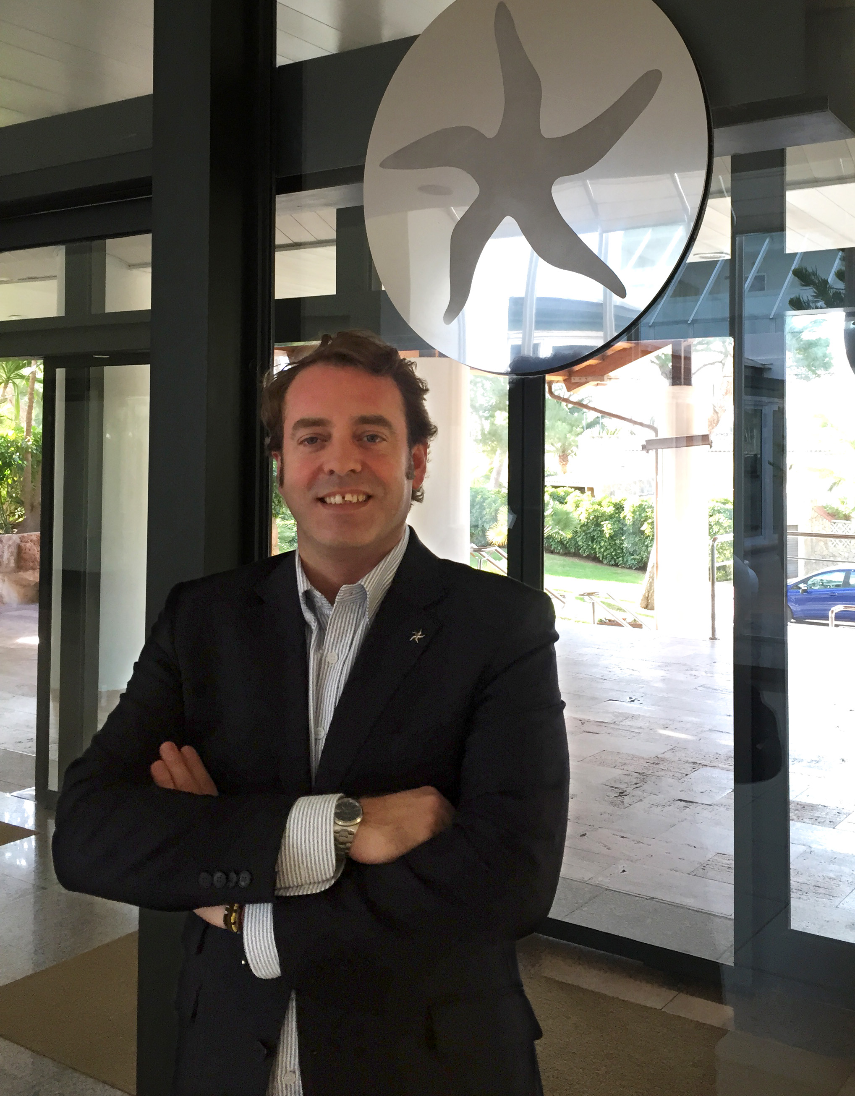
The new five stars hotel, the company’s 14th hotel on the island, will be open from July 2016. With a total of 66 rooms, IBEROSTAR Grand Hotel Portals Nous will feature all the exclusive services of The Grand Collection. Along with other factors such as its commitment to sustainability and energy efficiency and its avant-garde design by the prestigious architect and designer Marcel Wanders, IBEROSTAR Grand Hotel Portals Nous will be the leading reflection of the quality of IBEROSTAR’s product on the island of Mallorca.

Javier Tor has extensive experience in the tourism sector, in which he has completely dedicated his professional life for over 20 years. Educated at the School of University Studies in Hotel Management of Barcelona, Tor has developed his career in hotels such as the Ibiza Gran Hotel****GL, where he performed the role of Sales and Marketing Director; Grupo Transversal, ABBA Hoteles and Hoteles HUSA, where he occupied a variety of managerial posts in the area of sales at a national and international level.

Javier Tor said: “I look forward to a challenge as big as managing sales for the chain’s first Grand Collection hotel in Mallorca and see this as an important opportunity to keep growing the tourist sector in Mallorca. I am sure that this establishment will be a success and I hope that my work will help to position this hotel amongst the best of the island’s tourist offer”.

About IBEROSTAR Hotels & Resorts
IBEROSTAR Hotels & Resorts is a resort hotel chain based in Palma de Mallorca (Balearic Islands, Spain), founded by the Fluxà family in 1986. IBEROSTAR Hotels & Resorts is an integral part of GRUPO IBEROSTAR, one of the main Spanish tourist companies with over 80 years of experience, which currently has more than 100 hotels of 4 and 5 stars around the world.

For more information: www.iberostar.com

IBEROSTAR Press Office – Edelman
Juncal Alonso (Juncal.Alonso@edelman.com)
Leah Pummell (Leah.pummell@edelman.com)

