TOP FASHION DESIGNER, DAVIDELFIN DESIGNS NEW IBEROSTAR UNIFORMS

- Spanish hotel chain IBEROSTAR Hotels & Resorts has commissioned Davidelfin to design the new international uniforms

- The collection, made up of 15 outfits, mirrors the designer’s unique creative spirit

London, 1 July 2011 - Spanish hotel chain IBEROSTAR Hotels & Resorts has commissioned Davidelfin to design their new look uniforms. The designer, renowned around the world for his limitless capacity for creation and innovation in all his designs, has come up with styles that reflect the hotel chain’s unique and personal image to perfection.
David spent several months working on the designs for the exclusive IBEROSTAR by Davidelfin collection which will be worn by more than 21,000, employees in the 15 countries the company is present in.

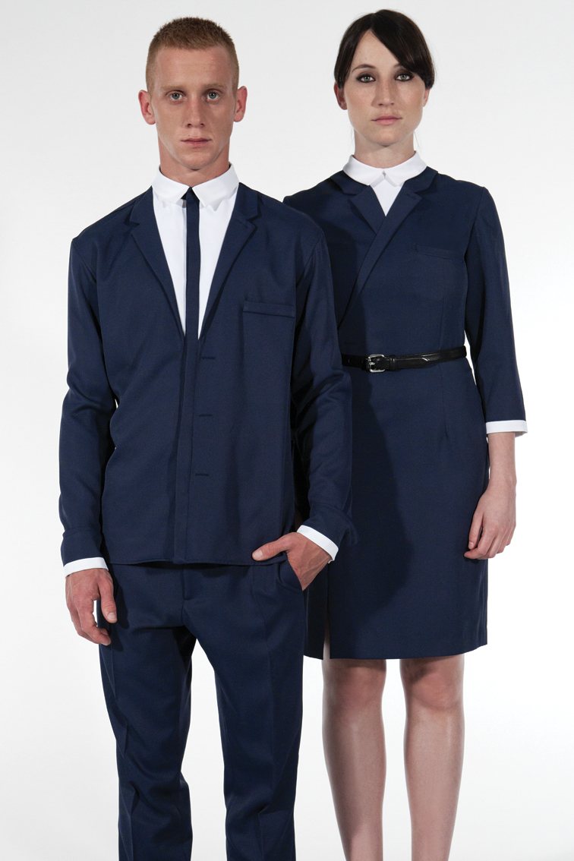
During the creative phase, the designer visited several of the hotels in the Caribbean and Mediterranean to obtain a first-hand insight into the employees’ needs. This enabled him to take in the full sense of the Iberostar spirit and essence, helping him to grasp the full scope of the requirements of both the hotel chain and its staff.

David Delfín, said “This has been a really thrilling and dynamic project and a real challenge. By working as a team we’ve managed to create uniforms that are 100% Davidelfin, in keeping with IBEROSTAR’S environment combining creativity and functionality whilst incorporating the needs of the various departments into consideration.”

He adds, “The garments blend in perfectly, taking on a lighter appearance. Gone are the layers, linings and shoulder pads. They play on appearances, creating optical effects that can be seen close up. Elegant, streamlined blue and white with a nautical touch which adapt perfectly to an urban setting.”

The result is 15 outfits designed for Reception, Restaurant, Pool Bar, Housekeeping, Daytime Entertainment, Evening Entertainment and Spa, which reflect perfectly the IBEROSTAR spirit seen through the contemporary and innovative eyes of Davidelfin. Each of the models created are in keeping with the functional requirements of each job: elegance and comfort for receptionists; lightweight, easy-to-wear styles for chambermaids; flexibility and easy movement for the entertainment teams… all true to the Davidelfin concept and the image and personality of the IBEROSTAR brand.

Renewing the uniforms is part of the ambitious brand strategy the IBEROSTAR Group is currently immersed in.

Luis Herault, Chief Marketing Officer at IBEROSTAR Hotels & Resorts, said “The uniforms are a key element for the brand and the way it presents itself. Their function is twofold: on the one hand they present an image to our customer and also dress our staff. Based on the characteristics of this project it was clear we needed a professional from the fashion world and David Delfín was our choice. We’re delighted with Delfín’s designs, which clearly meet all our needs: not only do they transmit the personality of our brand, but they’re also functional and highly original.”
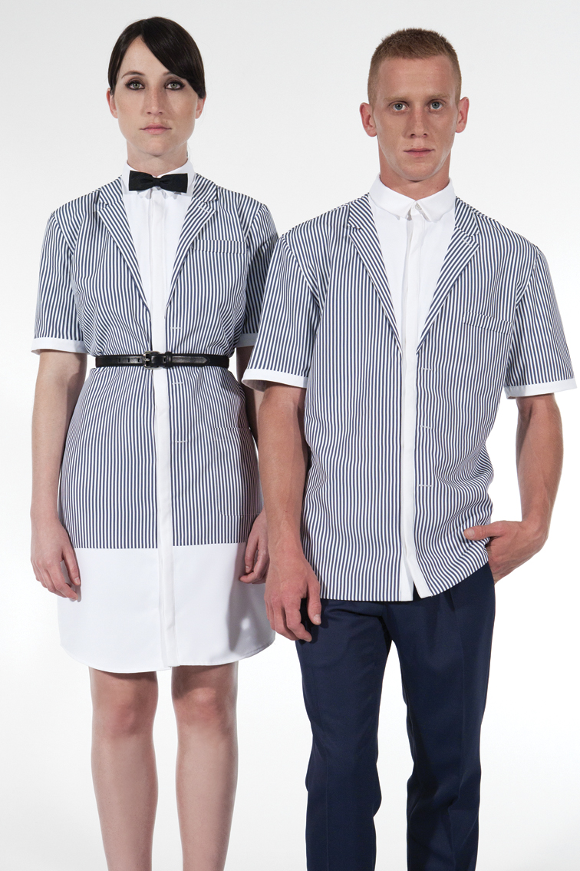
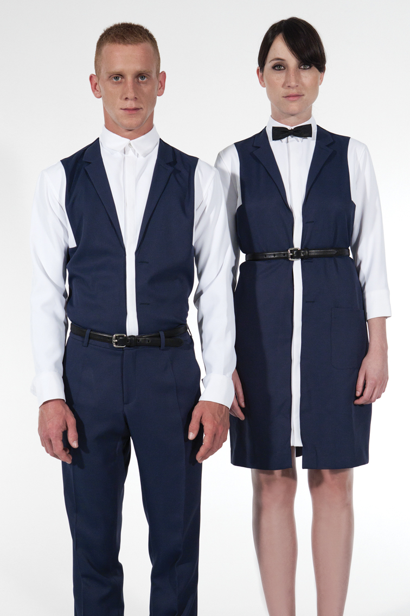
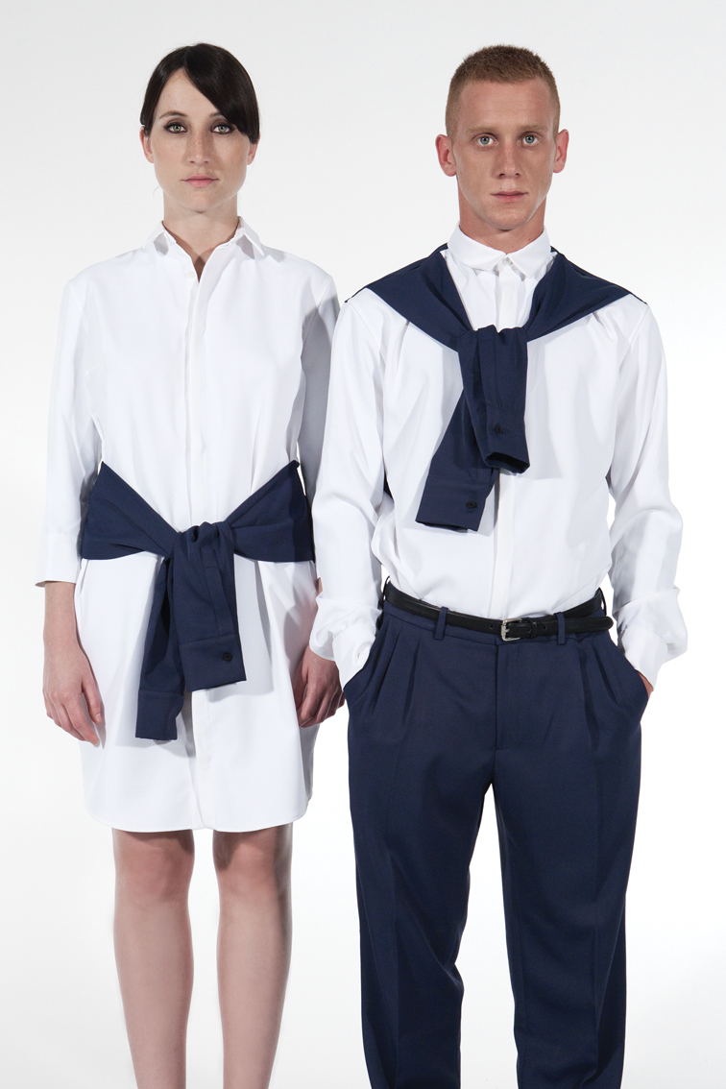
The new uniforms, whose main tone has been created à la carte style and named “Delfín Blue”, will be made in 10 different sizes to ensure that each member of staff looks and feels smart, comfortable, at easy and satisfied.

The new uniforms will be launched simultaneously at selected hotels in Majorca, Budapest and Mexico. They will be tested over a 3 month period to make sure they fit in perfectly with the chain’s operations before gradually being introduced to the remaining hotels during the course of 2012.

Notes for the editor:
- Download a selection of photos and sketches of the new Iberostar uniforms designed by Davidelfin at Fotos&Bocetos.rar
- Here you can download a video showing the full range of uniforms: Desfile Iberostar.mov.
This video is also available for viewing on the company’s YouTube channel at http://www.youtube.com/user/iberostar#p/u/0/o7YUxDk0b00
- Download the video featuring the project’s making of and comments from the designer at Iberostar&Davidelfin Making of.mov
This video can also be viewed directly on the company’s YouTube channel at http://www.youtube.com/user/iberostar#p/u/1/FAOWTtTZo0g

Further details available at prensa.iberostar.com

IBEROSTAR Press Office
Edelman
Tel: +44 203 047 2065
Fiona McHugh (Fiona.mchugh@edelman.com)
Nicole Taylor (Nicole.taylor@edelman.com)

