PRESS RELEASE

IBEROSTAR FURTHER STRENGTHENS ITS PRESENCE IN CUBA WITH TWO NEW HOTELS

- The hotel chain focuses on urban, sun and sand tourism following the acquisition of a hotel located in the heart of Havana and a second beachfront hotel in Cayo Ensenachos

- With these two latest incorporations, IBEROSTAR Hotels & Resorts now has eight hotels on the Caribbean island

London, 1 July 2011. IBEROSTAR Hotels & Resorts has strengthened its presence in Cuba with two new hotels in Havana and Cayo Ensenachos. The Spanish chain, which already has another six hotels on the Caribbean island, has extended its scope to take in the urban tourism sector, as well as extending its sun and sand offer.

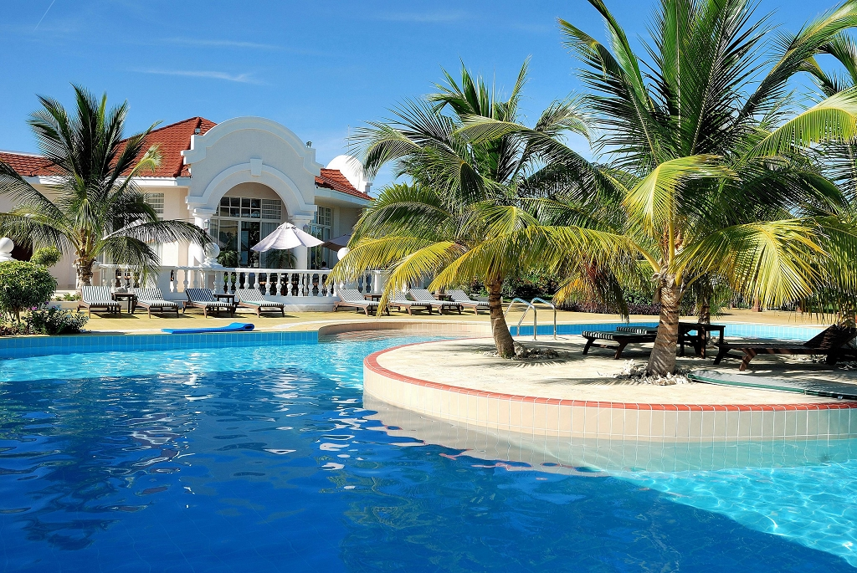
Situated on Cuba’s north coast and just five minutes from Cayo Las Brujas Airport, the IBEROSTAR Ensenachos stands on an unspoilt bay surrounded by two stunning beaches that are ideal for scuba diving as well as a host of other water sports and as sunbathing. The hotel has 506 rooms with balconies divided into three areas: one for families, another for adults only complete with a SPA, and a third area of luxury villas with Jacuzzis and a restaurant for the exclusive use of guests staying in this area.

In addition to the fully-equipped SPA and Wellness Centre, the hotel also boasts a water sports centre, swimming pool with Jacuzzi, six bars and 3 meeting rooms. En suite facilities include room service and a minibar that is restocked daily. The IBEROSTAR Ensenachos also offers a host of dining options including a buffet restaurant with show cooking, as well as two snack bars and three à la carte restaurants serving Asian, Italian and fish and seafood specialities. As for our younger guests, non-stop fun is guaranteed with the Miniclub, aqua park and an extensive entertainment programme.
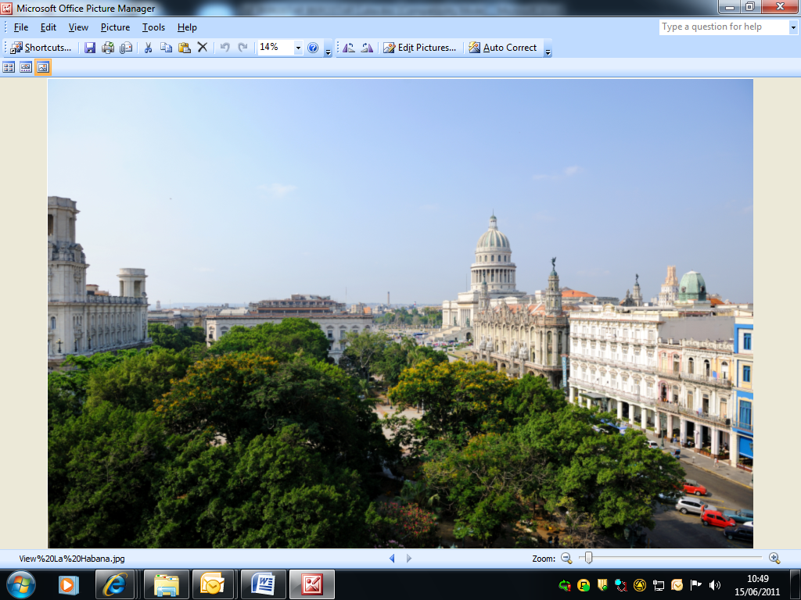
Targeting urban tourism, the IBEROSTAR Parque Central stands in the heart of Old Havana, facing the historic Central Park and just a stone’s throw from the monumental National Capitol Building. Facilities at this hotel, which boasts 365 rooms, 27 suites, 34 junior suites and a Presidential Suite, include two rooftop pools, a fitness room, massage room and two lobby bars where live music is performed each evening.

It also includes 10 meeting rooms, a WiFi Internet connection, 24 hour room service and a tourist information office and car rental service. The main restaurant, the Steak House and the Italian restaurant and two snack bars complete the facilities available at the IBEROSTAR Parque Central.

Both hotels offer an event and convention planning service plus a business centre.

Note for the editor:
Link to download photographs of the IB Ensenachos: IB Ensenachos.zip
Link to download photographs of the IB Parque Central: IB Parque Central.zip

For further information please visit the website: www.iberostar.com
For additional information, please contact Nicole Taylor at Edelman on 0203 047 4035 / Nicole.taylor@edelman.com or Fiona McHugh at Edelman on 020 3047 2065/ fiona.mchugh@edelman.com

