PRESS RELEASE
IBEROSTAR CELEBRATES
WORLD ENVIRONMENT DAY

- On 5th June, IBEROSTAR Hotels & Resorts will be commemorating the United Nation’s biggest day of the year for positive environmental action, which this year will focus on the fight to conserve our planet’s wildlife.

- The chain, which will be supporting this initiative for the second year running, has programmed a series of activities in the more than 100 hotels it operates around the world.

- Iberostar to address locally-based wildlife protection actions, including the project to protect tabasco turtle nests set up at the IBEROSTAR Cancún hotel in Mexico.

London, 31st May 2016 - IBEROSTAR Hotels & Resorts will once again be taking part in the annual World Environment Day, the United Nation’s biggest campaign aimed at raising people’s awareness of the need to protect the environment. Since its launch in 1974, this very special day is celebrated every 5th June in over 100 countries in order to promote the protection of our environment internationally.


The slogan for this year’s WED – Go Wild for Life - is based on illegal wildlife trade and in particular those species that are in danger of extinction. In recent years this issue has become one of the greatest environmental threats, and the campaign urges everyone to take action to contribute to protecting wildlife for future generations.

IBEROSTAR is eager to contribute to this initiative by involving all its hotels through an extensive programme of activities designed to raise guests’ awareness of the importance and care of the environment. The initiatives planned by the company include briefings with role play offering an insight into a number of sustainability issues and the company’s environmental policy. They will address more locally-based wildlife protection actions, such as the project to protect tabasco turtle nests set up at the IBEROSTAR Cancún hotel in Mexico.
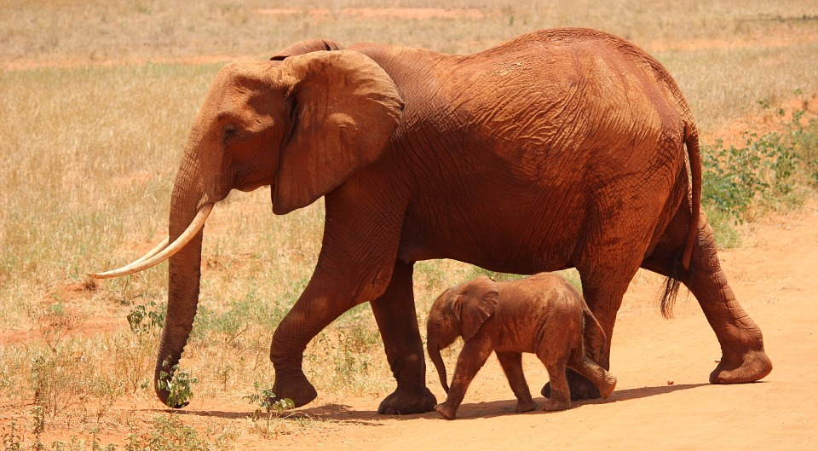
The activities that will be taking place at IBEROSTAR hotels in America include the following:

- Reforestation actions, whereby younger guests will be able to plant trees in specially designated areas of the hotel.

- Guided tours offering little ones the chance to observe the hotel’s flora and fauna, followed by a drawing competition based on the topic of ‘wildlife rescue and protection’.

-Beach cleaning involving employees, collaborators and guests (IBEROSTAR Praia do Forte).

In turn, in the EMEA region (Europe, Middle East and Africa), IBEROSTAR hotels will also be joining in this initiative with a series of actions:

- At the Miniclubs, children aged between 4 and 12 will be able to learn how to make musical instruments and fancy dress costumes from reused materials and later show them off at a fashion show, whilst the Maxiclubs (for children aged 13 to 17) will be organising environment-inspired field days and showing participants how to make puppets from recycled materials before getting together to put on a performance.

- Talks on endangered species. Participants will be shown images of various animals and will learn which are or are not in danger of disappearing. They will also receive information about animal poaching and the illegal wildlife trade.

- Educational workshops based on sports games to raise awareness of the importance of recycling. Participants will play with waste items that must be placed in the correct containers, depending on the type of recycling.

This initiative forms part of GRUPO IBEROSTAR’s Corporate Social Responsibility programme, whereby the company takes part in actions aimed at encouraging environmental care.

IBEROSTAR Hotels & Resorts is a resort hotel chain based in Palma de Mallorca (Balearic Islands, Spain), founded by the Fluxà family in 1986. IBEROSTAR Hotels & Resorts is an integral part of GRUPO IBEROSTAR, one of the main Spanish tourist companies with over 80 years of experience, which currently has more than 100 hotels of 4 and 5 stars around the world.

For more information: www.iberostar.com

IBEROSTAR Press Office – Edelman
Juncal Alonso (Juncal.Alonso@edelman.com)
Leah Pummell (Leah.pummell@edelman.com)

