Media Contact:

Diana Beard

Edelman on behalf of IBEROSTAR

212-738-6102

Diana.Beard@edelman.com

PRESS RELEASE

GRUPO IBEROSTAR APPOINTS ENRIC NOGUER
AS GENERAL MANAGER AMERICA

- Enric Noguer has been appointed GRUPO IBEROSTAR’s General Manager America, a new position that was created in March 2015.

- With a long-standing career in the tourism industry, backed up by a sound business grounding, Enric Noguer is carrying out his new role from the chain’s corporate offices in Mexico.

Palma de Mallorca, Spain (April 10, 2015) - IBEROSTAR Hotels & Resorts recently announced the appointment of Enric Noguer as GRUPO IBEROSTAR’s General Manager America. As the General Manager America, Noguer will be responsible for reaching sales targets, operations and implementing the Group’s strategy in a region of crucial importance for the company.

With his long-standing experience in the tourism sector, Enric Noguer brings to the Group his extensive background where he was previously with the TUI Group in Majorca and the Dominican Republic, before moving to BlueBay Hotels & Resorts as CEO. Another notable position Noguer held was Regional Director for America at the Miami-based Hotelbeds, part of the TUI Group.
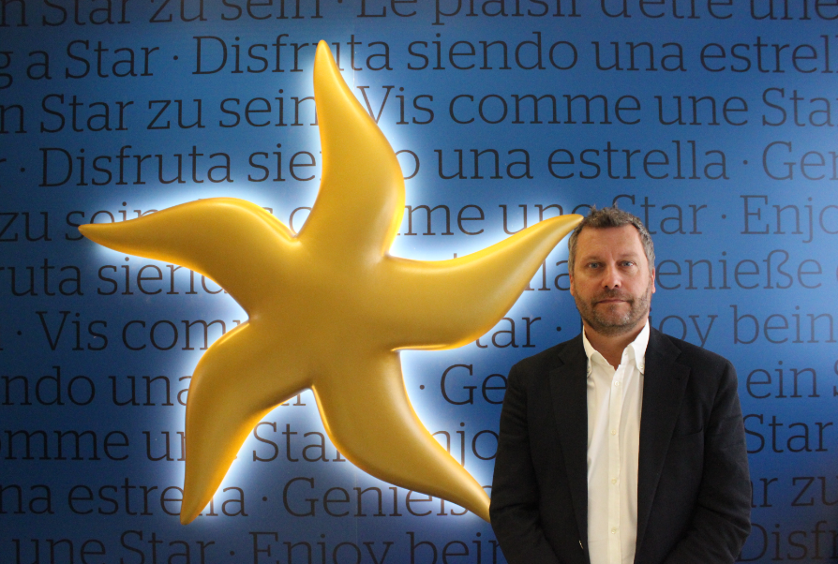
Boasting a solid international academic background, Noguer has a degree in Business Science and an MBA from ESADE Business School. He also holds a postgraduate qualification in International Economics‎ and Finance from Brandeis University (Boston, USA).

Following this move to GRUPO IBEROSTAR, Noguer is now a member of the team led by José Antonio González, Vice Chairman & CEO America for the Group and will be in charge of coordinating the corporate and commercial areas as well as operations in the region.

Enric Noguer said “Joining IBEROSTAR has been a tremendous reward and also a real challenge. IBEROSTAR is an international leader in the tourism sector and I am confident that I will be able to make a positive contribution to GRUPO IBEROSTAR, further positioning the company in a continent that offers tremendous opportunities.”

Currently made up by three divisions, GRUPO IBEROSTAR owns and operates a hotel division, a travel service division, and a real estate division including the following: IBEROSTAR Hotels & Resorts, IBEROSERVICE Incoming Services (receptive division), and IBEROSTATE Golf, Villas & Condos (real estate division).

Note for the editor: A high definition photograph of Enric Noguer can be downloaded at this link.

About IBEROSTAR Hotels & Resorts
IBEROSTAR Hotels & Resorts is a resort hotel chain based in Palma de Mallorca (Balearic Islands, Spain), founded by the Fluxà family in 1986. IBEROSTAR Hotels & Resorts is an integral part of GRUPO IBEROSTAR, one of the main Spanish tourist companies with over 80 years of experience, which currently has more than 100 hotels of four and five stars in 16 countries around the world.


###

