**ESCAPE WITH THE FAMILY THIS SUMMER TO IBEROSTAR HOTELS & RESORTS’ ALL-INCLUSIVE MEXICO AND CARIBBEAN PROPERTIES AND ENJOY “KIDS STAY FREE” PROMOTION**

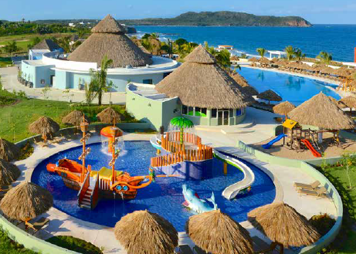

*(IBEROSTAR Playa Mita Splash Park in Riviera Nayarit, Mexico)*

Despite the never ending cold temperatures, summer is coming up faster than we think, so why not enjoy a family vacation with a little extra savings? IBEROSTAR Hotels & Resorts is offering a [**kids stay free**](http://www.iberostar.com/en/kids-stay-free) promotion at select all-inclusive resorts in Mexico and the Caribbean. Spend quality time with your children at IBEROSTAR Playa Mita’s picturesque beaches and Splash Park this summer. Or experience the untouched beauty of the Dominican Republic, where IBEROSTAR’s hotels offer unparalleled amenities and plenty of family friendly activities.

When sharing a room with two adults paying full price, you can enjoy a free stay for your child at select properties.This promotion is valid when booked **now through April 30, 2015** for travel from May 1 to August 15, 2015. Book your reservations through your preferred travel agent or operator, or by calling 888-923-2722 or visiting [www.iberostar.com](http://www.iberostar.com). Offer can be combined with other promotions— based upon availability and only valid for U.S. residents.

IBEROSTAR Hotels & Resorts currently offers 16 family-friendly properties in Mexico and the Caribbean. At IBEROSTAR, families will discover a wide spectrum of exciting and engaging activities to fill up their days. Parents can enjoy a relaxing day at the beach or indulge at the on-site SPA, as young travelers make friends at the specialty Kids Club and the Splash Park or enjoy video games at the Teen Club. There’s never a dull moment!

**“Kids Stay Free” is being offered at the following family resorts, considered among the best all-inclusives for kids:**

**VALID FOR TRAVEL FROM MAY 1, 2015 to AUGUST 15, 2015**

**Mexico:**

* **Maximum two kids 12 and under stay free for every two adults paying full price:**
* **IBEROSTAR Cozumel** (Cozumel, Mexico)
* **One child free for every two adults paying full price:** 
  + **IBEROSTAR Playa Mita** (Riviera Nayarit, Mexico)
  + **IBEROSTAR Paraíso Beach** (Riviera Maya, Mexico)
  + **IBEROSTAR Paraíso Del Mar** (Rivera Maya, Mexico)
  + **IBEROSTAR Tucán** (Playa del Carmen, Mexico)
  + **IBEROSTAR Quetzal** (Playa del Carmen, Mexico)
  + **IBEROSTAR Cancún** (Cancún, Mexico)
  + **IBEROSTAR Paraíso Lindo** (Riviera Maya, Mexico)
  + **IBEROSTAR Paraíso Maya** (Riviera Maya Mexico)

**Dominican Republic:**

* **One child free for every two adults paying full price:**
* **IBEROSTAR Punta Cana** (Punta Cana, Dominican Republic)
* **IBEROSTAR Dominicana** (Punta Cana, Dominican Republic)
* **IBEROSTAR Costa Dorada** (Puerto Plata, Dominican Republic)
* **IBEROSTAR Bávaro** (Punta Cana, Dominican Republic)
* **IBEROSTAR Hacienda Dominicus** (Bayahibe, Dominican Republic)

**Jamaica:**

* **One child free for every two adults paying full price:** 
  + **IBEROSTAR Rose Hall Suites** (Montego Bay, Jamaica)
  + **IBEROSTAR Rose Hall Beach** (Montego Bay, Jamaica)

**About IBEROSTAR Hotels & Resorts**

IBEROSTAR Hotels & Resorts is a resort hotel chain based in Palma de Mallorca (Balearic Islands, Spain), founded by the Fluxà family in 1986. IBEROSTAR Hotels & Resorts is an integral part of GRUPO IBEROSTAR, one of the main Spanish tourist companies with over 80 years of experience, which currently has more than 100 hotels in 16 countries around the world. For more information, please visit [iberostar.com](http://www.iberostar.com/).