PRESS RELEASE

IBEROSTAR HOTELS & RESORTS ANNOUNCES RENOVATION PROJECTS IN THE MEDITERRANEAN

- IBEROSTAR Hotels & Resorts is carrying out a number of renovation projects throughout 2015, which are designed to bring all of its hotels up to the superb standards of quality the company is renowned for.

- The IBEROSTAR Royal Cristina in Palma de Mallorca will boast 400 fully-refurbished rooms. IBEROSTAR Royal Cristina is the second hotel to be renovated by the chain in Playa de Palma, following the reopening of the IBEROSTAR Royal Cupido in 2010.

- The IBEROSTAR Diar El Andalous in Tunisia will also be renovated in order to bring it up to 5 star status.
Madrid, May 25, 2015 - IBEROSTAR Hotels & Resorts will be carrying out a series of renovation projects in a number of its hotels during the course of 2015, in an effort to further consolidate its undisputed position at the forefront of the tourism industry.

In order to maintain the superb standards of quality for which the company is renowned, IBEROSTAR has embarked on a project to upgrade the IBEROSTAR Royal Cristina, situated in Playa de Palma (Majorca). The company invested over 16 million USD in renovating the hotel and is committed to guaranteeing its guests’ complete satisfaction. The company has carried out exhaustive renovation work on the existing 330 rooms, while adding 70 new rooms. Improvements have also been made to the pool area by adding a terrace and jacuzzi fit for 16 people. The sun terrace has also been completely remodelled.

Other work includes the renovation of the Spa Zone, which now boasts a brand new semi-Olympic swimming pool. The fitness room has been refitted and a cycling area has been created, offering top quality individual bicycle cages and a cleaning and repair zone, making the hotel the ideal choice for cyclists.

The main restaurant and buffet have been modernised in order to incorporate the Iberostarchef concept into the hotel, offering all guests outstanding gastronomy. Additionally, as part of its commitment to providing a range of quality services, the IBEROSTAR Royal Cristina now has a new Cooking Classroom offering courses tailored to suit the tastes of all guests.

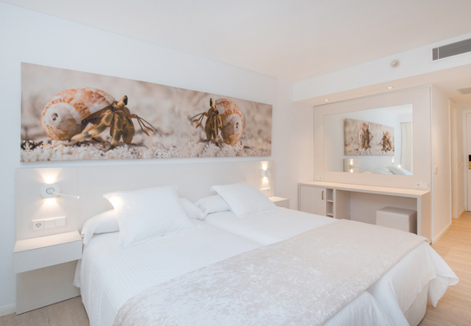
IBEROSTAR aims to guarantee a great vacation experience for all family members, therefore the company has renovated the children’s pool, the outdoor stage, and has created a new entertainment area for its younger guests. Furthermore, there is a Star Shop selling a wide range of the chain’s products, designed for guests of all ages.

The IBEROSTAR Royal Cristina boasts a prime location about a half mile from Playa de Palma beach and about nine miles from the heart of the city. The hotel offers a wide range of products and services making it the perfect destination for a fun-filled family vacation. Guests can make the most of a wide variety of water activities, outdoor sports and a fully equipped spa & wellness zone.

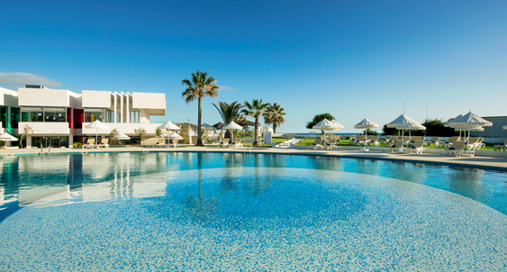
Internationally, the company has also carried out extensive renovation work on the IBEROSTAR Diar El Andalous in Tunisia. Following completion of this work, the hotel now boasts 5 star status, bringing the number of IBEROSTAR hotels in this category in the country to three. The renovation included the refurbishment of 301 rooms and the addition of 82 rooms. The project also included the complete renovation of the lobby, the creation of three new specialities restaurants and a Spa Center featuring a hammam.

These projects are aligned with the company’s strategy of renewing its hotels in order to ensure they fully meet all its guests’ needs and expectations.

About IBEROSTAR Hotels & Resorts

IBEROSTAR Hotels & Resorts is a resort hotel chain based in Palma de Mallorca (Balearic Islands, Spain), founded by the Fluxà family in 1986. IBEROSTAR Hotels & Resorts is an integral part of GRUPO IBEROSTAR, one of the main Spanish tourist companies with over 80 years of experience, which currently has more than 100 hotels of 4 and 5 stars in 16 countries around the world.

For more information visit: http://www.iberostar.com/

IBEROSTAR Press – Edelman
Tel: +1 (212) 738-6102
Diana Beard (diana.beard@edelman.com)

