PRESS RELEASE

IBEROSTAR HOTELS & RESORTS OPENS IBEROSTAR CALA MILLOR IN MAJORCA

- The 4-star IBEROSTAR Cala Millor opened on May 1, 2015 becoming the fourteenth hotel operated by IBEROSTAR on Majorca (Spain).
- The hotel was completely renovated prior to its opening and is owned by tennis star Rafael Nadal.

- The new hotel is situated just a short distance from the specially protected nature area of Punta de n’Amer and boasts 171 rooms, further consolidating Majorca’s position as a key destination in the chain’s portfolio.

Palma de Mallorca, May 15, 2015. - On May 1, 2015 IBEROSTAR Hotels & Resorts opened the IBEROSTAR Cala Millor hotel, situated on the east coast of the island of Majorca. As part of the chain’s Premium category, the hotel provides a full range of facilities and services, guaranteeing a complete holiday experience for couples and families.
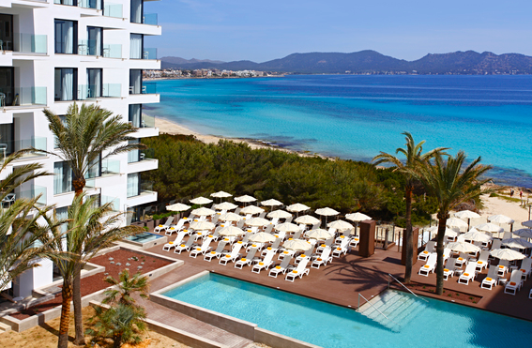
This recent opening brings the total number of hotels operated by IBEROSTAR on Majorca to 14, furthering its offerings on the island, as a part of the chain’s strategy to boost its presence in the destinations it already operates in.

One of the key attractions of this hotel is its prime location. Situated just a short distance from the specially protected nature area of Punta de n’Amer, the hotel stands on the seafront and offers stunning sea views as well as a variety of sports and leisure activities.

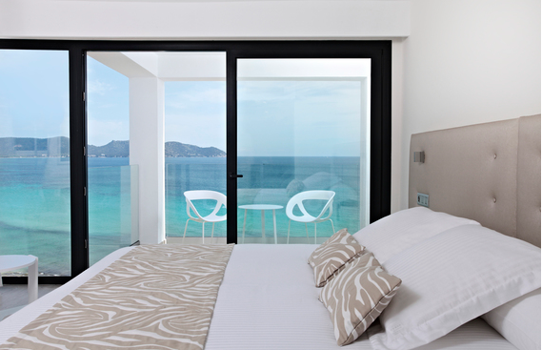
The IBEROSTAR Cala Millor boasts 171 rooms of various types which each include a terrace or balcony, telephone, air conditioning and satellite TV. Guests of the hotel can enjoy a wide range of services including the fitness room, a range of water sports within easy reach of the hotel, a Miniclub (for children ages 4 to 12), and a golf course located just a couple miles away.

Facilities at the new hotel include a buffet restaurant, snack bar, outdoor pool with a sun terrace and a spa with a wet zone, which offers various choices of relaxing treatments and massages.

Aurelio Vázquez, the CEO for EMEA GRUPO IBEROSTAR stated, “The IBEROSTAR Cala Millor furthers our offerings on Majorca and our commitment to the island, a destination that plays a key role in the company’s commercial strategy. It is also further proof of our commitment to consistently offer only the best quality products in the finest locations.”

The new IBEROSTAR hotel is part of the chain’s Premium category, made up of four and five star establishments providing couples and families the chance to enjoy a fabulous range of entertainment, leisure and gastronomy options.

Note for the editor: Photos of the new IBEROSTAR Cala Millor hotel can be downloaded from the following link

About IBEROSTAR Hotels & Resorts

IBEROSTAR Hotels & Resorts is a resort hotel chain based in Palma de Mallorca (Balearic Islands, Spain), founded by the Fluxà family in 1986. IBEROSTAR Hotels & Resorts is an integral part of GRUPO IBEROSTAR, one of the main Spanish tourist companies with over 80 years of experience, which currently has more than 100 hotels of 4 and 5 stars in 16 countries around the world.

For more information visit: http://www.iberostar.com/

IBEROSTAR Press – Edelman
Tel: +1 (212) 738-6102
Diana Beard (diana.beard@edelman.com)

