IBEROSTAR HOTELS & RESORTS CONGRATULATES ÁNGEL LEÓN ON SECOND MICHELIN STAR ACCOLADE AND WELCOMES HIM TO THEIR INTERNATIONAL CULINARY TOUR

- Ángel León was recently awarded his second Michelin star and will be the next chef participating in the Iberostarchef on Tour. This December, he will prepare three exclusive dinner experiences at IBEROSTAR hotels in the Caribbean and Mexico.

- Iberostarchef on Tour kicked off in November with renowned 2 Michelin-starred chef, Dani García, who created three exclusive dinners in Mexico, the Dominican Republic and Cuba with more than 250 guests in attendance.

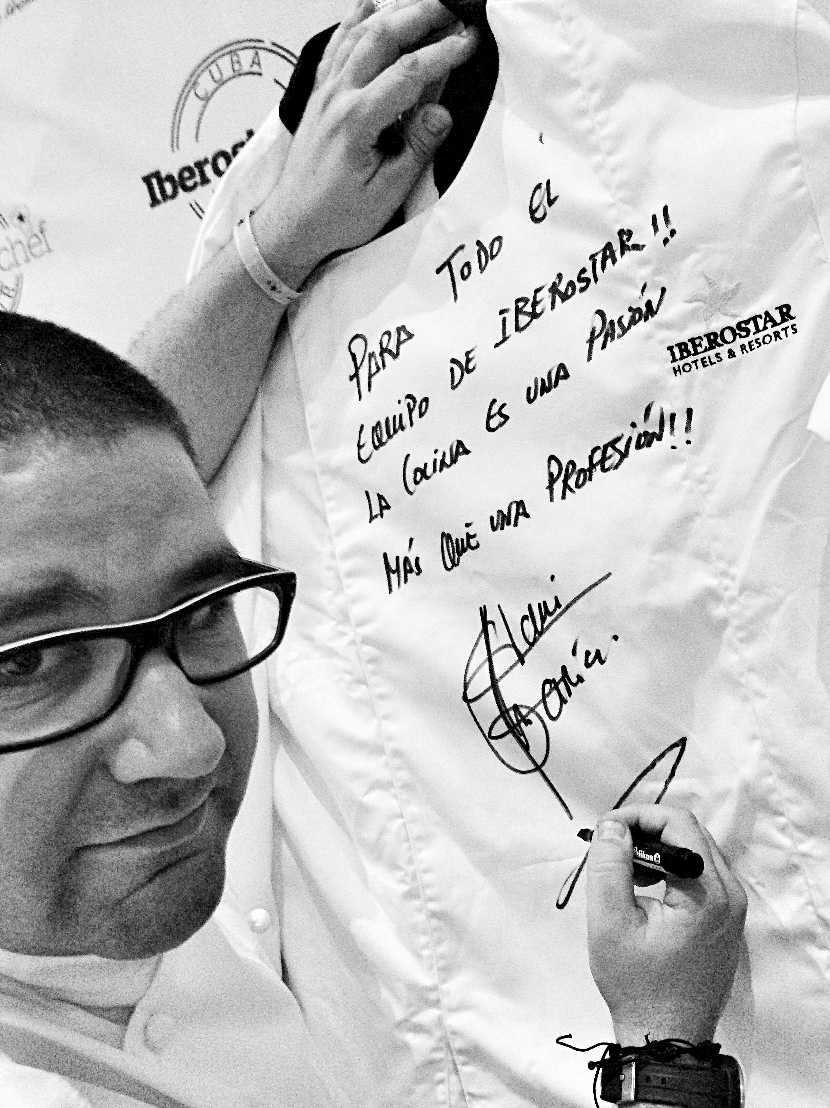
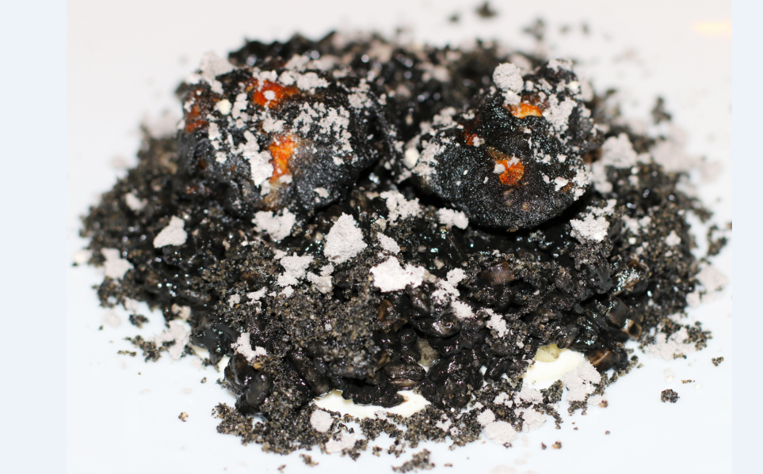

Madrid, December 1, 2014. As part of IBEROSTAR Hotels & Resorts yearlong “IberostarChef on Tour” program, they have enlisted star chef, Ángel León, who most recently was awarded his second Michelin star. Further enhancing their competitive edge in the all-inclusive marketplace, the Spanish hospitality brand is determined to showcase their commitment to gastronomy by continuously bringing forward the finest Spanish cuisine to its clients worldwide.
Together, IBEROSTAR and Ángel León will offer three exclusive dinners with a specially designed menu for guests in the Dominican Republic (December 4th), Cuba (December 9th) and Mexico (December 13th), all through the international culinary tour.
Guests will be able to enjoy an superb menu designed especially by Ángel León, including dishes such as chistorra and fish butifarra, anchovy empanadilla, squid egg emulsion, sea plankton rice, glazed oily fish belly, and milk and biscuits.
IberostarChef on Tour consists of 30 exclusive dinners, where 16 of Spain’s top Michelin-starred chefs prepare delicious and memorable meal experiences for guests at a selection of IBEROSTAR’s 5-star hotels in Mexico (Riviera Maya), the Dominican Republic (Punta Cana), Cuba (La Habana) and Spain (Mallorca and the Canary Islands).
The program had a successful kickoff in November with Dani García, a 2 Michelin-starred chef, where three exclusive dinner events took place with more than 250 guests in attendance at IBEROSTAR Grand Hotel Bávaro (Punta Cana, the Dominican Republic), IBEROSTAR Parque Central (La Habana, Cuba) and IBEROSTAR Grand Hotel Paraíso (Riviera Maya, Mexico).
The exquisite menu was curated by Dani García and featured sweet and savory options such as one bite muffins, oxtail ravioli with creamy potatoes and truffles, passion fruit yogurt, tocino de cielo (custard dessert) and osmosized pineapple.
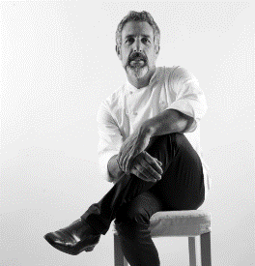
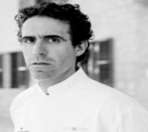
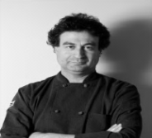
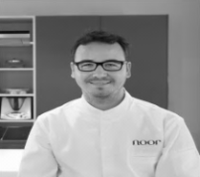
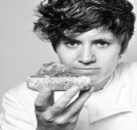
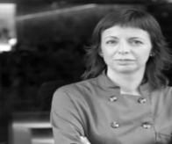
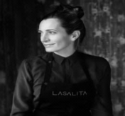

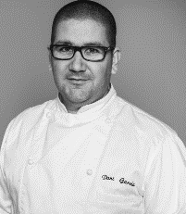
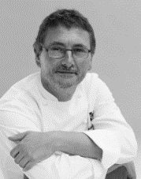
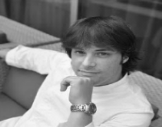
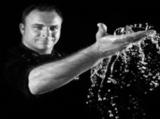
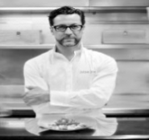
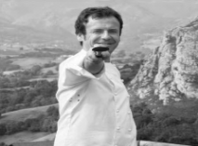
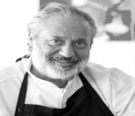
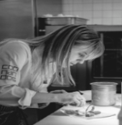
The 16 renowned chefs who are participating in this unique tour experience include: Dani García**, Ángel León**, Quique Dacosta***, Andoni Aduriz**, Nacho Manzano**, Manolo de la Osa*, Pepe Solla*, Fernando Pérez Arellano*, Jordi Cruz**, Pepe Rodríguez*, Paco Morales*, Fina Puigdevall**, Beatriz Sotelo*, Yolanda León*, Macarena de Castro* and Begoña Rodrigo “Spain’s Top Chef 2013.”
The site, iberostarchefontour.com, is available in both Spanish and English, and features detailed information about the culinary tour.
About IBEROSTAR Hotels & Resorts
IBEROSTAR Hotels & Resorts is a resort hotel chain based in Palma de Mallorca (Balearic Islands, Spain), founded by the Fluxà family in 1986. IBEROSTAR Hotels & Resorts is an integral part of GRUPO IBEROSTAR, one of the main Spanish tourist companies with over 80 years of experience, which currently has around 100 hotels across the world.
For more information, please visit iberostar.com.

IBEROSTAR Press Office
Edelman

Candace Meade (Candace.Meade@edelman.com)

Kellie Jelencovich (Kellie.Jelencovich@edelman.com)

Caitlin Galeotti (Caitlin.Galeotti@edelman.com)

Below is the complete IBEROSTAR Chef on Tour schedule:
CHEFS | CHEF TOUR | WHERE AND WHEN
DANI GARCÍA ** | November 2014 | Dominican Rep. – Oct. 31  Cuba – Nov. 4  Mexico – Nov. 8
ANGEL LEON ** | December 2014 | Dominican Rep. – Dec. 4  Cuba – Dec. 9  Mexico – Dec. 13
QUIQUE DACOSTA *** | January 2015 | Dominican Rep. – Jan. 16  Cuba – Jan. 20  Mexico – Jan. 24
ANDONI ADURIZ ** | February 2015 | Palma de Mallorca –Feb. 7
NACHO MANZANO ** | March 2015 | Dominican Rep. – Mar. 6  Cuba – Mar. 10  Mexico – Mar. 13
MANOLO DE LA OSA * | April 2015 | Dominican Rep. – Apr. 17  Cuba – Apr. 21  Mexico – Apr. 25
PEPE SOLLA * | May 2015 | Dominican Rep. – May 8  Cuba – May 12  Mexico – May 16
FERNANDO PÉREZ ARELLANO * | June 2015 | Dominican Rep. – May 29  Cuba – Jun. 2  Mexico – Jun. 6
JORDI CRUZ ** | July 2015 | Dominican Rep. – Jul. 10  Cuba – Jul. 14  Mexico – Jul. 18
PEPE RODRÍGUEZ * | August 2015 | Tenerife – TBC
PACO MORALES * | September 2015 | Palma de Mallorca – TBC
MUJERES CON ESTRELLA  Fina Puigdevall 2*  Beatriz Sotelo 1*  Yolanda León 1*  Macarena de Castro 1*  Begoña Rodrigo “Top Chef España 2013” | October 2015 | Dominican Rep. – Oct. 16  Cuba – Oct. 20  Mexico – Oct. 24

