**DOUBLE MICHELIN- STARRRED CHEF ÁNGEL LEÓN JOINS IBEROSTARCHEF ON TOUR**

* ***IBEROSTAR Hotels & Resorts will welcome Ángel León to cook in three different hotels in the Caribbean and Mexico in December***
* ***Iberostarchef on Tour, started in November this year, is an exclusive programme designed by the hotel chain, to bring Spanish fine dining to guests around the world hosted by prestigious Michelin-starred chefs***

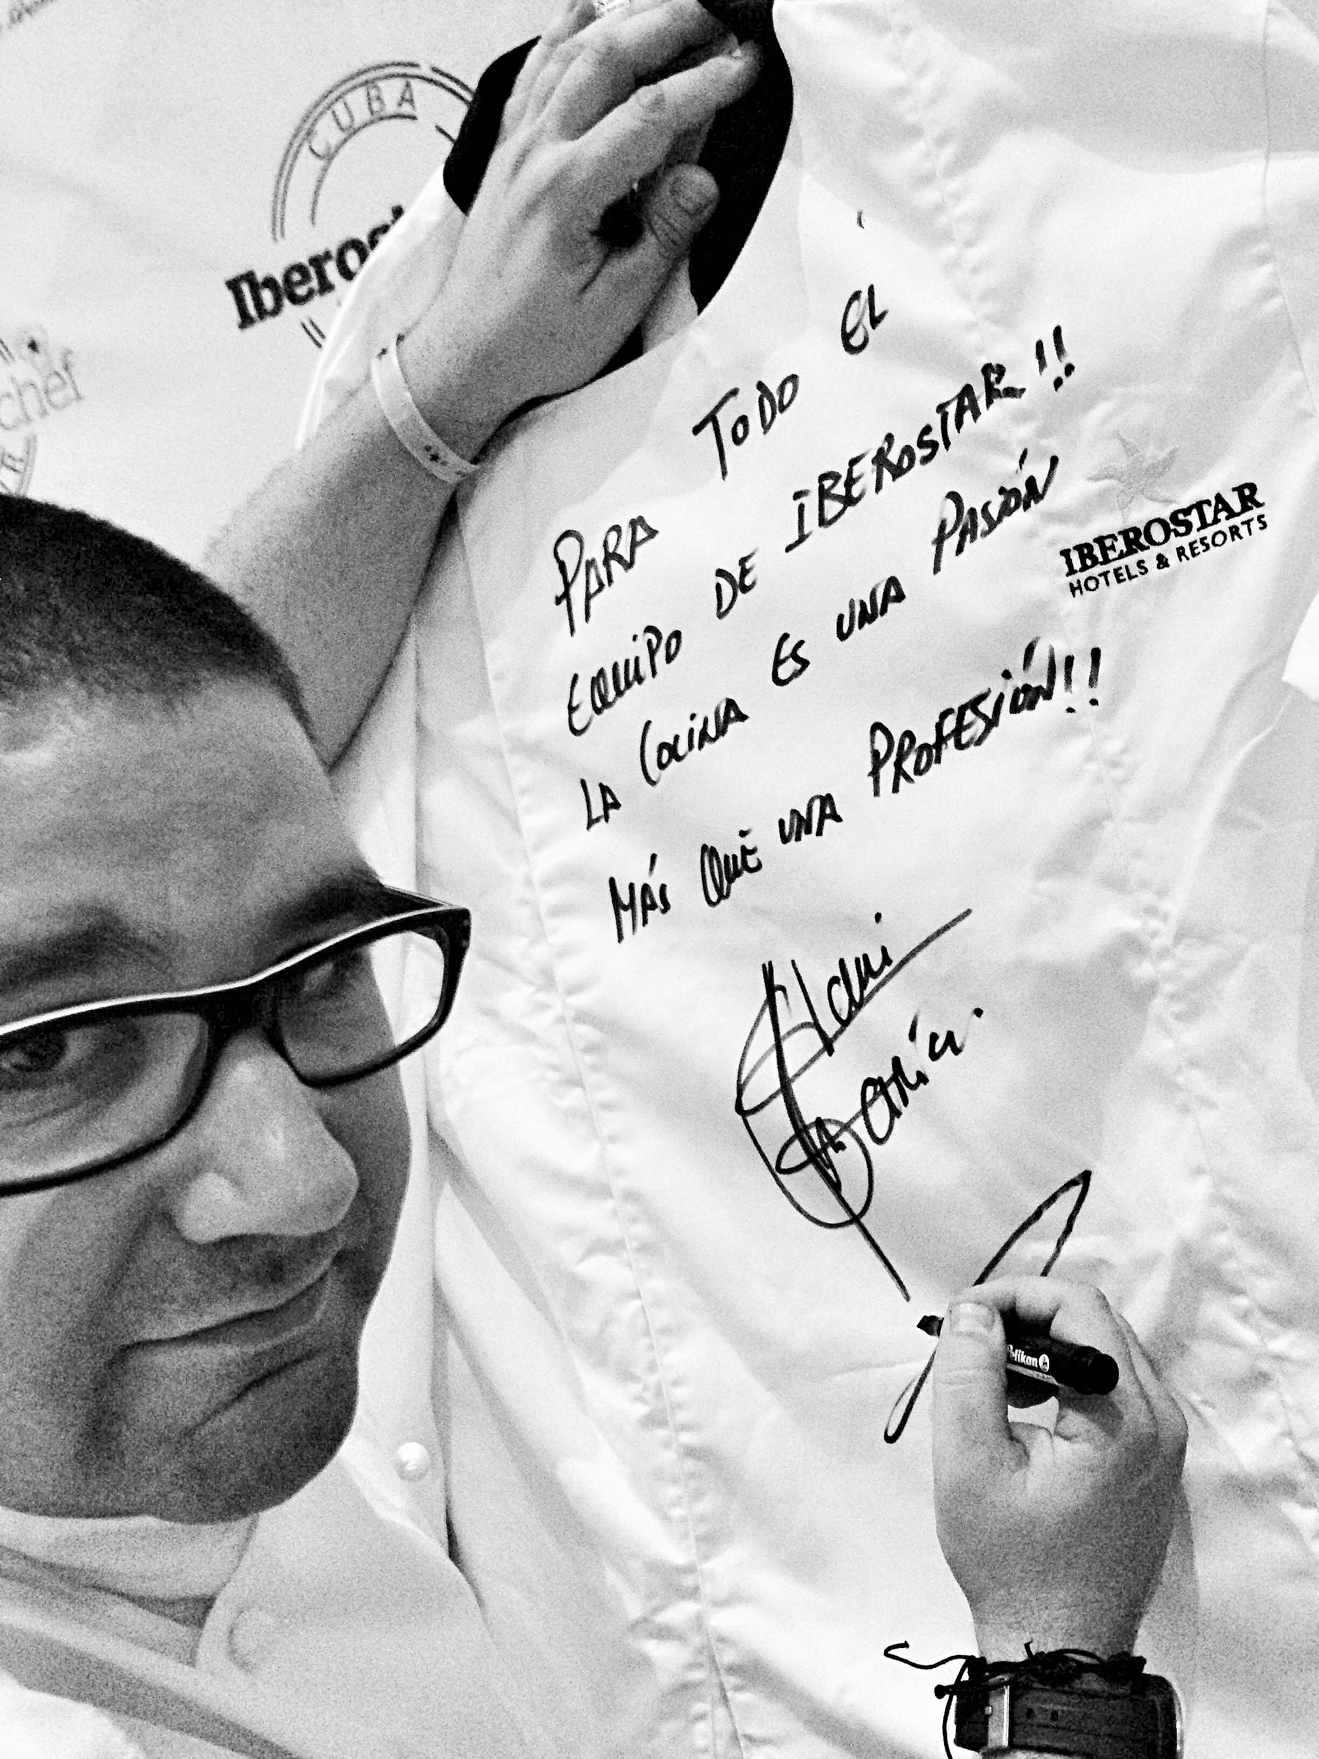***London, December 1, 2014.*** As part of Iberostarchef on Tour, renowned Spanish chef, **Ángel León**, who was recently awarded a second Michelin star, will be offering guests three exclusive dinners in the Caribbean and Mexico.

Iberostarchef on Tour is part of the hotel chain’s continued commitment to providing superb gastronomy and unique dining experiences for guests in Spain and destinations across the Caribbean. The programme consists of 30 exclusive dinners, with 16 of Spain’s top Michelin-starredchefs cooking for guests at a selection of **IBEROSTAR’S** 5-star hotels in **Mexico** (Riviera Maya), **the Dominican Republic** (Punta Cana), **Cuba** (La Habana) and **Spain** (Mallorca and the Canary Islands).

The programme began in November with Dani García, two Michelin-starred chef, who served three dinners at the **IBEROSTAR Grand Hotel Bávaro** (Punta Cana, the Dominican Republic), **IBEROSTAR Parque Central** (La Habana, Cuba) and **IBEROSTAR Grand Hotel Paraíso** (Riviera Maya, Mexico).

With exquisite dishes on the menu such as oxtail ravioli with creamy potatoes and truffles, as well as passion fruit yogurt, tocino de cielo (a custard dessert) and osmosized pineapple, over 250 guests enjoyed Dani’s exclusive menu.

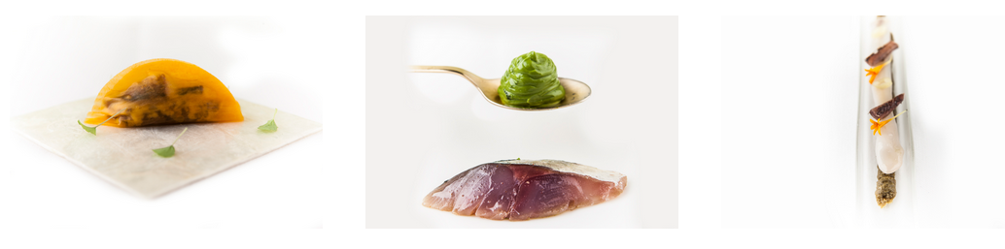

Ángel León will bring his culinary style to the Dominican Republic (December 4th), Cuba (December 9th) and Mexico (December 13th).

Ángel León, known as Chef of the Sea and winner of the 2012 National Gastronomical Prize, has devised an innovative menu exclusive to Iberostarchef on Tour:

* Chistorra and fish butifarra (sausage)
* Anchovy empanadilla, anchovies in vinegar and alioli (garlic mayonnaise) / smoked sardines on olive stones
* Squid egg emulsion
* Sea plankton rice
* Glazed oily fish belly
* Milk and biscuits

The 16 renowned chefs who are participating in this unique experience are **Dani García**\*\***, Ángel León**, Quique Dacosta***, Andoni Aduriz**, Nacho Manzano**, Manolo de la Osa*, Pepe Solla*, Fernando Pérez Arellano*, Jordi Cruz**, Pepe Rodríguez*, Paco Morales*, Fina Puigdevall**, Beatriz Sotelo*, Yolanda León*, Macarena de Castro* and Begoña Rodrigo “Spain’s Top Chef 2013.”**

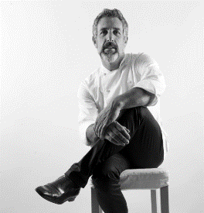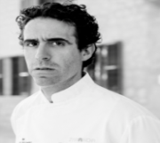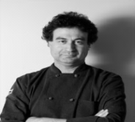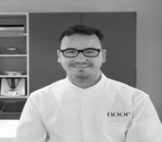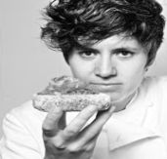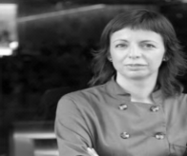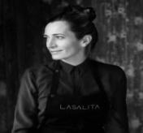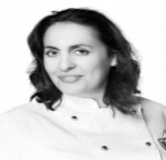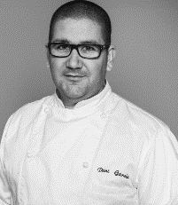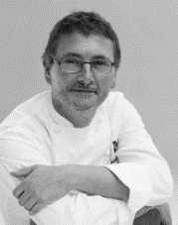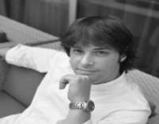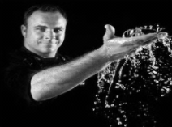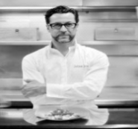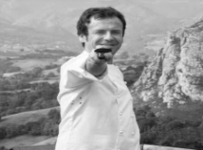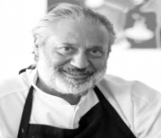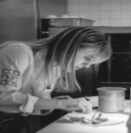

For further details, including a full schedule for the culinary tour, please visit [www.*iberostarchefontour.com*](http://www.iberostarchefontour.com)

**About IBEROSTAR Hotels & Resorts**

IBEROSTAR Hotels & Resorts is a resort hotel chain based in Palma de Mallorca (Balearic Islands, Spain), founded by the Fluxá family in 1986. IBEROSTAR Hotels & Resorts is an integral part of GRUPO IBEROSTAR, one of the main Spanish tourist companies with over 80 years of experience, which currently has around 100 around the world.

**For more information:** iberostar.com

IBEROSTAR Press Office

Edelman London

Tel: +44 203 047 4035

Nicole Taylor ([Nicole.taylor@edelman.com](mailto:Nicole.taylor@edelman.com))

Leah Pummell ([leah.pummell@edelman.com](mailto:leah.pummell@edelman.com)

To follow is the complete ***IBEROSTAR Chef on Tour*** schedule:

|  |  |  |
| --- | --- | --- |
| **CHEFS** | **CHEF TOUR** | **WHERE AND WHEN** |
| **DANI GARCÍA \*\*** | November 2014 | Dominican Rep. – Oct. 31  Cuba – Nov. 4  Mexico – Nov. 8 |
| **ANGEL LEON \*\*** | December 2014 | Dominican Rep. – Dec. 4  Cuba – Dec. 9  Mexico – Dec. 13 |
| **QUIQUE DACOSTA \*\*\*** | January 2015 | Dominican Rep. – Jan. 16  Cuba – Jan. 20  Mexico – Jan. 24 |
| **ANDONI ADURIZ \*\*** | February 2015 | Palma de Mallorca –Feb. 7 |
| **NACHO MANZANO \*\*** | March 2015 | Dominican Rep. – Mar. 6  Cuba – Mar. 10  Mexico – Mar. 13 |
| **MANOLO DE LA OSA \*** | April 2015 | Dominican Rep. – Apr. 17  Cuba – Apr. 21  Mexico – Apr. 25 |
| **PEPE SOLLA \*** | May 2015 | Dominican Rep. – May 8  Cuba – May 12  Mexico – May 16 |
| **FERNANDO PÉREZ ARELLANO \*** | June 2015 | Dominican Rep. – May 29  Cuba – Jun. 2  Mexico – Jun. 6 |
| **JORDI CRUZ \*\*** | July 2015 | Dominican Rep. – Jul. 10  Cuba – Jul. 14  Mexico – Jul. 18 |
| **PEPE RODRÍGUEZ \*** | August 2015 | Tenerife – TBC |
| **PACO MORALES \*** | September 2015 | Palma de Mallorca – TBC |
| **MUJERES CON ESTRELLA**  Fina Puigdevall 2*  Beatriz Sotelo 1*  Yolanda León 1*  Macarena de Castro 1*  Begoña Rodrigo “Top Chef España 2013” | October 2015 | Dominican Rep. – Oct. 16  Cuba – Oct. 20  Mexico – Oct. 24 |