**MICHELIN STAR CHEFS ASSEMBLE FOR INTERNATIONAL TOUR OF IBEROSTAR**

* **IBEROSTAR Chef on Tour *is the new exclusive program designed by the hotel chain, to bring Spanish fine dining to guests around the world by offering a unique experience of the highest quality at the hands of 16 prestigious Michelin-starred chefs***
* ***Over the course of the next 12 months, IBEROSTAR will organise a total of 30 dinners with different chefs at 5-star hotels in Mexico, the Dominican Republic, Cuba and Spain***

***London October 22, 2014.* IBEROSTAR Hotels & Resorts** has continued its commitment to gastronomy by bringing to life the finest in Spanish cuisine with the announcement of the ***IBEROSTAR Chef on Tour 2014 – 2015***.Featuring 30 exclusive dinners, 16 of Spain’s top Michelin-starredchefs will cook for guests at a selection of **IBEROSTAR’S** 5-star hotels in **Mexico** (Riviera Maya), **the Dominican Republic** (Punta Cana),Cuba (La Habana) and **Spain** (Mallorca and the Canary Islands).

The 16 renowned chefs who will participate in this unique experience are **Dani García**\*\***, Ángel León*, Quique Dacosta***, Andoni Aduriz**, Nacho Manzano**, Manolo de la Osa*, Pepe Solla*, Fernando Pérez Arellano*, Jordi Cruz**, Pepe Rodríguez*, Paco Morales*, Fina Puigdevall**, Beatriz Sotelo*, Yolanda León*, Macarena de Castro* and Begoña Rodrigo “Spain’s Top Chef 2013.”**

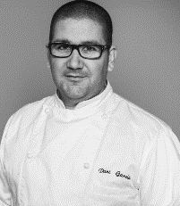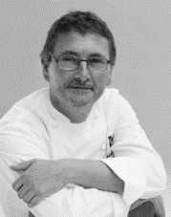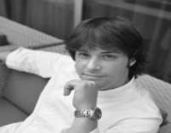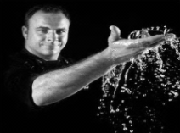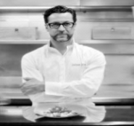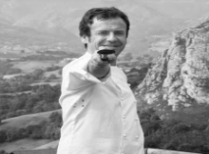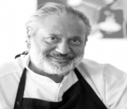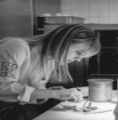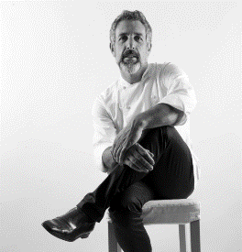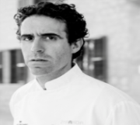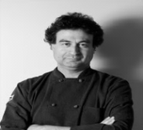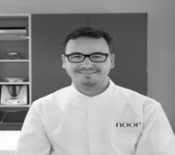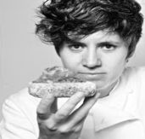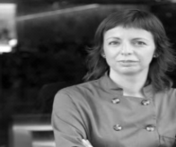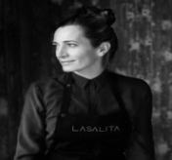

Beginning in **late 2014 and continuing through to 2015**, each of the **16 chefs** will travel to **IBEROSTAR’S** hotels and takeover the kitchens to create an exclusive menu tailored to each destination for the enjoyment of guests, who can sample the finest in Spanish cuisine with the accompaniment of exquisite international wines.

With this ambitious project, **IBEROSTAR** has strengthened its commitment to its culinary offering and unites the most talented chefs from Spain with the finest hotels in **IBEROSTAR’S** portfolio.

The Majorcan chain has also **designed a special website** where anyone who wants to enjoy this unique experience can learn more about the ***IBEROSTAR Chef on Tour***, including detail around the concept and tour dates: [iberostarchefontour.com](http://www.iberostarchefontour.com/en/)

***IBEROSTAR Chef on Tour*** has been developed under the umbrella of **Iberostarchef**, a seal of quality that encompasses all of the company’s culinary initiatives. Gastronomy is one of **IBEROSTAR’S** main pillars, in addition to treatment and entertainment.

**About IBEROSTAR Hotels & Resorts**

IBEROSTAR Hotels & Resorts is a resort hotel chain based in Palma de Mallorca (Balearic Islands, Spain), founded by the Fluxá family in 1986. IBEROSTAR Hotels & Resorts is an integral part of GRUPO IBEROSTAR, one of the main Spanish tourist companies with over 50 years of experience, which currently has around 100 around the world.

**For more information:** iberostar.com

IBEROSTAR Press Office

Edelman London

Tel: +44 203 047 4035

Nicole Taylor ([Nicole.taylor@edelman.com](mailto:Nicole.taylor@edelman.com))

Leah Pummell ([leah.pummell@edelman.com](mailto:leah.pummell@edelman.com))

***IBEROSTAR Chef on Tour*** schedule:

|  |  |  |
| --- | --- | --- |
| **CHEFS** | **CHEF TOUR** | **WHERE AND WHEN** |
| **DANI GARCÍA \*\*** | November 2014 | IBEROSTAR Grand Hotel Bávaro, Dominican Rep. – Oct. 31  IBEROSTAR Parque Central, Cuba – Nov. 4  IBEROSTAR Grand Hotel Paraíso, Mexico – Nov. 8 |
| **ANGEL LEON \*** | December 2014 | IBEROSTAR Grand Hotel Bávaro, – Dec. 5  IBEROSTAR Parque Central – Dec. 9  IBEROSTAR Grand Hotel Paraíso – Dec. 13 |
| **QUIQUE DACOSTA \*\*\*** | January 2015 | IBEROSTAR Grand Hotel Bávaro – Jan. 16  IBEROSTAR Parque Central – Jan. 20  IBEROSTAR Grand Hotel Paraíso – Jan. 24 |
| **ANDONI ADURIZ \*\*** | February 2015 | Palma de Mallorca – TBC |
| **NACHO MANZANO \*\*** | March 2015 | IBEROSTAR Grand Hotel Bávaro – Mar. 6  IBEROSTAR Parque Central – Mar. 10  IBEROSTAR Grand Hotel Paraíso – Mar. 13 |
| **MANOLO DE LA OSA \*** | April 2015 | IBEROSTAR Grand Hotel Bávaro – Apr. 17  IBEROSTAR Parque Central – Apr. 21  IBEROSTAR Grand Hotel Paraíso – Apr. 25 |
| **PEPE SOLLA \*** | May 2015 | IBEROSTAR Grand Hotel Bávaro – May 8  IBEROSTAR Parque Central – May 12  IBEROSTAR Grand Hotel Paraíso – May 16 |
| **FERNANDO PÉREZ ARELLANO \*** | June 2015 | IBEROSTAR Grand Hotel Bávaro – May 29  IBEROSTAR Parque Central – Jun. 2  IBEROSTAR Grand Hotel Paraíso – Jun. 6 |
| **JORDI CRUZ \*\*** | July 2015 | IBEROSTAR Grand Hotel Bávaro – Jul. 10  IBEROSTAR Parque Central – Jul. 14  IBEROSTAR Grand Hotel Paraíso – Jul. 18 |
| **PEPE RODRÍGUEZ \*** | August 2015 | Tenerife – TBC |
| **PACO MORALES \*** | September 2015 | Palma de Mallorca – TBC |
| **MUJERES CON ESTRELLA**  Fina Puigdevall 2*  Beatriz Sotelo 1*  Yolanda León 1*  Macarena de Castro 1*  Begoña Rodrigo “Spain’s Top Chef 2013” | October 2015 | IBEROSTAR Grand Hotel Bávaro – Oct. 16  IBEROSTAR Parque Central – Oct. 20  IBEROSTAR Grand Hotel Paraíso – Oct. 24 |