MEDIA CONTACTS:

Michelle Sobhraj
Edelman
212-704-8156
michelle.sobhraj@edelman.com

SIXTEEN MICHELIN-STARRED CHEFS GATHER FOR
IBEROSTAR HOTELS & RESORTS INTERNATIONAL CULINARY TOUR

Year-long “IBEROSTAR Chef on Tour” Program will Offer Thirty Dinners with Prestigious Chefs at Properties in Mexico, Dominican Republic, and Spain
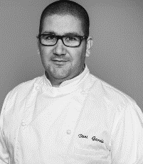
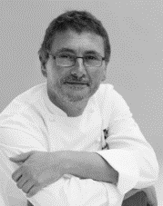


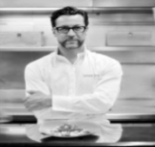
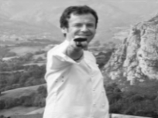
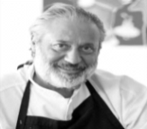
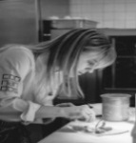
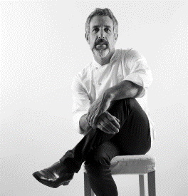
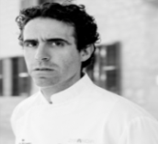
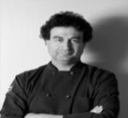
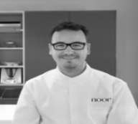
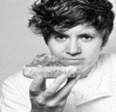
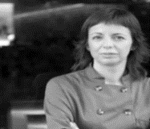
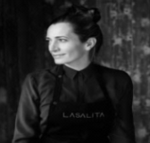


Madrid, Spain (October 22, 2014) – The Spanish hospitality brand looks to further enhance its competitive edge in the all-inclusive marketplace with the introduction of “IBEROSTAR Chef on Tour,” an initiative focused on sharing IBEROSTAR Hotels & Resorts’ indigenous Spanish-style cuisine with guests around the world. Kicking-off this month, the tour is comprised of 16 internationally-recognized chefs who collectively hold 22 Michelin Stars. Over the course of 12 months, IBEROSTAR will organize a total of 30 dinners with the various chefs in five-star properties across Mexico (Riviera Maya), the Dominican Republic (Punta Cana), and Spain (Mallorca and Tenerife).

The 16 renowned chefs participating are as follows (with Michelin Star annotation): Dani García**, Ángel León*, Quique Dacosta***, Andoni Aduriz**, Nacho Manzano**, Manolo de la Osa*, Pepe Solla*, Fernando Pérez Arellano*, Jordi Cruz**, Pepe Rodríguez*, Paco Morales*, Fina Puigdevall**, Beatriz Sotelo*, Yolanda León*, Macarena de Castro* and Begoña Rodrigo, voted “Spain’s Top Chef 2013.”

Beginning in late 2014 and continuing through 2015, each of the 16 chefs will travel to IBEROSTAR’S luxury resorts to create an exclusive menu tailored to each destination for the enjoyment of guests, who can sample the finest in Spanish cuisine with the accompaniment of the most exquisite international wines.
BEROSTAR Hotels & Resorts has also designed iberostarchefontour.com, where consumers interested in this unique experience can access any of the IBEROSTAR Chef on Tour dates as well as detailed information about the culinary tour.

With this project, IBEROSTAR has strengthened its commitment to its culinary offering and unites the most talented chefs from Spain with the finest hotels in IBEROSTAR’S portfolio.
IBEROSTAR Chef on Tour is developed under the umbrella of Iberostarchef, a seal of quality that encompasses all of the company’s culinary initiatives.
Below is the complete IBEROSTAR Chef on Tour schedule:
CHEFS | CHEF TOUR | WHERE AND WHEN
DANI GARCÍA ** | November 2014 | Dominican Rep. – Oct. 31  Cuba – Nov. 4  Mexico – Nov. 8
ANGEL LEON * | December 2014 | Dominican Rep. – Dec. 5  Cuba – Dec. 9  Mexico – Dec. 13
QUIQUE DACOSTA *** | January 2015 | Dominican Rep. – Jan. 16  Cuba – Jan. 20  Mexico – Jan. 24
ANDONI ADURIZ ** | February 2015 | Palma de Mallorca – TBC
NACHO MANZANO ** | March 2015 | Dominican Rep. – Mar. 6  Cuba – Mar. 10  Mexico – Mar. 13
MANOLO DE LA OSA * | April 2015 | Dominican Rep. – Apr. 17  Cuba – Apr. 21  Mexico – Apr. 25
PEPE SOLLA * | May 2015 | Dominican Rep. – May 8  Cuba – May 12  Mexico – May 16
FERNANDO PÉREZ ARELLANO * | June 2015 | Dominican Rep. – May 29  Cuba – Jun. 2  Mexico – Jun. 6
JORDI CRUZ ** | July 2015 | Dominican Rep. – Jul. 10  Cuba – Jul. 14  Mexico – Jul. 18
PEPE RODRÍGUEZ * | August 2015 | Tenerife – TBC
PACO MORALES * | September 2015 | Palma de Mallorca – TBC
MUJERES CON ESTRELLA  Fina Puigdevall 2*  Beatriz Sotelo 1*  Yolanda León 1*  Macarena de Castro 1*  Begoña Rodrigo “Top Chef España 2013” | October 2015 | Dominican Rep. – Oct. 16  Cuba – Oct. 20  Mexico – Oct. 24

About IBEROSTAR Hotels & Resorts
IBEROSTAR Hotels & Resorts is a resort hotel chain based in Palma de Mallorca (Balearic Islands, Spain), founded by the Fluxà family in 1986. IBEROSTAR Hotels & Resorts is an integral part of GRUPO IBEROSTAR, one of the main Spanish tourist companies with over 50 years of experience, which currently has around 100 hotels across the world.

For more information, please visit iberostar.com.

###

