Media Contact:

Michelle Sobhraj

Edelman 212-704-8156

michelle.sobhraj@edelman.com

IBEROSTAR LAUNCHES “SUPERFAN IBEROSTAR” LOYALTY PROGRAM REWARDING REPEAT CLIENTS

First Superfan Surprise Kicks-off with Toni Nadal Visit

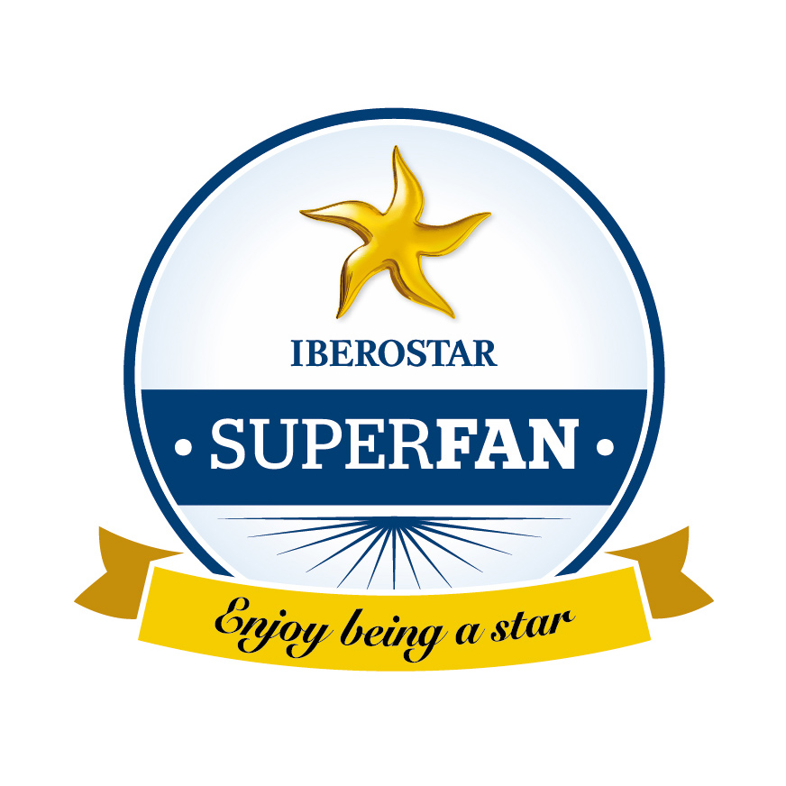
Madrid, Spain (July 31, 2014) – Today, IBEROSTAR Hotels & Resorts announced the debut of Superfan IBEROSTAR, which aims to thank and reward the loyalty of the Spanish hospitality chain's most devoted and special clients. The launch of this new initiative kicked off with Toni Nadal, world-recognized coach of tennis pro Rafael Nadal. Along with IBEROSTAR, the two forces joined to reward Ildefonso Sánchez, an 89-year-old guest who has enjoyed more than 25 vacations at the IBEROSTAR Royal Andalus in Spain, and who is also a self-proclaimed fan of Toni Nadal.

IBEROSTAR Hotels & Resorts has a 42% base of repeat clients with an average of three stays. From this group, a small portion exceeds twenty stays, and proves to be genuine ambassadors and friends of the brand. Superfan IBEROSTAR will honor these brand-loyal visitors with unique experiences including a reception with a private transfer upon arrival at the airport, an upgrade and exclusive VIP treatment. Among all those Superfan clients, IBEROSTAR will choose five of the most unique and incredible stories related with the brand. In addition to the complimentary services, a day of surprise will be arranged for them, accommodating their personal tastes and interests.

“The Superfan IBEROSTAR initiative marks a crucial point in our commitment to our clients. We think it’s important to reward some of our most loyal guests and to return the affection that they have demonstrated to IBEROSTAR and all those who work here,” said Luis Hérault, Chief Marketing Officer at IBEROSTAR. “Our first Superfan is Ildefonso Sánchez, and more will be joining him over the next five years. To achieve this, we are working with our hotels around the world to identify clients who stand out with their loyalty and extraordinary gestures towards the brand."

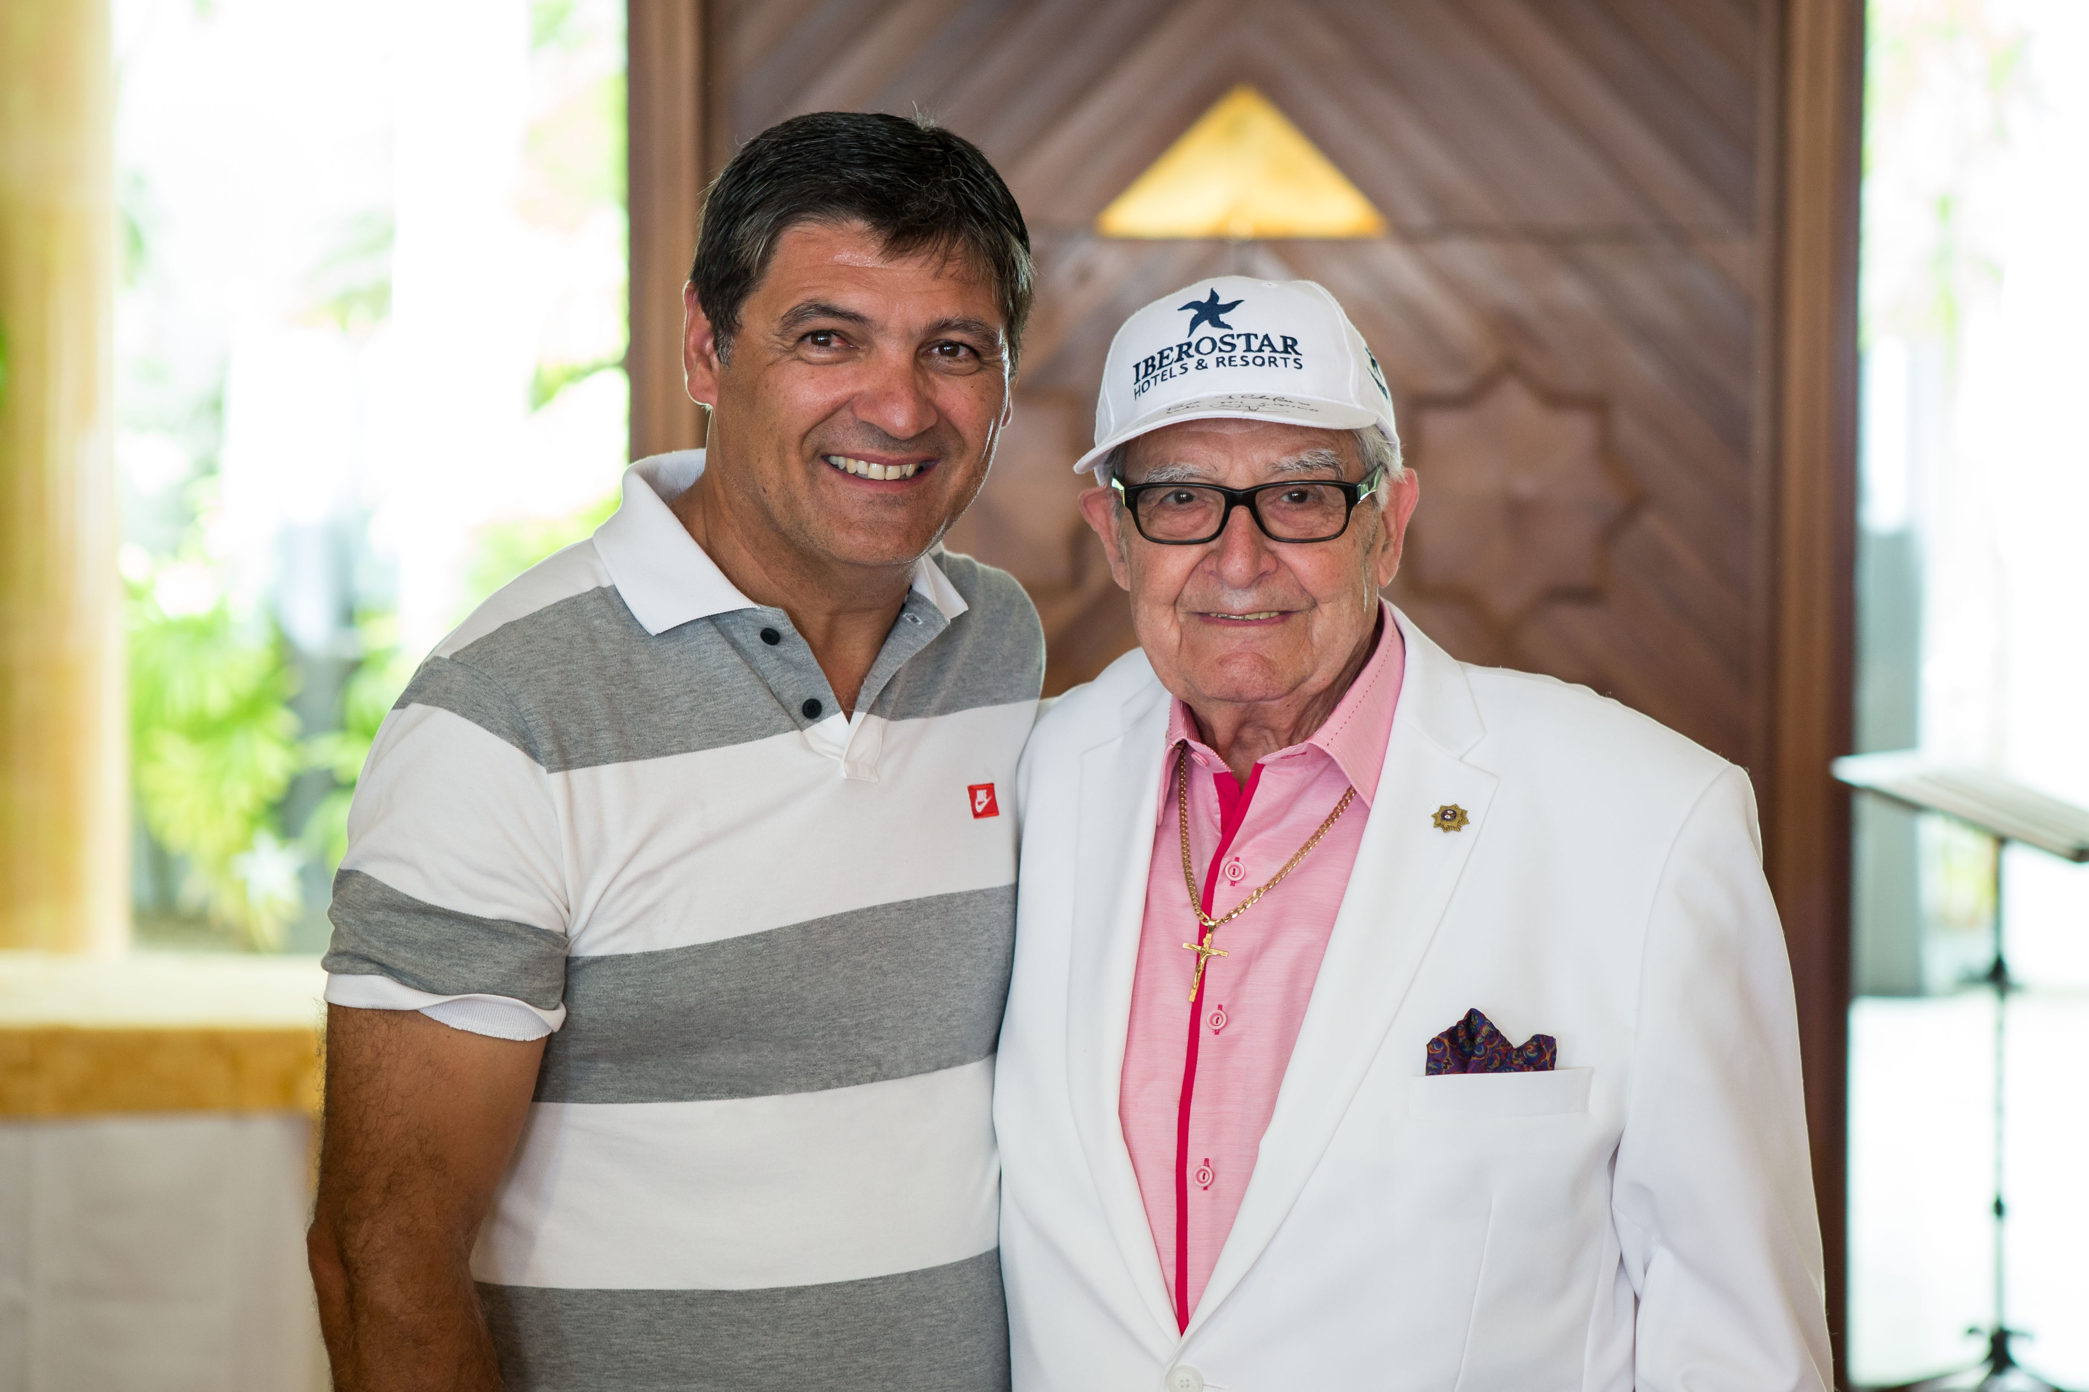

Every Christmas, Mr. Sánchez sends warm wishes to the IBEROSTAR staff, thanking them for their continued dedication to guest service. Overwhelmed by his support, the IBEROSTAR hotel manager gifted Mr. Sánchez with the iconic IBEROSTAR hat, identical to the item worn by Toni Nadal on the tennis court as part of an existing partnership with the brand. Earlier this year, Mr. Sánchez misplaced his iconic IBEROSTAR hat and wrote a letter to the CEO to share his upsetting loss. The rest is history with IBEROSTAR choosing Mr. Sánchez as the first Superfan IBEROSTAR with a series of surprises, which awaited him during his recent stay. His trip concluded in the ultimate moment—a meet and greet with Toni Nadal, where he gave Mr. Sánchez a newly-signed IBEROSTAR hat.

Following the success of the first Superfan IBEROSTAR, the company will continue the program and is currently working on selecting future candidates. Each surprise experience will be personalized based on the emotional connection that the Superfan IBEROSTAR has to the brand.

Note for the editor:
Via this link you can see a video with all the details of the new project and the tribute to Ildefonso Sánchez as the first Superfan IBEROSTAR.

About IBEROSTAR Hotels & Resorts
IBEROSTAR Hotels & Resorts is a family-owned Spanish hospitality company with more than 50 years of experience in the travel industry. IBEROSTAR provides unique vacation experiences, rooted in superior customer service and quality, in the world’s most popular vacation destinations. With around 100 hotels in 13 countries, IBEROSTAR Hotels & Resorts is committed to offering excellence in quality and service and providing personal attention to each guest. For more information, please visit iberostar.com.

###

