PRESS RELEASE

IBEROSTAR HONOURS ITS MOST LOYAL GUESTS

- IBEROSTAR Hotels & Resorts has developed a new initiative, Superfan IBEROSTAR, which aims to reward the allegiance of the chain's most loyal and special guests

- IBEROSTAR Hotels & Resorts has a 42% base of repeat guests, each of whom on average stay more than three times

- Ildefonso Sánchez, an 89-year-old Spanish ex-pat who has stayed at the IBEROSTAR Royal Andalus more than 25 times, was the first Superfan to be rewarded, which culminated in a surprise visit by tennis coach Toni Nadal

London, 15 July 2014 - For IBEROSTAR Hotels & Resorts guest satisfaction and customer care is an absolute priority to not only ensure guests enjoy their stay, but to also encourage guests to book with them again and continue their great experience with the brand. The loyalty and positive comments received from hotel guests are the most rewarding for IBEROSTAR and testament to the standard of hospitality shown by the hotel chain.


In light of this loyalty, the hotel chain has a 42% repeat customer rate, IBEROSTAR has implemented Superfan IBEROSTAR, an initiative with the objective to identify, thank and reward these repeat customers by making their holiday a unique and personal experience. A reception with a private transfer upon arrival at the airport, an upgrade and exclusive VIP treatment are just a few examples of the special attention that the Superfan will receive. From the list of Superfans, IBEROSTAR will also identify five individuals who have unique and incredible stories related to the brand. In addition to the list of rewards these five, will receive a very special surprise day which takes into consideration their tastes and interests.
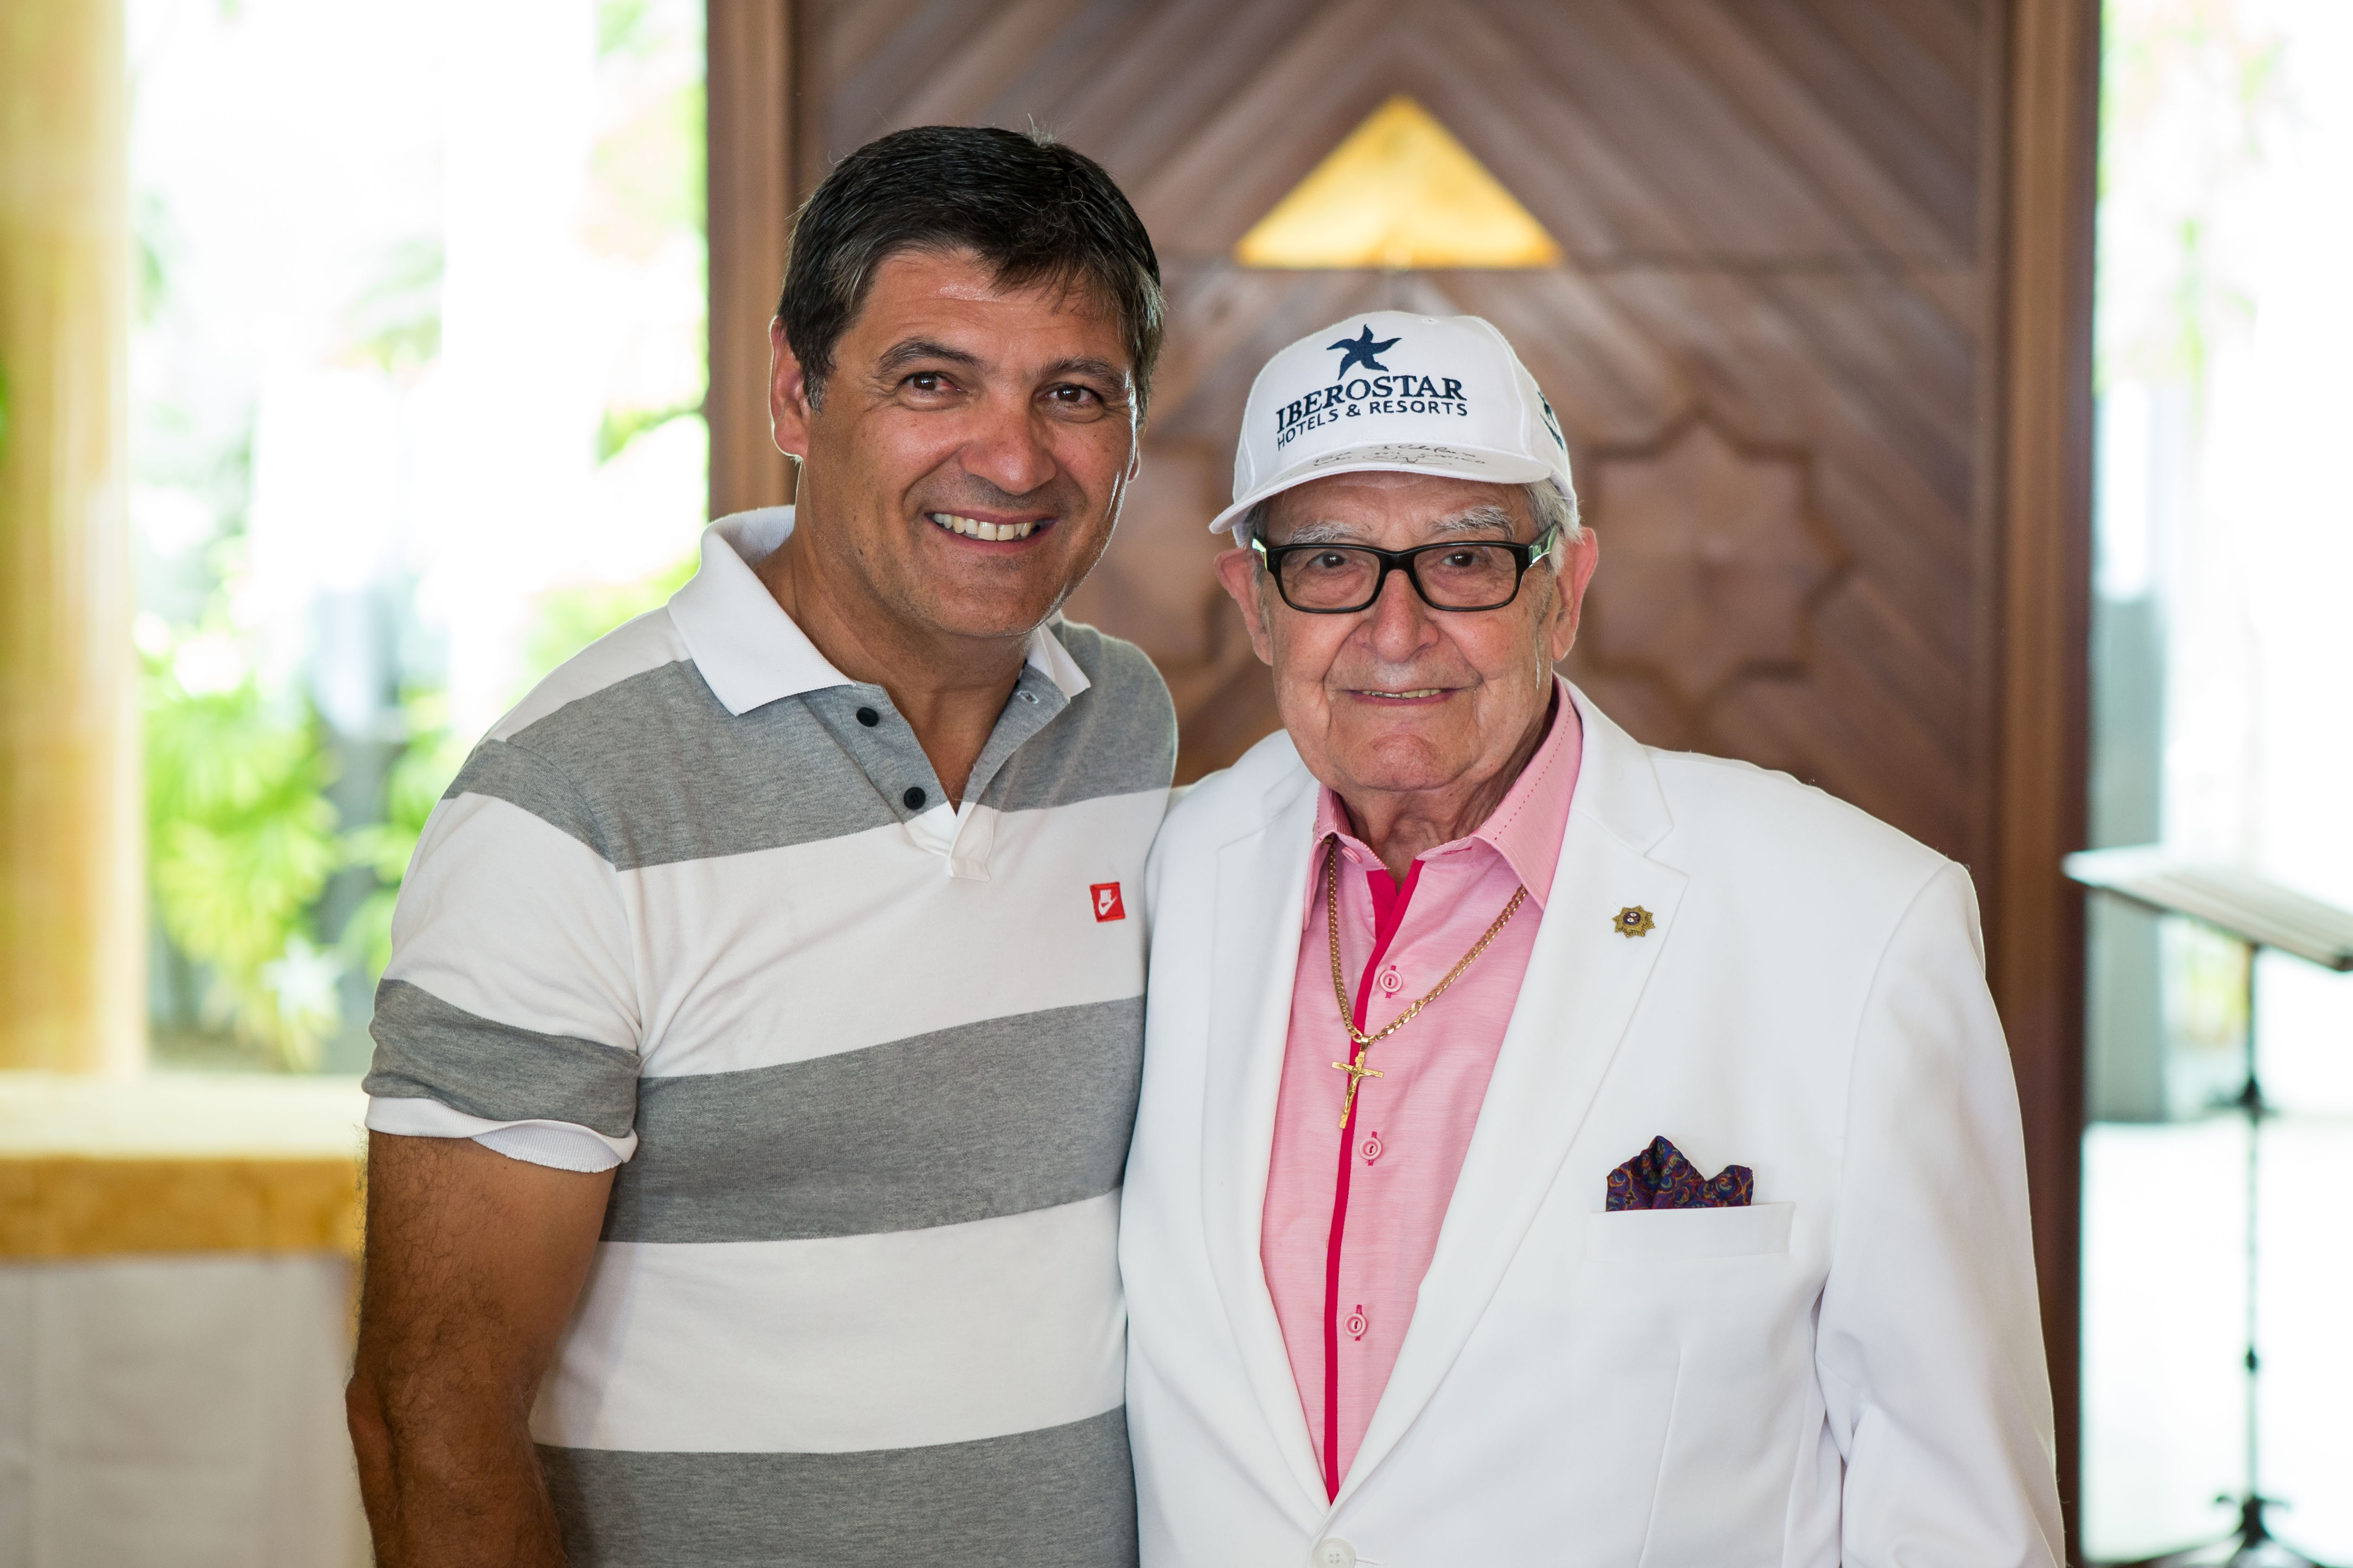
The first Superfan IBEROSTAR was Ildefonso Sánchez, a Spanish ex-pat living in Germany, whose second home is the IBEROSTAR Royal Andalus (Chiclana). At 89 years of age, he has enjoyed over 25 holidays at this hotel.

Ildefonso, is a self-confessed fan of tennis coach Toni Nadal. When he lost his IBEROSTAR cap, identical to that of Toni which the hotel manager gave to him as a gift years before, he had no hesitation in writing a letter to the CEO of the company to share his regret. When he was selected as the first Superfan IBEROSTAR, the chain wanted to thank Ildefonso for his loyalty, preparing a whole series of surprises for him and his wife during their most recent stay at the IBEROSTAR Royal Andalus, the climax of which was a surprise visit by Toni Nadal, who handed him a new and signed IBEROSTAR cap.

For Luis Hérault, Chief Marketing Officer at IBEROSTAR: “The Superfan IBEROSTAR initiative marks a crucial point in our commitment to our clients. We want to say thank you and reward some of our most loyal guests with the affection that they have demonstrated for the company and the staff. Our first Superfan is Ildefonso, and more will be joining him over the next five years. To achieve this, we are working closely with our hotels around the world to identify clients who stand out for their loyalty and extraordinary gestures towards the brand.”

Following the success of the first Superfan IBEROSTAR, the company is now focused on selecting the next candidates. The surprise activities that form part of the next award remain unknown, as they will depend on the emotional link and wishes shown by the guest to be honoured.

IBEROSTAR Hotels & Resorts has a 42% base of repeat guests with an average of at least three stays. A small number exceed twenty stays and are thus genuine ambassadors and friends of the brand.

Note for the editor:

- Via this link you can see a video with all the details of the new project and the tribute to Ildefonso Sánchez as the first Superfan IBEROSTAR.

About IBEROSTAR Hotels & Resorts
IBEROSTAR Hotels & Resorts is a resort hotel chain based in Palma de Mallorca (Balearic Islands, Spain), founded by the Fluxá family in 1986. IBEROSTAR Hotels & Resorts is an integral part of GRUPO IBEROSTAR, one of the main Spanish tourist companies with over 50 years of experience, which currently has around 100 hotels in 13 countries around the world.
For more information: iberostar.com
IBEROSTAR Press Office
Edelman London
Tel: +44 203 047 4035
Nicole Taylor (Nicole.taylor@edelman.com)
Leah Pummell (leah.pummell@edelman.com)

