### PRESS RELEASE

**IBEROSTAR LAUNCHES “INSIDE IBEROSTAR” MICROSITE**

* ***New microsite is part of a global brand communication strategy.***
* ***The brand’s new site features a wealth of information about IBEROSTAR’s products and services to help travelers plan their upcoming holidays.***

**Madrid, 12 May 2014** – This week **IBEROSTAR Hotels & Resorts** debuts the brand’s new microsite, “[**Inside IBEROSTAR**](http://inside.iberostar.com/),” which provides users with all the information they need to plan their next IBEROSTAR vacation. This year’s campaign builds upon the success of last year and shifts its media and advertising strategy to highlight IBEROSTAR’s key pillars through 10 interactive video sections. An investment of over **six million Euros**, the new campaign will maintain the last year’s title of “[**Inside IBEROSTAR**](http://inside.iberostar.com/)” and “**Enjoy being a star**” as the brand’s slogan.

By browsing the videos, images and brand content, users can learn about the company, its competitive advantages, and three fundamental pillars: **service**, **dining** and **entertainment**. Visitors can also explore content dedicated to specific activities such as golf, weddings, honeymoons, and business meetings.

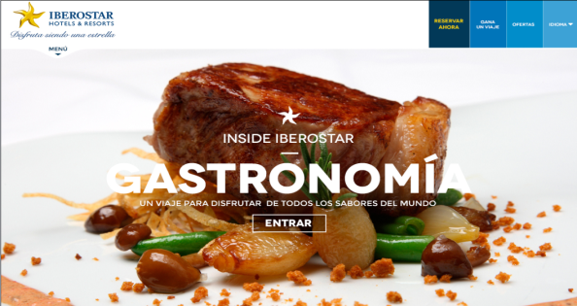

According to **Luis Hérault, Director General of Marketing at IBEROSTAR,** “*The new communication strategy shifts our media objectives from publicizing important information to becoming an integral part of the ‘****IBEROSTAR Customer Relationship Model****´. We understand that communication is a key factor prior to making a trip decision and we want to inspire our current and prospective clients as they plan their getaway.”*

The campaign was developed by the Spanish advertising agency **Sra. Rushmore**, the brand’s agency of record since 2009. Noted by **Carlos Murillo, Head of Accounts and Digital Integration at the agency,** *“The new campaign posed a major challenge in integrating ourselves in the IBEROSTAR Customer Relationship Model. By keeping ‘****Inside IBEROSTAR*** *as the campaign’s concept, we evolved from the development of preliminary ad copy to informational content about the products and services that the company offers its customers. Ultimately, the new microsite allows users to discover what IBEROSTAR can offer them on their next vacation.”*

The new campaign has been designed in three versions to accommodate PCs, Mobiles, and tablets, in addition to **seven languages** (English, Spanish, French, German, Portuguese, Italian, and Russian), covering 95% of IBEROSTAR’s current clientele and reaching more than 100 countries.

The international campaign can be viewed online at iberostar.com and on the company’s social networking sites. The campaign will be supported through a combination of public relations and specific online media-buying planned in the US, UK, Spain, Germany, Brazil, Mexico, Canada and Russia from May to December 2014.

**Note for the editor:**

* Please visit a short demo on the new campaign available [here](https://www.youtube.com/watch?v=AMl4HYYe34Y&feature=youtu.be) for further insight **explanatory video** clarifies the details of the campaign.

**About IBEROSTAR Hotels & Resorts**

IBEROSTAR Hotels & Resorts is a family-owned Spanish hospitality company with more than 50 years of experience in the travel industry. IBEROSTAR provides unique vacation experiences, rooted in superior customer service and quality, in the world’s most popular vacation destinations. With around 100 hotels in 13 countries, IBEROSTAR Hotels & Resorts is committed to offering excellence in quality and service and providing personal attention to each guest.

**For more information, visit:** iberostar.com

**Press Contacts IBEROSTAR**

**Edelman**

Tel: 212-704-8156

**Michelle Sobhraj** ([michelle.sobhraj@edelman.com](mailto:michelle.sobhraj@edelman.com))