MEDIA CONTACTS:

Michelle Sobhraj
Edelman
212-704-8156
michelle.sobhraj@edelman.com

IBEROSTAR HOTELS & RESORTS CELEBRATES GRAND OPENING OF FIRST HOTEL ON MEXICO’S PACIFIC COAST

Governor of Riviera Nayarit, Roberto Sandoval, and Mexico’s Undersecretary of Tourism Operations, Carlos Joaquin, joined GRUPO IBEROSTAR Executive Chairman, Miguel Fluxá, in Grand Opening Ceremony of IBEROSTAR Playa Mita

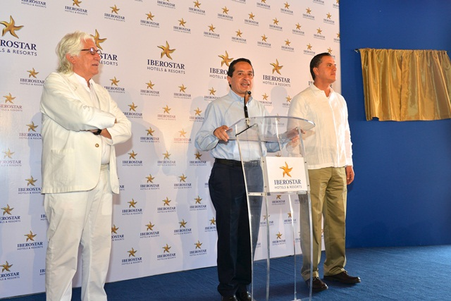

Carlos Joaquin, Mexico Undersecretary of Tourism Operations, speaks at the
IBEROSTAR Playa Mita grand opening ceremony along with Miguel Fluxá, GRUPO IBEROSTAR Executive Chairman (left) and Roberto Sandoval, Governor of Riviera Nayarit (right)

Palma de Mallorca, Spain (December 16, 2013) – Spanish hospitality brand IBEROSTAR Hotels & Resort held the grand opening ceremony yesterday of the new five-star, all-inclusive IBEROSTAR Playa Mita on Riviera Nayarit’s Pacific Coast., Miguel Fluxá led the honors along with Carlos Joaquin, Mexico’s Undersecretary of Tourism Operations, and Governor of Riviera Nayarit, Roberto Sandoval. IBEROSTAR has invested 100 million euros in the construction of the resort, which brings its total number of establishments in Mexico to 10.

Following a ceremony to unveil a plaque commemorating the opening, Mr. Joaquín stated, ”For the Federal Government, the opening of this hotel is of great importance as it allows us to continue improving the infrastructures in the region to offer a high quality destination. Tourism is strategic for the economic development of Mexico, and it is our intention to be efficient and competitive in positioning our country among the top destinations internationally.”

According to Miguel Fluxá, “At IBEROSTAR, we all feel tremendously proud for the opening of this new hotel and for contributing to the development of the magnificent region of Nayarit. The new IBEROSTAR Playa Mita reinforces our solid commitment to quality, which is a defining characteristic of our brand. We believe that the fantastic facilities, the warmth of our employees and the extraordinary natural surroundings will be instrumental in the IBEROSTAR Playa Mita’s success.”

Governor Sandoval also spoke a few words in recognition of the chain's important focus on the region: “We want to thank IBEROSTAR for bringing quality and warmth to this region. The government of the state of Nayarit is truly focused on offering to visitors the paradise of the Pacific with hotels with the standard of quality of the IBEROSTAR Playa Mita that we are officially opening today.”

The opening of IBEROSTAR Playa Mita will bring a significant boost to the development of tourism in Riviera Nayarit, which has become widely-recognized as a luxury destination on Mexico’s Pacific Coast. The region boasts more than 180 miles of beautiful coastline and cultural and natural heritage. IBEROSTAR Playa Mita has further contributed to the rapid development of the region with the creation of 450 jobs.

The addition of this resort to the brand’s portfolio further reflects the company's strong international growth and drive for expansion, focusing both on new destinations and increasing presence in countries such as Mexico, where it already holds a solid presence.

IBEROSTAR Playa Mita is part of the brand’s Premium Gold category, characterized by its offering of five-star hotels with luxury services. The property features 452 guest rooms, including 120 oceanfront junior suites, 18 adult-only Spa Rooms, two Presidential Suites and four accessible rooms. Guests can spend the day on the beach enjoying non-motorized water sports, lounge by the resort’s two pools, enjoy pampering and total relaxation at SPA Sensations, or get in a workout at the tennis courts and fitness center. Golfers can hit the links at the Litibu Golf Club, conveniently located onsite. This 18-hole, oceanfront, championship course, designed by Greg Norman, wows with stunning views of the Pacific.

Note for the editor:
Link to download images of the opening ceremony: https://edelmanftp.box.com/s/y3ll4sh7impgmb6m879z
Link to download images of the hotel:
https://edelmanftp.box.com/s/8a3t4zkwee4b3yax0c50

About IBEROSTAR Hotels & Resorts
IBEROSTAR Hotels & Resorts is a family-owned Spanish hospitality company with more than 50 years of experience in the travel industry. IBEROSTAR provides unique vacation experiences, rooted in superior customer service and quality, in the world’s most popular vacation destinations. With more than 100 hotels in 16 countries, IBEROSTAR Hotels & Resorts is committed to offering excellence in quality and service and providing personal attention to each guest.

For more information: iberostar.com

