MEDIA CONTACTS:

Michelle Sobhraj
Edelman
212-704-8156
michelle.sobhraj@edelman.com

IBEROSTAR HOTELS & RESORTS STRENGTHENS GLOBAL PORTFOLIO WITH ADDITION OF THE IBEROSTAR MAGIA MACEIÓ IN BRAZIL

Hotel Will Be Brand’s Fourth Property in Brazil and First Resort in the Alagoas Region

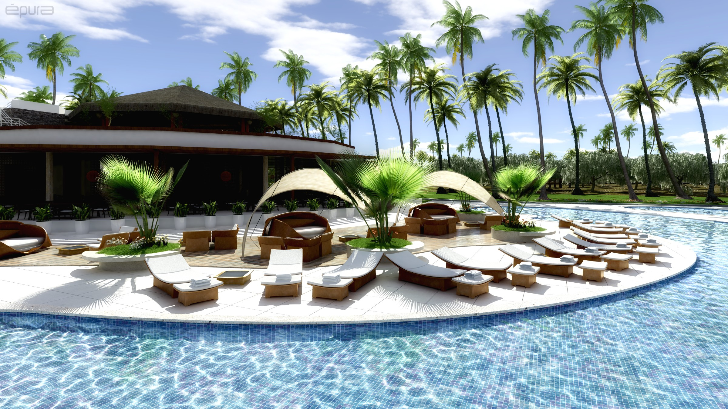
IBEROSTAR Magia Maceió Pool Area IBEROSTAR Magia Maceió Suite

Palma de Mallorca, Spain (October 16, 2013) – Further strengthening its robust global portfolio of hotels, IBEROSTAR Hotels & Resorts, the hotel division of GRUPO IBEROSTAR, recently announced the development of its newest hotel in Brazil, the IBEROSTAR Magia Maceió. The resort will mark the fourth hotel in Brazil for the brand, but will be the first in the popular Alagoas region. The new hotel complex is currently in the construction stages and will plan to open in 2015 in Alagoas’ booming capital of Maceió.

At the announcement event held today at the Town Hall of Maceió, Mr. José Antonio González, Vice Chairman and CEO America of GRUPO IBEROSTAR, signed an agreement to commence the development of the hotel complex and thus ushered in the first resort managed by an international chain in the state of Alagoas/Maceió. The event was additionally attended by Teotonio Vilela, Governor of Alagoas; Daniela Novis, Secretary for Tourism in Alagoas; Rui Palmeira, Mayor of Maceió; and Claudia Pessoa, Secretary for Tourism in Maceió.

“This agreement is testimony to our firm commitment to an emerging destination which we consider to be central to our international expansion strategy,” said Mr. González. “At IBEROSTAR, we believe in the potential of this destination, and we are delighted to contribute to the increase in accommodation choices, as well as to the creation of new jobs. Undoubtedly, this positive news will be welcomed with great enthusiasm in the region.”

The 968,752-square-foot 5-star hotel will be a Premium Gold resort and will feature 226 rooms and 18 suites, expansive pools (more than 21,000 sq. ft.), a bar, a spa and fitness center, four meeting spaces, and a mini-market, as well as retail shops. Guests of the resort can also indulge at one of the property’s four restaurants, including a full-service buffet, as well as Japanese, Italian and Mediterranean restaurants.

Situated in the northeast of Brazil, Alagoas is known for its beautiful white sandy beaches, swaying palm trees and its magnificent climate – much like the Caribbean. Alagoas is also home to the second largest barrier reef in the world, which causes the formation of spectacular natural pools around the coast.

In addition to the upcoming IBEROSTAR Magia Maceió, the brand’s Brazilian hotel portfolio includes the IBEROSTAR Grand Hotel-Ship Amazon, IBEROSTAR Praia do Forte and IBEROSTAR Bahía.

Images available upon request.

About IBEROSTAR Hotels & Resorts
IBEROSTAR Hotels & Resorts is a family-owned Spanish hospitality company with more than 50 years of experience in the travel industry. IBEROSTAR provides unique vacation experiences, rooted in superior customer service and quality, in the world’s most popular vacation destinations. With more than 100 hotels in 16 countries, IBEROSTAR Hotels & Resorts is committed to offering excellence in quality and service and providing personal attention to each guest.

For more information, please visit iberostar.com.

