A TASTE OF CLASS:
IBEROSTAR’s CUISINE

- To promote high quality cuisine, IBEROSTAR Hotels & Resorts has produced an international cookbook with 42 recipes created by its 14 star chefs

- This initiative is part of the IBEROSTAR Chef concept, which aims to promote and advertise one of its main three pillars: gastronomy

Customer satisfaction is crucial to IBEROSTAR. Therefore the company has strived to promote its main three pillars of gastronomy, service, and entertainment through various initiatives.


One of these initiatives is the creation of the IBEROSTAR Chef, a new concept which encompasses the company's culinary offering and linking all the gastronomy initiatives including; show cooking, special events, training courses in its own cookery workshops, and cookbooks such as the one launched in June 2013: IBEROSTAR’s Cuisine.

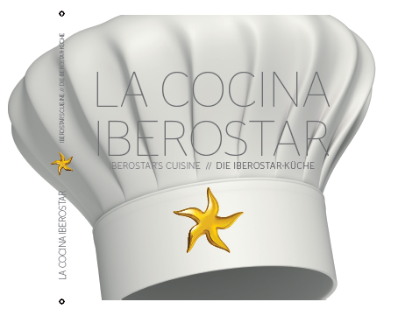
The book includes recipes created by the top chefs currently working for the Majorca hotel chain. Each recipe reflects the gastronomic specialties which are cooked every day in the hotels in the parts of the world where the company has presence.

With a total of 42 recipes, the book is comprised of starters, main courses and desserts to suit all tastes. Each recipe includes details about the ingredients, the steps to make the dish and the level of difficulty.

According to Luis Herault, the company's Chief Marketing Officer: “Gastronomy is a crucial pillar in IBEROSTAR. It's a key component to ensure our customers enjoy a perfect vacation and receive a high quality service. This book is one of the initiatives under the IBEROSTAR Chef brand, which pays homage to our chefs who, through their dedication and great talent, contribute to maintain the excellent quality of our gastronomy every day".

The 14 chefs, who have contributed to the book, work in countries from Greece, Tunisia, Jamaica and even Brazil. They were selected to provide a touch of diversity and cultural richness to the recipes.

Dishes featured in the book such as a “black suckling pig with colored potatoes, cabbage stew, and red onion marmalade” and desserts like the “yogurt and passion fruit pastry cylinders with guava mojito granita” are just a few examples of the fusion between traditional recipes based on local products and innovative styles and new flavors.

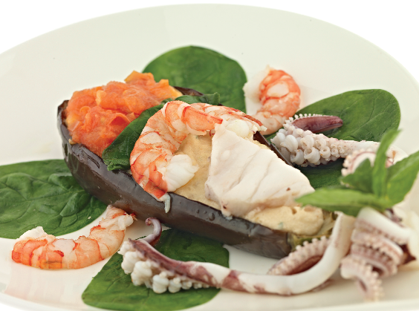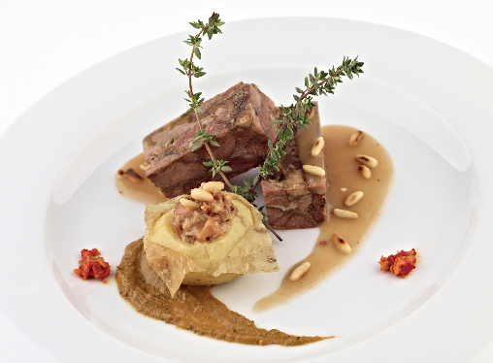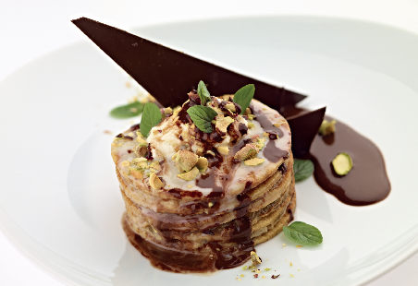

The book, available in Spanish, English, and German, was carefully designed by IBEROSTAR and includes large pictures of every recipe, as well as a brief profile of each of the chefs. The book is expected to be updated with new recipes every three years.

The IBEROSTAR Cuisine will be available to buy soon for €25 from the IBEROSTAR hotel stores Starmarket and Starshop.

About IBEROSTAR Hotels & Resorts
IBEROSTAR Hotels & Resorts is a family-owned hotel chain based in Palma, Majorca. IBEROSTAR resorts are 4 and 5 star properties, located in 16 countries across Spain, Europe, the Mediterranean, the Caribbean, and South America. The hotel chain belongs to GRUPO IBEROSTAR, one of the most consolidated Spanish tourist groups with 50 year experience. IBEROSTAR Hotels & Resorts currently has over 100 hotels.

IBEROSTAR Press Office
Edelman
Tel: +44 203 047 4035
Nicole Taylor (Nicole.taylor@edelman.com)
Luke Smart (luke.smart@edelman.com)

