MEDIA CONTACTS:

Michelle Sobhraj
Edelman
Tel: 212-704-8156
michelle.sobhraj@edelman.com

IBEROSTAR Hotels & Resorts Launches Cookbook
as part of new iberostar chef culinary BRAND

“La Cocina IBEROSTAR” Highlights Over 40 Recipes Created By the Company’s
Chefs Worldwide

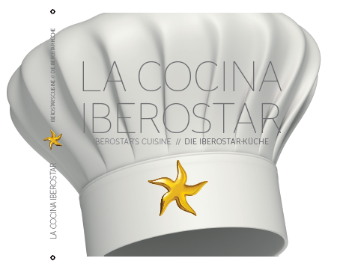


Palma de Mallorca, Spain (August 19, 2013) – IBEROSTAR Hotels & Resorts continues its commitment to quality, customer service and customized experiences with the creation of IBEROSTAR Chef, a new initiative focusing on elevating awareness of the brand’s culinary offerings through special events, training courses for guests and the August launch of La Cocina IBEROSTAR, the brand’s first-ever cookbook.

This hardcover book includes an array of recipes by expertly trained chefs currently working at several of the more than 100 properties in the IBEROSTAR portfolio. With recipes from Morocco to Mexico, the book reflects the high quality of culinary offerings available at IBEROSTAR hotels worldwide. Comprised of 42 recipes, La Cocina IBEROSTAR includes starters, main courses, and desserts for every taste bud. Each recipe details the required ingredients and its level of difficulty, as well as step-by-step instructions.

“Gastronomy is an important pillar of the IBEROSTAR brand and an integral part of our customer experience,” said Luis Herault, Chief Marketing Officer for GRUPO IBEROSTAR. “This book is one of the initiatives under the IBEROSTAR Chef brand, which strives to pay homage to our chefs, who through their dedication and great talent contribute to the excellent quality of our culinary offerings every day."

A total of 14 chefs are featured in the cookbook, working in countries as diverse as Greece, Tunisia, Jamaica, and Brazil. These talented individuals were selected to provide a touch of diversity and cultural richness to the recipes.

Dishes include entrées such as “black suckling pig with colored potatoes, cabbage stew, and red onion marmalade” and desserts like “yogurt and passion fruit pastry cylinders with guava mojito granite,” representing the fusion between traditional recipes based on local products and innovative styles and new flavors.

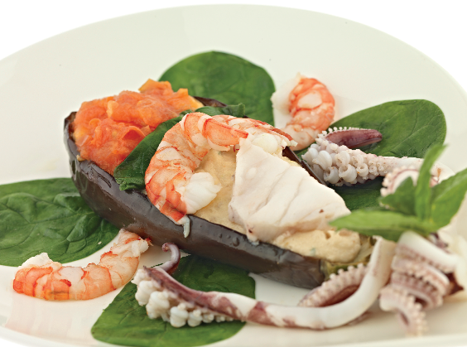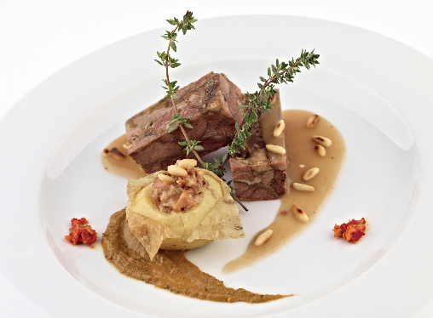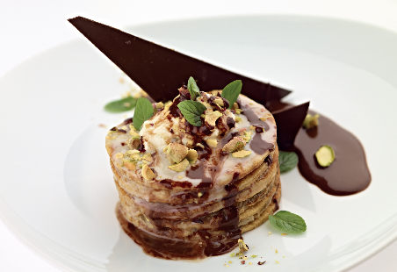

The book, written in Spanish, English, and German, was carefully designed by IBEROSTAR and includes large pictures of every recipe, as well as a brief profile of each of the chefs. The book is expected to be updated with new recipes every three years.

La Cocina IBEROSTAR retails for 25 Euros (approximately $33 USD) and is available only at IBEROSTAR hotel stores Starmarket and Starshop.

IBEROSTAR Hotels & Resorts currently offers more than 100 hotels worldwide, ranging from the adults-only Grand Collection to couple- and family-friendly Premium Gold and Premium category resorts, together offering a variety of ideal locations for memorable vacation experiences. Earlier this year, IBEROSTAR announced the opening of its newest property, IBEROSTAR Playa Mita in Riviera Nayarit, Mexico, will take place in December 2013.

About IBEROSTAR Hotels & Resorts
IBEROSTAR Hotels & Resorts is a family-owned Spanish hospitality company with more than 50 years of experience in the travel industry. IBEROSTAR provides unique vacation experiences, rooted in superior customer service and quality, in the world’s most popular vacation destinations. With more than 100 hotels in 16 countries, IBEROSTAR Hotels & Resorts is committed to offering excellence in quality and service and providing personal attention to each guest.

For more information, please visit iberostar.com.

