PRESS RELEASE

IBEROSTAR HOTELS IN THE DOMINICAN REPUBLIC RECEIVE THE GREEN KEY

- All six IBEROSTAR hotels in the Dominican Republic receive the Green Key certification

- Award recognises tourist establishments that have achieved the very highest standards in sustainable development and environmental responsibility

- Certification positions the Majorcan hotel chain as a leader in the responsible development of tourist establishments and IBEROSTAR's commitment to its destinations' communities

London, 3 June 2013. All IBEROSTAR Hotels & Resorts properties in the Dominican Republic have received the Green Key certification, an award that recognises the drive for sustainable development.

Green Key, an eco-label awarded by the Environmental Law Institute of the Dominican Republic representing the Foundation for Environmental Education (FEE), aims to promote good environmentally friendly practices in tourist establishments. This certification is awarded in 41 countries with more than 2,100 establishments receiving the award.

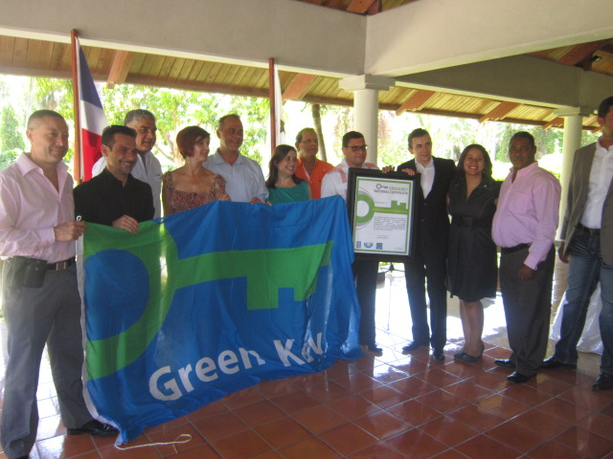
IBEROSTAR Hotels & Resorts began its international expansion twenty years ago with the opening of its first hotel in the Dominican Republic, the 5* IBEROSTAR Bávaro.

Since 1993 the Majorcan chain has invested in its hotels and services on the island to ensure they are of the highest possible standard. This work has been recognised internationally and the Green Key certification rewards the properties on the Dominican Republic.

“The Green Key recognition for all our hotels in the Dominican Republic is a reflection of IBEROSTAR's commitment to environmental care and responsible development. This certification has been possible thanks to the efforts of all the chain's personnel and partners in the country”, said María José Berbel, IBEROSTAR Operations Director in the Dominican Republic.

The ceremony was attended by the Deputy Minister Fausto Fernández, on behalf of the Ministry of Tourism, and the Deputy Minister of the Environment, Mariano Morla. Cesarina Aquino Rivas, the Green Key National Coordinator, highlighted the progress made in each of the IBEROSTAR hotels since their first hotel opening on the island and indicated that all the certified hotels had successfully passed a rigorous external audit conducted at the end of 2012.

All IBEROSTAR Hotels & Resorts hotels in the Dominican Republic have received this recognition. They are as follows: IBEROSTAR Dominicana, IBEROSTAR Punta Cana, IBEROSTAR Bávaro, IBEROSTAR Grand Bávaro, IBEROSTAR Hacienda Dominicus and IBEROSTAR Costa Dorada.

-Ends-

Notes to Editor:

About IBEROSTAR Hotels & Resorts
IBEROSTAR Hotels & Resorts is a family-owned hotel chain based in Palma, Majorca. IBEROSTAR resorts are 4 and 5 star properties, located in 16 countries across Spain, Europe, the Mediterranean, the Caribbean, and South America. The hotel chain belongs to GRUPO IBEROSTAR, one of the most consolidated Spanish tourist groups with 50 year experience. IBEROSTAR Hotels & Resorts currently has over 100 hotels.

IBEROSTAR Press Office
Edelman
Tel: +44 203 047 4035
Nicole Taylor (Nicole.taylor@edelman.com)
Luke Smart (luke.smart@edelman.com)

