**Media Contacts:**

Andrea Braunstein / Michelle Sobhraj

Edelman on behalf of IBEROSTAR

212-704-4517 / 212-704-8156

andrea.braunstein@edelman.com / [michelle.sobhraj@edelman.com](mailto:michelle.sobhraj@edelman.com)

**FIVE IBEROSTAR HOTELS & RESORTS PROPERTIES**

**RECEIVE AAA FOUR DIAMOND RATINGS**

***Properties in Jamaica and Mexico Honored***

**Palma de Mallorca, Spain (March 27, 2013)** – Leading Spanish hospitality brand, IBEROSTAR Hotels & Resorts, was recently recognized for its strong dedication to outstanding quality and superior service and amenities, receiving five AAA Four Diamond Ratings for several of its all-inclusive properties in Jamaica and Mexico.

AAA, which annually reviews and rates hotels based on extensive criteria, recently presented the IBEROSTAR Grand Hotel Paraíso and IBEROSTAR Paraíso Maya in Riviera Maya, Mexico; the IBEROSTAR Cancun in Cancun, Mexico, as well as the IBEROSTAR Grand Hotel Rose Hall and IBEROSTAR Rose Hall Suites in Montego Bay, Jamaica with the prestigious honor.

Based on numerous comprehensive measures, including the style of operation, quality, overall concept and service level, only a chosen few hotels that offer an extensive array of amenities and a high degree of hospitality, service and attention to detail are extended the respected award. With only 4.8% of AAA’s 30,000 rated hotels receiving the accolade each year, the awards further highlight the brand’s continued commitment to quality and solidifies its status as an industry leader in the all-inclusive category.

Two of the properties awarded the AAA Four Diamond, the IBEROSTAR Grand Hotel Paraíso and IBEROSTAR Cancun, will be featured on two programs airing on The Golf Channel this spring. The entire season of *Big Break: Mexico* was filmed on location at the IBEROSTAR Grand Hotel Paraíso and its championship, P.B. Dye- designed IBEROSTAR Playa Paraíso Golf Course, while *Big Break Academy* was filmed at the IBEROSTAR Cancun and the beautiful IBEROSTAR Cancun Golf Club.

IBEROSTAR’s adults-only Grand Collection defines a new category of luxury hotels and resorts, based on the concept of exclusivity, style and relaxation in spectacular locations. These five-star properties offer services aimed at crafting a unique and unforgettable experience, including exquisite décor, gourmet dining, 24-hour concierge, butler and room service; and numerous amenities such as spa services and world-class golf.

With more than 100 properties worldwide, IBEROSTAR Hotels & Resorts prides itself on providing the highest quality services and excellent vacation experiences for travelers of all ages. The brand currently offers 18 properties in Mexico and the Caribbean, ranging from the adults-only Grand Collection to couple- and family-friendly Premium Gold and Premium category resorts. From gourmet dining and luxurious spas, to 18-hole championship golf, water sports, Mini Clubs for kids and more there’s something for everyone to enjoy.

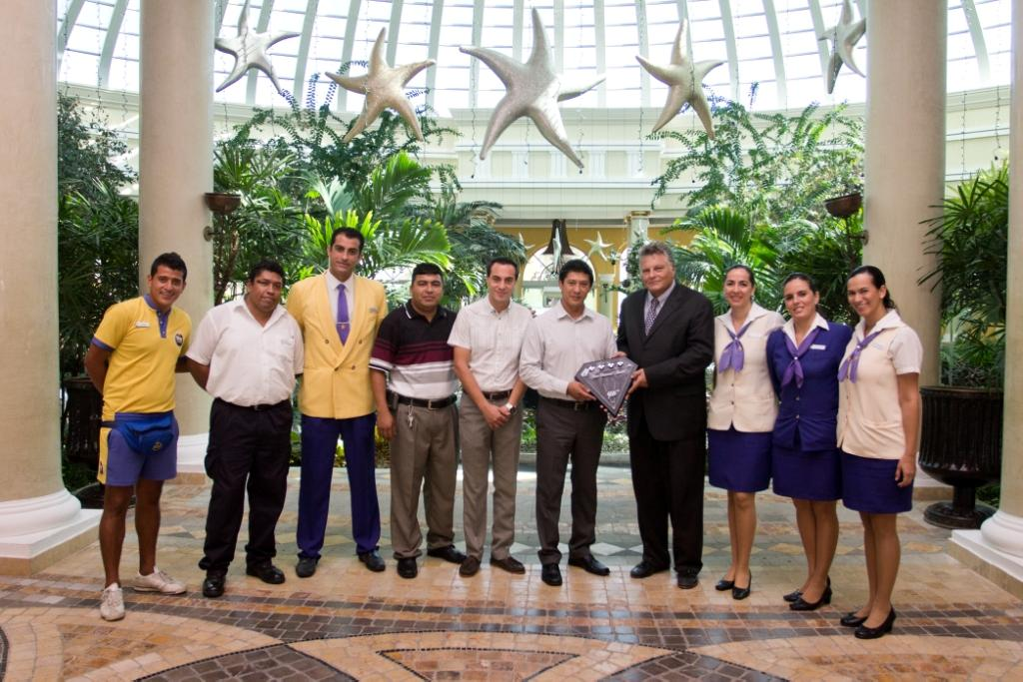

*Tony Perrone (right) of AAA presenting Alfonso Lopez (left), GM of the IBEROSTAR Grand Hotel Paraíso, and his staff with the AAA Four Diamond Award.*

**About IBEROSTAR Hotels & Resorts**

IBEROSTAR Hotels & Resorts is a family-owned Spanish hospitality company with more than 50 years of experience in the travel industry. IBEROSTAR provides unique vacation experiences, rooted in superior customer service and quality, in the world’s most popular vacation destinations. With more than 100 hotels in 16 countries, IBEROSTAR Hotels & Resorts is committed to offering excellence in quality and service and providing personal attention to each guest.

For more information, please visit [iberostar.com](http://www.iberostar.com).

**###**