MEDIA CONTACTS:

Andrea Cohen / Michelle Sobhraj
Edelman
212-704-4517 / 212-704-8156
andrea.cohen@edelman.com / michelle.sobhraj@edelman.com

IBEROSTAR HOTELS & RESORTS UNVEILS NEW
“INSIDE IBEROSTAR” BRAND CAMPAIGN
Behind-the-Scenes Videos Show How IBEROSTAR Creates
Extraordinary Vacation Experiences for Guests

Palma de Mallorca, Spain (February 13, 2013) – IBEROSTAR Hotels & Resorts has debuted a new microsite that brings to life the IBEROSTAR experience through documentary-style videos. It is part of a strategy that, over a three-year period, has focused on brand communication, shifting attention from offline to online communication channels in order to guarantee maximum global coverage and strengthen IBEROSTAR’s key competitive advantages, namely personal service, gastronomy and entertainment.

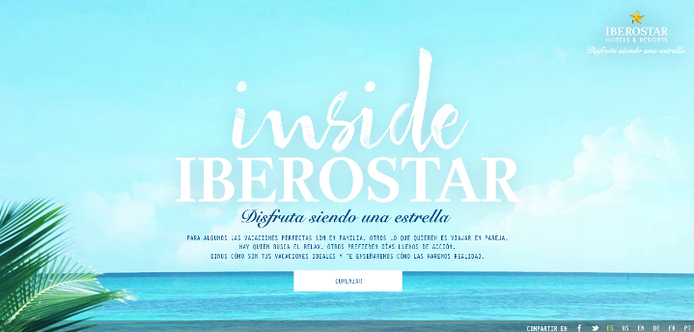
The highly-intuitive and easy-to-browse Inside IBEROSTAR microsite (www.insideiberostar.com) offers users 13 videos showing real guests enjoying their vacations and behind the scenes looks at how hotel staff ensure guests’ happiness. Additionally, the microsite allows users to tailor their choice of videos in accordance with their personal travel preferences by asking them three simple questions: 1) What do you look for in a holiday? 2) Are you one of those people for whom eating is a pleasure?, and 3) Who do you travel with?

According to Luis Hérault, IBEROSTAR’s Chief Marketing Officer, “This 100% online campaign meets its prime objective, which is helping our current and future customers to rank IBEROSTAR as their number one option when it comes to where to spend their vacations”.

Developed by the Spanish advertising agency Sra. Rushmore, the new Inside IBEROSTAR website is available in six languages (Spanish, English, Portuguese, German, French and Russian), thereby enabling it to reach consumers in more than 100 countries and almost 90% of the company’s customers, turning it into the company’s first ever 100% global campaign. A major support strategy will also be launched on the company’s social platforms in order to promote and support the microsite’s online presence, together with media plans in the USA and UK, further proof of the campaign’s international vocation.

As Carlos Murillo, Head of Accounts and Digital Integration at Sra. Rushmore explains, “The creative idea of this campaign was clear. It was time to shift the spotlight and provide a documentary-style insight into how the hotel staff makes everything that goes on in the hotel possible, as well as showing what a great time everyone has at IBEROSTAR.”

Click here to view the campaign’s introductory video, presented by Mr. Hérault, CMO GRUPO IBEROSTAR.

About IBEROSTAR Hotels & Resorts

IBEROSTAR Hotels & Resorts is a family-owned Spanish hospitality company with more than 50 years of experience in the travel industry. IBEROSTAR provides unique vacation experiences, rooted in superior customer service and quality, in the world’s most popular vacation destinations. With more than 100 hotels in 16 countries, IBEROSTAR Hotels & Resorts is committed to offering excellence in quality and service and providing personal attention to each guest.

For more information, please visit iberostar.com.

# # #

